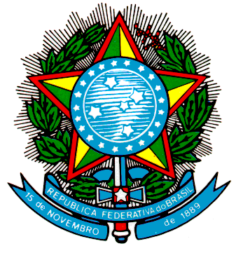
MINISTÉRIO DA SAÚDE
Gabinete do Ministro
Assessoria de Assuntos Internacionais em Saúde

Intersessional seminar on good practices, key challenges, and new developments relevant to access to medicines and vaccines as a human right to health.
Geneva, Switzerland and virtually on Zoom platform, 8 December 2021

United Nations High Commissioner for Human Rights, Michelle Bachelet,

World Health Organization Director-General, Tedros Adhanon.

It is with great satisfaction that I take part in this seminar on practices, challenges, and developments related to access to medicines and vaccines, in the context of the human right to health.

The Covid-19 pandemic has demonstrated the fragility of global supply chains and the need to ensure fair and equitable access to safe, effective, and quality medicines and vaccines at the lowest possible cost.

Despite the recognition of extensive immunization against Covid-19 as a global public good, only 5.2% of the population in low-income countries received at least one dose of vaccine. Overcoming inequality in access to immunization and promoting the global distribution of vaccines is even more crucial in the current scenario, following the emergence of the Omicron variant.

In this context, Brazil has strongly supported discussions and initiatives aimed at strengthening national and regional capacity for the production of medicines and other health technologies, aiming at increasing equitable access to these medicines and vaccines.

In the debates regarding the negotiations of a new international instrument under the auspices of the WHO, the issue of equitable access to countermeasures is a priority for Brazil.

Expanding access deserves to be considered not only from the point of view of individuals, especially of those who are most vulnerable, such as the elderly, people with disabilities, and people living in poverty, but also from the perspective of the need to promote access for all countries to new health technologies.

It is also important to ensure adequate resources for research, development, and innovation aimed at all diseases and health conditions, especially neglected tropical diseases. It means, therefore, leaving no one behind.

Ladies and Gentlemen,

Ensuring access to vaccines for all Brazilians, in particular through the expansion of our national production capacity, is a priority for the Government of President Jair Bolsonaro.

In Brazil, our Unified Health System is the pillar of our response to the pandemic. Thanks to advances in vaccination, with more than 75% of the target population fully immunized, it was possible to reduce within six months by 90% the number of deaths and cases of covid-19.

The contribution of Brazil's economic-industrial complex was fundamental to our response to the pandemic. About 65% of the doses of vaccines distributed in Brazil were produced in the national territory. We believe that we can go further and play a decisive role in promoting access to countries of our region.

Last November 19th, under the Brazilian Pro Tempore Presidency, we adopted the Declaration of Ministers of Health of Mercosur on the Need to Expand the Regional Capacity for the Production of Medicines, Vaccines and Health Technologies.

We are very proud of Brazil’s selection, announced by WHO last September, as a regional center for the development and production of m-RNA vaccines in Latin America and the Caribbean.

With these initiatives, Brazil will continue to contribute to strengthening the global health arena, for the benefit of the human right to health, the promotion of universal access, and strong and inclusive national health systems.

Thank you very much!

