Asia-Pacific Regional Review Meeting on the Implementation of the Istanbul Programme of Action
in Preparation for the Fifth United Nations Conference on the Least Developed Countries (UNLDC-5)

Special session on harnessing science, technology and innovation to support structural transformation and LDC graduation by the Technology Bank for the Least Developed Countries

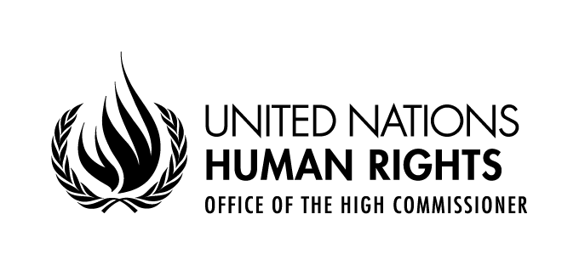

Statement delivered by
Diego Valadares Vasconcelos Neto
Human Rights Officer,
Right to Development Section
OHCHR Focal point for LDCs, LLDCs and SIDS

30 August - 2 September 2021
UNHQ, Geneva, Switzerland, and virtual via Webex

Thank you, Mr. Chair,
Access to technology, science and innovation in LDCs is still a major challenge. LDCs need support from the international community to close technology gaps and address digital divides, keep up with rapid technology change and make progress towards achieving the Sustainable Development Goals and realizing human rights, including the right to development, economic social and cultural rights, and even some civil and political rights, such as freedom of expression.
The Open Ended Intergovernmental Working Group on the Right to Development considers knowledge a public good and a key instrument for development. It also considers that transfer of technology in development partnerships should respect the right of everyone to benefit from scientific progress and its applications. From a right to development perspective, transfer of technology should ensure the fair distribution of benefits for all in relation to technological development.
As mentioned in the 2019 Human Rights Council Report 42/29, The Technology Bank has the potential to provide an important contribution for the realization of the right to development in least developed countries.
The 2020 Report on the Right to Development, report 45/21, referenced the Tech Access initiative of the Technology bank for LDCs, UNDP, WHO, and UNCTAD which aims to support developing countries in scaling up local production of critical health technologies needed to combat COVID-19, including personal protective equipment and diagnostic and medical devices.
We are happy to confirm that co-chair of this session, Mr. Setipa, will be one of the speakers in the next Human Rights Council Social Forum Speaking in the pane “Overcoming global challenges towards recovering better” on 12 October, 2021.
Finally, I would like to present a question to Ms. Tina Jabeen, Managing Director and CEO of Start-Up Bangladesh Limited: Based on your experience, how can we foster an enabling environment for start-ups that promote access to technology by women and by historically discriminated groups in other LDCs.
Thank you, Mr. Chair.

Report of the Secretary-General and the United Nations High Commissioner for Human Rights on the Right to Development, 2019, A/HRC/42/29, para.41.
Report of the Working Group on the Right to Development on its seventh session (Geneva, 9-13 January 2006), E/CN.4/2006/26, para. 51.
A/HRC/42/29, para.45. The report also recommended that Member States and other stakeholders “Continue and enhance cooperation with initiatives that promote technology transfer, especially to least developed countries.” (para.65(c)).
Report of the Secretary-General and the United Nations High Commissioner for Human Rights on the Right to Development, 2020, A/HRC/45/21, para.54. See also the more recent reference in the 2021 report, A/HRC/48/26, para.70.

