Asia-Pacific Regional Review Meeting on the Implementation of the Istanbul Programme of Action
in Preparation for the Fifth United Nations Conference on the Least Developed Countries (UNLDC-5)
Session 6: SOCIAL AND HUMAN DEVELOPMENT AND GOOD
GOVERNANCE AT ALL LEVELS

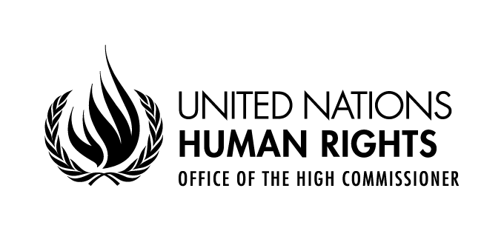

Statement delivered by
Diego Valadares Vasconcelos Neto
Human Rights Officer,
Right to Development Section
OHCHR Focal point for LDCs, LLDCs and SIDS

30 August - 2 September 2021
UNHQ, Geneva, Switzerland, and virtual via Webex

Mr. Chair,
Your Excellencies,

The Office of the United Nations High Commissioner for Human rights welcomes very much the theme of the current session; we acknowledge the statements from all the participants. In particular, we think the representative of the UN Women to the Middle East for having emphasised the quote by the High Commissioner for Human on aspects related to the right to freedom of expression online.
Mr. Chair,
Your Excellencies,
Human Rights Mechanisms, including treaty bodies, special procedures of the human rights council, and the universal periodic review, can provide valuable guidance for an ambitious programme of work for LDCs that substantially contributes to the social and human development and good governance at all levels.
Poverty and inequality had undermined human rights and hindered their sustainable development, especially in LDCs. Structural and systematic discrimination against the poor and marginalized had perpetuated poverty and inequalities, which has resulted in inadequate access to food, education, health services and digital technologies. This has had extreme impact on children, youth and women.
The Social Forum, one of the mechanisms of the Human Rights Council, focused its 2020 Session on “good practices, success stories, lessons learned and current challenges in combating poverty and inequalities". After two days of interactive debates between civil society, academics, Member States, intergovernmental organizations, the Forum made recommendations that can contribute to the subject of the current session and inspire the new programme of work.
The social forum recommended that states should promote a just transition to green and decent jobs and accessible education. This should be complemented by providing social protection measures. Strong social safety nets to their entire population are necessary for LDCs to overcome the herculean challenges they face to fight poverty. But to achieve this, they depend on strong international solidarity to fund social policies. Member States could consider including in the new programme of action the creation of a universal social protection fund that help LDCs finance their domestic social protection programmes. Particular attention should be given to those working in the informal sector. Efforts to eradicate poverty should tackle the inequalities that are present within and among countries and such efforts should target the root causes behind poverty and inequality. To achieve a real transformation, this program must tackle the unequal distribution of power, resources and opportunities that extend gender inequality, poverty, and environmental degradations.
Responses to COVID-19 must be focused on the well-being of the overall population, taking into account the specific socio-economic context affecting large sections of marginalized peoples in the developing countries.
The 2020 Human Rights Council Social Forum made many other relevant recommendations, and we refer participants to consult its report A/HRC/46/59.
I thank you, Mr. Chair.

