Asia-Pacific Regional Review Meeting on the Implementation of the Istanbul Programme of Action
in Preparation for the Fifth United Nations Conference on the Least Developed Countries (UNLDC-5)
Session 5: Structural transformation and resilient infrastructure for sustained economic growth, poverty alleviation and decent work for all

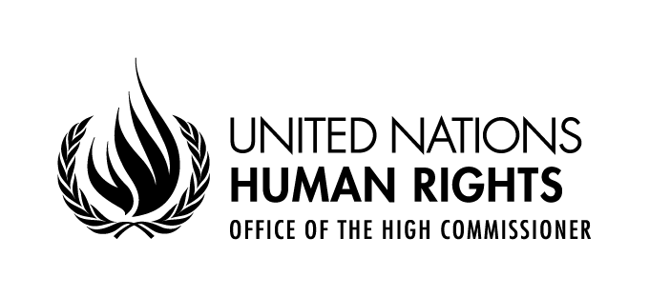

Statement delivered by
Diego Valadares Vasconcelos Neto
Human Rights Officer,
Right to Development Section
OHCHR Focal point for LDCs, LLDCs and SIDS

30 August - 2 September 2021
UNHQ, Geneva, Switzerland, and virtual via Webex

Excellencies,
Distinguished delegates,
Ladies and gentlemen,
At the outset, I would like to congratulate the keynote speakers and panellists for their excellent interventions. In this short intervention, I will not elaborate on the theme of the present session, but I would like to invite participants to follow meetings and reports relevant to the current discussion.
The operationalization of the right to development can contribute to promoting structural transformation and resilient infrastructure, poverty alleviation and decent work for all in Least Developed Countries. The 2020 joint report of the Secretary General and the High Commissioner on the right to development focused specifically on the challenges to the realization of the right to development in LDCs. During the Forty-Eight Session of the United Nations Human Rights Council, from 13 September to 8 October, different reports on the right to development will be presented. These include the Secretary General and High Commissioner report on the right to development on the response to and the recovery from the coronavirus disease (COVID-19) pandemic. It also includes the thematic study by the Expert Mechanism on the Right to Development on operationalizing the right to development in achieving the Sustainable Development Goals.
We would also like to invite the participants of the current session to follow events that will take place in the next months that may contribute to the build up to the Doha Conference on Least Developed Countries. In October 2021, the Human Rights Council will be holding the Social Forum under the theme of fighting COVID 19 pandemic through international solidarity and human rights perspective. I am happy to announce that you, Mr. Co-Chair, Mr. Joshua Setipa, Managing Director for The Technology Bank for Least Developed Countries, has kindly accepted to be one of the speakers during the Forum, addressing the panel “Overcoming global challenges towards recovering better”. We invite all to register and actively participate in the Social Forum.
The Intergovernmental Working Group on the Right to Development will meet from 22nd to 26th of November where it is going to discuss the text of a legally binding instrument (LBI) on the right to development.
From March next year, as mandated by the Human Rights Council in Resolution 47/11, the OHCHR will organize a series of regional seminars, one for each of the five geographical regions, on the contribution of development to the enjoyment of all human rights, in order to allow Member States, relevant United Nations agencies, funds and programmes, international and regional organizations, national human rights institutions, civil society organizations and other stakeholders to identify challenges and gaps and share good practices and experiences in this regard. We encourage all participants of this meeting to actively engage with these regional seminars.
Finally, I would like to make a question to panellists regarding those left behind during the transformation of LDC economies.
What measures can be undertaken by Asia-Pacific LDCs to ensure that inclusive transformation takes place that does not leave behind working in those sectors that are scaled down, those in informal jobs, and that there is a just transition from carbon intensive technologies to low-carbon economies?

A/HRC/45/21, Sections III and IV.
https://www.ohchr.org/EN/HRBodies/HRC/RegularSessions/Session48/Pages/ListReports.aspx
A/HRC/48/26, Sections III and IV
A/HRC/48/63.
https://www.ohchr.org/EN/Issues/Poverty/SForum/Pages/SForum2021.aspx
https://www.ohchr.org/EN/Issues/Poverty/SForum/Pages/Accreditation.aspx
https://www.ohchr.org/en/issues/development/pages/wgrighttodevelopment.aspx
The Zero draft of the LBI is UN Doc. A/HRC/WG.2/21/2. A commented version is available as A/HRC/WG.2/21/2/Add.1
https://www.ohchr.org/EN/Issues/Development/Pages/contributionofdevelopment.aspx

