Asia-Pacific Regional Review Meeting on the Implementation of the Istanbul Programme of Action
in Preparation for the Fifth United Nations Conference on the Least Developed Countries (UNLDC-5)
Session 2: Supporting our climate,
recovery from the covid-19 pandemic, and
building a resilient society against future shocks

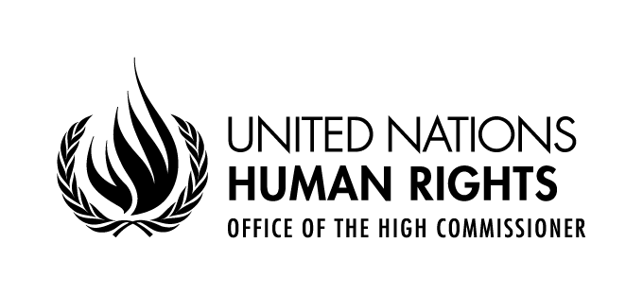

Statement delivered by
Diego Valadares Vasconcelos Neto
Human Rights Officer,
Right to Development Section
OHCHR Focal point for LDCs, LLDCs and SIDS

30 August - 2 September 2021
UNHQ, Geneva, Switzerland, and virtual via Webex

Excellencies,
Distinguished delegates,
Ladies and gentlemen,

The United Nations High Commissioner for Human Rights and her Office welcomes this Asia-Pacific Review meeting. Through its presence in Asian LDC’s, including in Afghanistan, Bangladesh, Cambodia, Timor-Leste, Nepal, Yemen and through its regional offices in Bangkok for South-East Asia and in Suva for the Pacific region, the OHCHR contributes to advance sustainable development through human rights and undertakes various others activities relevant for the successful implementation of the Istanbul Programme of Action. For example, it provides guidance for the realization of the rights to health and to education, both important to the improvement of the human assets index LDC criteria.
OHCHR actively contributes to the Preparatory Process of UN LDC 5, including by organizing panel discussions in partnership with UN-Women, organizing training activities in partnership with OHRLLS, and through substantive inputs. The 2020 joint report of the Secretary General and the High Commissioner on the Right to Development (A/HRC/RES/45/21) provides a series of recommendations relating to the new programme of work for LDCs. This includes active, free and meaningful participation in the negotiations process that gives priorities to the voices of peoples from LDCs. The report recommends expanding productive capacity for inclusive, equitable and sustainable development by addressing international and national resource mobilization challenges for transformative change relating to access to new and traditional technologies, sustainable debt, urbanization, opportunities for young people, gender equality, disaster risk reduction, smooth and just transition from the LDC status. The accountability and monitoring framework of the new programme of action should use rights-based indicators, drawing from relevant guidelines from human rights mechanisms, the OHCHR and the UN Secretary General.

Excellencies, Distinguished delegates, Ladies and gentlemen,
Human rights, including the right to development, climate action, and recovering better from COVID-19 are closely intertwined.
To avert future global threats, including pandemics, we must protect rights to a safe, clean, healthy and sustainable environment upon which we all depend for our health and wellbeing. A human rights-based approach to the COVID-19 crisis is also needed to address its unequal impacts on the poor, vulnerable and marginalized and its underlying drivers, including environmental degradation.
Substantive elements of the right to a healthy and sustainable environment include a safe climate, water and sanitation, clean air, healthy and sustainably produced food, non-toxic environments, healthy ecosystems and biodiversity. We should re-think our interactions with nature, including by integrating the human rights to the post-2020 Global Biodiversity Framework. We need to protect environmental human rights defenders. Countries should guarantee meaningful and informed participation in policy making. The OHCHR guidelines on public participation (A/HRC/39/28) includes guidance for national policies and for international processes such as the current one. We should minimize the harmful impacts of medical and other waste including of waste trade to LDCs.
The SG and the HC have called vaccines and other relevant technologies to be treated as world public goods. We are all on this together, and only when the weakest among is safe from COVID-19 will we all overcome the current crisis.
Excellencies, Ladies and Gentlemen
The virus threatens everyone. Climate change threatens everyone. Human rights uplift everyone. By respecting human rights in this time of crisis, we will build more effective and inclusive solutions for the emergency of today and the recovery for tomorrow.
Bearing this in mind, I would like to ask participants how can human rights, including the right to development, and the right to a healthy and sustainable environment, be integrated to the new Programme of Action?

See https://www.ohchr.org/EN/HRBodies/SP/Pages/COVID-19-and-Special-Procedures.aspx and https://www.ohchr.org/EN/HRBodies/Pages/COVID-19-and-TreatyBodies.aspx
https://www.ohchr.org/EN/NewsEvents/Pages/COVID19Guidance.aspx
https://www.un.org/sites/un2.un.org/files/un_policy_brief_on_human_rights_and_covid_23_april_2020.pdf
https://www.ohchr.org/Documents/Issues/PublicAffairs/GuidelinesRightParticipatePublicAffairs_web.pdf

