HUMAN RIGHTS SITUATION OF HERDER WOMEN:
SOME ISSUES RELATED TO THEIR RIGHT TO BE FREE FROM VIOLENCE AND THEIR SEXUAL AND REPRODUCTIVE
HEALTH AND RIGHTS

“States Parties shall take in all fields, in particular in the political social, economic and cultural fields, all appropriate measures, including legislation, to ensure the full development and advancement of women, for the purpose of guaranteeing them the exercise and enjoyment of human rights and fundamental freedoms on a basis of equality with men .”
(Article 3, the Convention on the Elimination of All Forms of Discrimination against women)

“States Parties shall take into account the particular problems faced by rural women and the significant roles which rural women play in the economic survival of their families, including their work in the non-monetized sectors of the economy, and shall take all appropriate measures to ensure the application of the provisions of the present Convention to women in rural areas .”
(Article 14, the Convention on the Elimination of All Forms of Discrimination against Women)

“States Parties shall take all appropriate measures to eliminate discrimination against women in the field of health care in order to ensure, on a basis of equality of men and women, access to health care services, including those related to family planning .”
(Article 12, the Convention on the Elimination of All Forms of Discrimination against Women)

According to 19th STATUS REPORT ON HUMAN RIGHTS AND FREEDOMS IN MONGOLIA, Ulaanbaatar, 2020

The National Human Rights Commission of Mongolia submits its annual report on human rights and freedoms in Mongolia to the State Great Khural within the first quarter of every year, in accordance with Part 7 .1 .11 of Article 7, Part 9 .1 of Article 9, and Part 17 .1 of Article 17 of the Law on the National Human Rights Commission of Mongolia .
The 19th annual report on human rights and freedoms in Mongolia was developed within the scope of four major topics namely, “Human rights situation of herder women: some issues related to their right to be free from violence and their sexual and reproductive health and rights”, “Status of implementation of the Law of Mongolia on the promotion of gender equality”, “Some vital issues on storage and protection of toxic and hazardous chemicals”, and “International human rights indices and rankings of Mongolia.
.

Chapter I. Human rights situation of herder women: some issues related to their right to be free from violence and their sexual and reproductive health and rights. This chapter presents the outcome and conclusions of the survey the Commission conducted with the support of the United Nations’ Population Fund into status of herder women’s right to be free from violence and their sexual and reproductive rights in 2019, which was based on the complaints and information it received .

Based upon the complaints and information lodged to the National Human Rights Commission, the Commission has conducted a study to assess the situation of human rights of herder women living in remote rural areas, particularly their right to health including their right to access to sexual and reproductive health care and their right to be free from violence in kind support of United Nations Population Fund in 2019 . Under the study scope, 19 soums(very small administrative unit) of Dornod, Sukhbaatar, Umnugovi, Bayankhongor, Zavkhan and Khuvsgul provinces were selected for the Commission’s study team field visits, and
total 631 herder women from 20 provinces were included in the study as survey participants. This chapter covers the individual and focus-group interviews with herder women as well as governors and public servants of selected provinces and soums, and analysis on data of herder women who received legal advices from the Commission and cases collected during the study. It also covers the analysis on data and studies related to the herders provided by government and non-government organizations including the National Statistics Office, the Ministry of Health, the Research Institute of Labor and Social Protection of the Ministry of Labor and Social Protection, the Ministry of Environment and Tourism, National Police Agency, National Emergency Management Agency, General Authority for Social Insurance, General Executive Agency of Court Decision, the Judicial Research, Information and Training Institute of the Judicial General Council and National Center Against Violence .

1 .1 Statistics of herder women and some issues related to their status, livelihood, and employment
As of 2019, ¼ of total workers and 24 .1 per cent of total workforce engage with livestock sector.

Out of a total registered 285,482 herders in 2019, 166,368 persons or 58 .3 per cent of them are male, 119,114 persons or 41 .7 per cent of them are female herders . Thus, male herders prevail in the sector. Of total herders, 31 per cent of them herders between 15-34 age, 59 .2 per cent of them are herders between 35-59 age, while 9 .9 per cent of them account for herders above 60 years-old. Among young herders aged between 15-24, 69 .8 per cent of them are male, whereas 30 .2 per cent of them are female herders. In recent years, a number of young and middle-aged herders tend to decrease, causing a further shortage of next generation to become herders. Asides that, the sex ratio gap of herders widens as indicated in the statistics of the National Statistics Office.

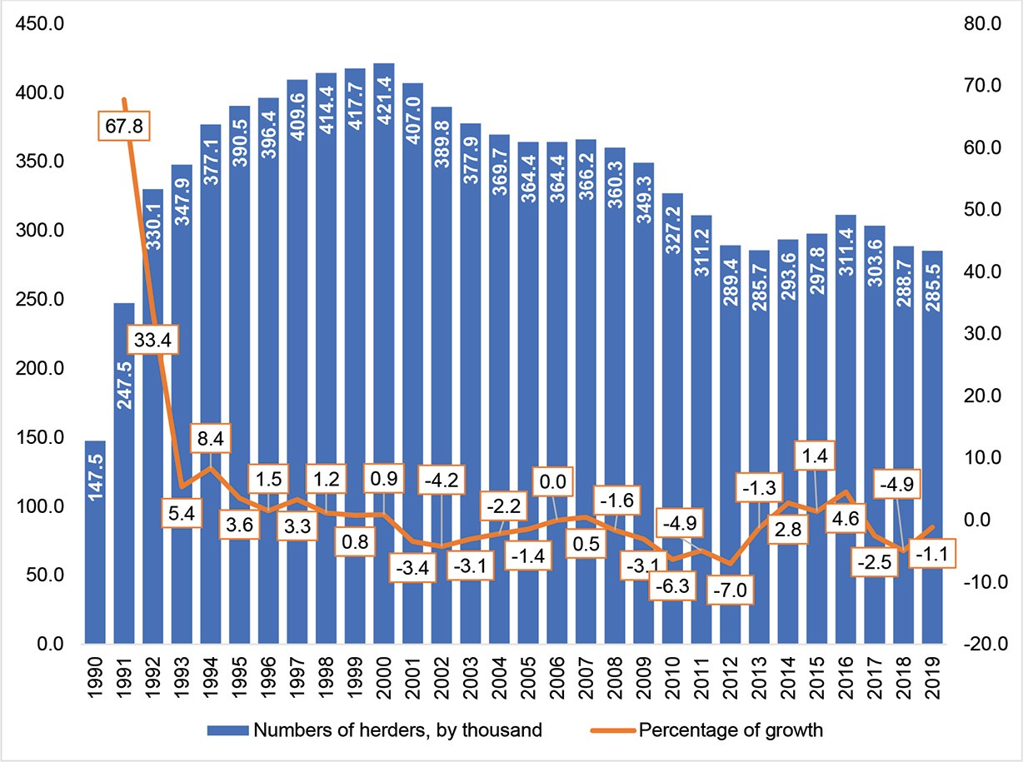
Chart 1 .1: Statistics of herders (1990-2019)

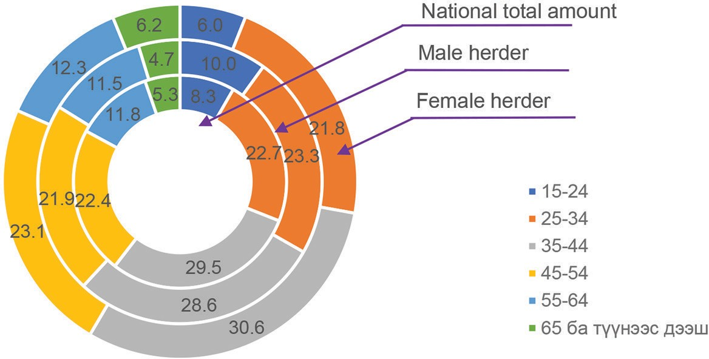
Chart 1 .2 Classification of herders’ age and sex (2019, by percentage)
Chart 1 .3 Age-gender pyramid of herders (2019
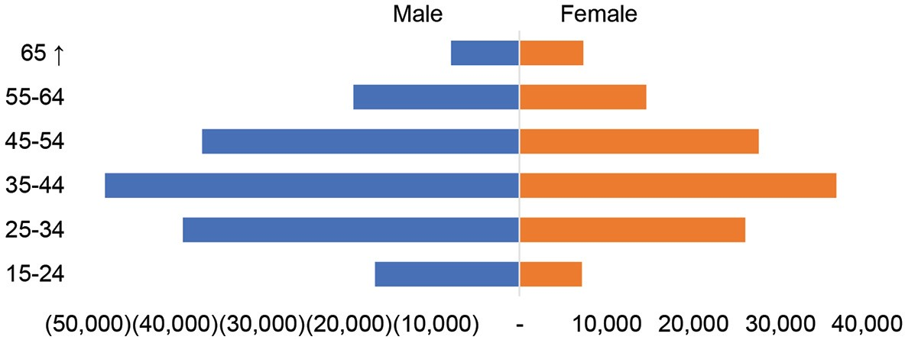

Please see a below chart for the age composition of herder women involved in the study
Chart 1 .4 Age classification
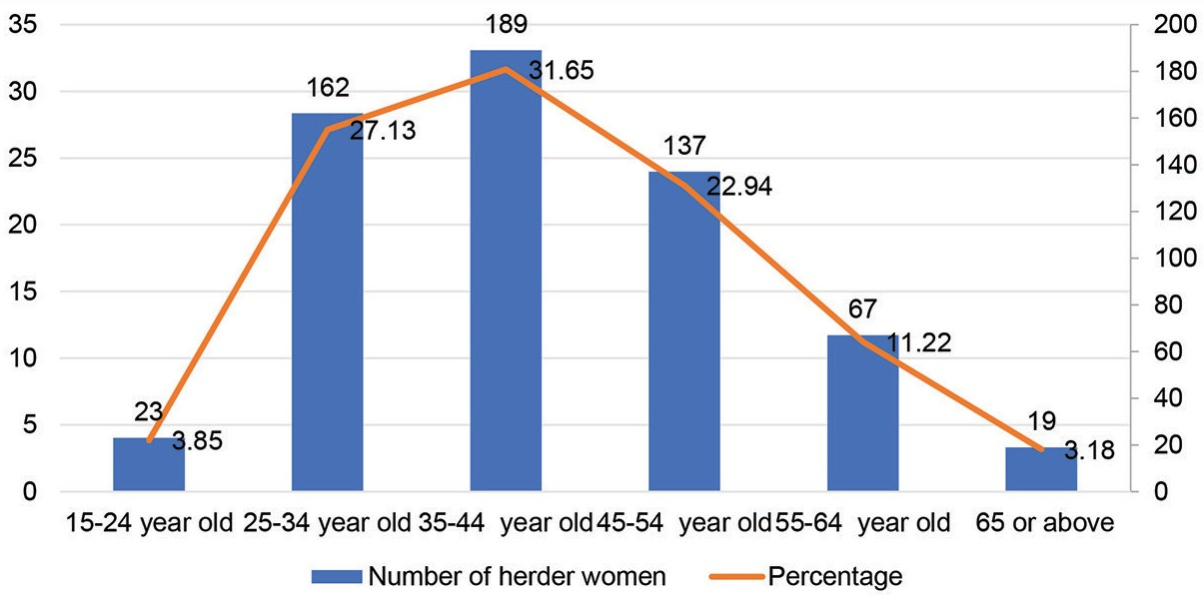

In livestock sector, a concept, “assistant herder” and “hired herder” has emerged and in recent years, the concept “assistant herder” has been used frequently. Thus, the National Statistics Office started to release some statistical information on assistant herders .
A herder household consists of herder(s) and their nuclear family which conducts livestock husbandry around the year for the main purpose of livelihood and source of income. The term “herder” is divided into three categories. First category is household having livestock refers to those who raises livestock as an activity auxiliary to its livelihood and mainly resides in urban areas. A household with livestock and a household having livestock altogether defined as a herder household .
More than 70 per cent of respondent herder women belong to herder household category . For example, 84 .4 per cent of the survey respondents were herder women who herd livestock daily, while 12 .6 per cent of them were women who live in urban areas and raise livestock as a supplement to their main business.

Chart 1 .5 Category of herder household
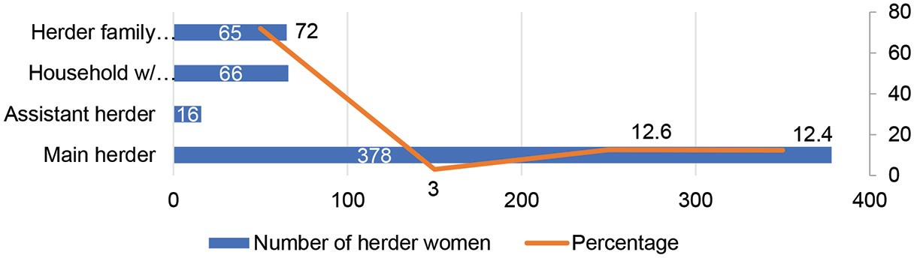

The study entailed some issues related to herder women’s marital and education status, livelihood, income sources, challenges in their household chores and herding, their coverage in health and social insurance, and assistant herder status in the below section .
Marital status

Of total 285,482 herders, 81 per cent of them are married, of which, 76 per cent of them registered their marriage, whereas 5 per cent of them haven’t registered their marriage yet . While 12 .8 per cent of them are not married, 4 .9 per cent of them are widow, 0 .7 per cent of them are divorced, and 0 .6
per cent of them are separated.

Table 1 .1 Herders’ marital status by age (2019, by umber and percentage)
Age group | Total | Never married | Married with registration | Married without registration | Separated | Divorced | Widow
Total | 285,482 | 36,581 | 216,832 | 14,410 | 1,697 | 2,057 | 13,905
15-24 | 23,776 | 15,529 | 6,484 | 1,719 | 16 | 16 | 12
25-34 | 64,693 | 11,138 | 47,365 | 5,462 | 219 | 261 | 248
35-44 | 84,134 | 5,166 | 72,939 | 3,641 | 502 | 703 | 1,183
45-54 | 64,006 | 2,866 | 54,452 | 2,377 | 583 | 712 | 3,016
55-64 | 33,680 | 1,375 | 26,456 | 1,005 | 301 | 307 | 4,236
65 ↑ | 15,193 | 507 | 9,136 | 206 | 76 | 58 | 5,210
Percentage
Total | 100 | 12.8 | 76.0 | 5.0 | 0.6 | 0.7 | 4.9
15-24 | 100 | 65.3 | 27.3 | 7.2 | 0.1 | 0.1 | 0.1

25-34 | 100 | 17.2 | 73.2 | 8.4 | 0.3 | 0.4 | 0.4
35-44 | 100 | 6.1 | 86.7 | 4.3 | 0.6 | 0.8 | 1.4
45-54 | 100 | 4.5 | 85.1 | 3.7 | 0.9 | 1.1 | 4.7
55-64 | 100 | 4.1 | 78.6 | 3.0 | 0.9 | 0.9 | 12.6
65 ↑ | 100 | 3.3 | 60.1 | 1.4 | 0.5 | 0.4 | 34.3
Please see a below table for the marital status of herder women who participated in the study.

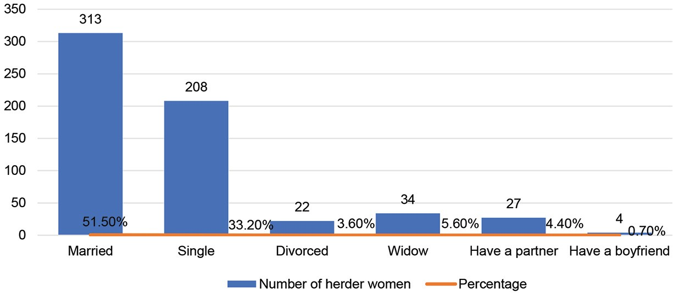
Chart 1 .6 Marital status

Of total survey participants, 3 .6 per cent of them were divorced . Meetings with local public servants as well as interviews with herders in selected provinces and soums(small administrative unit) indicated that since the school starting age starts at as early as six, it contributes to splitting up the young families, sometimes culminating in divorces.

Case 1 .1

As I have lived in the rural area for many years, I have my say that people tend to divorce because of the educational system in recent years. For example, young rural women often visit soum centers to send their six-year old kid to school. As a result, husbands stay at home behind looking after their herd. Those husbands have no choice, but to stay at home to support their family. Having separated for a long time, some husbands sometimes see single girls or wives of others. At the same time, wives living in soum centers also having nothing to do wander around and eventually developed in irrevocable differences with their husbands at home. This is one of the reasons young couples file divorce.
(Interview with a public servant in a soum, Sukhbaatar province)

Case 1 .2

Herder parents bring their kids to soum center. I think they should leave their kids in soum and herd their livestock in countryside. I also assume they sometimes visit soum centers to flee their heavy workload at home. As a result, husbands staying at home abuse alcohols and have affairs with someone. For example, six to seven years ago, a woman brought her kid to soum center and then she divorced with her husband and left her four kids to their father. Those kids used to stay with their father only during summer while staying at school dorm for the rest of the time. I think the reason why this occurred is that the mother brought her kid to soum center.
(Interview with a public servant in a soum, Khuvsgul province)

Since those problems are a concerning issue for both parents and children, some of the provinces are working towards addressing this issue. For example, Zavkhan province is one of the provinces seeking to propose new plans within its authority to care for children who are living far from their parents by furnishing dorms to tailor the needs of elementary school children and implementing a so-called “Ger Urguu” project in its soums.

Case 1 .3

We are facing a shortage of herder women in rural areas. Divorces are becoming more common because rural women visit soum centers to send their six-year old kid to school and stay with her kids during the term. To reduce the divorce rate, our province launched “Ger Urguu” facility for those six-year old kids for the first time. This facility is working well in several soums. We are working to create an environment where six-year old kids feel being at home without need of physical presence of their parents. For example, we renovated our dormitory in Tsagaanchuluut soum. First, we study how many six-year old kids would be enrolled in school this year and then we allocate rooms according to the number of kids. Since teaching personnel is not sufficient, we recruited additional staff with the support of local funding.

(Interview with governors of Zavkhan province)

More than 90 per cent of the survey participants answered that they are married with full consent, while women who married with the intervention of their parents and relatives accounted for 4 per cent . Whereas, 16 women answered that they had forced marriage.

Education
As of total herders, 23 .2 per cent of herders had a primary education, 39 .9 per cent of them had a lower-secondary education, 23 .1 per cent of herders had a secondary education, 6 .4 per cent of them had a vocational education, 3 .7 per cent of them had a tertiary education and 3 .7 per cent of them had no education at all . Of total female herders, 3 .3 per cent of them had no education at all, 20 .8 per cent of them had a primary education, 38 .3 per cent of them had a lower-secondary education, 25 .9 per cent of them had a secondary education, 7 per cent of them had a vocational education and 4 .6 per cent of them had a tertiary education .
Table 1 .2 Comparison of herders’ education by age group (2019, by number and percentage)
By age | Total | No educa-  tion | Primary education | Lower-sec- ondary education | Secondary education | Technical or voca- tional | Tertiary education
Total | 285,482 | 10,461 | 66,193 | 113,999 | 66,002 | 18,182 | 10,645
15-24 | 23,776 | 1,033 | 3,576 | 9,013 | 7,068 | 2,073 | 1,013
25-34 | 64,693 | 2,914 | 15,427 | 20,079 | 17,352 | 3,589 | 5,332
35-44 | 84,134 | 3,172 | 21,723 | 39,535 | 16,417 | 1,398 | 1,889
45-54 | 64,006 | 1,527 | 8,354 | 29,051 | 18,201 | 5,842 | 1,031
55-64 | 33,680 | 1,027 | 9,166 | 13,161 | 5,658 | 3,858 | 810
65 ↑ | 15,193 | 788 | 7,947 | 3,160 | 1,306 | 1,422 | 570
Percentage
Total | 100 | 3.7 | 23.2 | 39.9 | 23.1 | 6.4 | 3.7
15-24 | 100 | 4.3 | 15 | 37.9 | 29.7 | 8.7 | 4.3
25-34 | 100 | 4.5 | 23.8 | 31 | 26.8 | 5.5 | 8.2
35-44 | 100 | 3.8 | 25.8 | 47 | 19.5 | 1.7 | 2.2
45-54 | 100 | 2.4 | 13.1 | 45.4 | 28.4 | 9.1 | 1.6
55-64 | 100 | 3 | 27.2 | 39.1 | 16.8 | 11.5 | 2.4
65 ↑ | 100 | 5.2 | 52.3 | 20.8 | 8.6 | 9.4 | 3.8

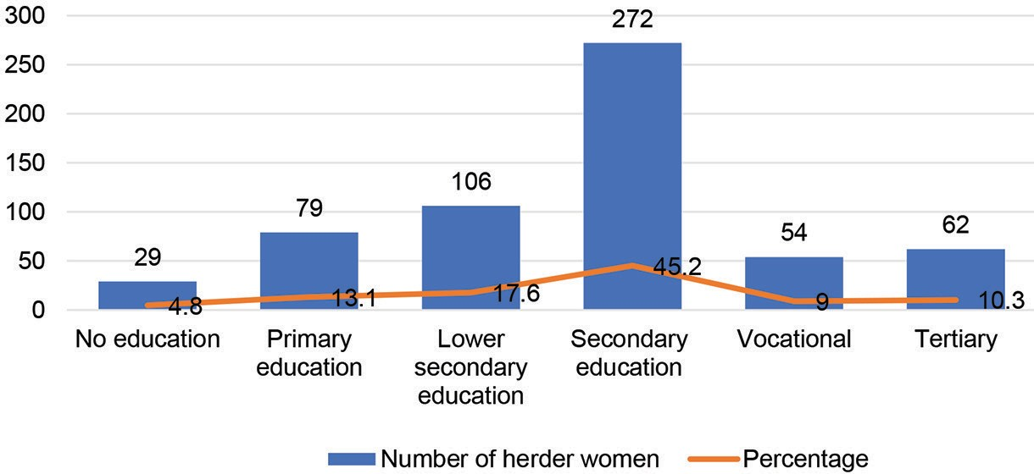
Chart 1 .7 Education level
The women herders themselves as well as province and soum educational officers admitted during the interview that herders cannot exercise their right to seek and impart information and to be involved in general education training programs. For example, in 1990 after the country’s transition to market economy, privatization of cooperative livestock farming took place. As a result, the school drop-outs among many children, particularly boys in rural areas prevailed and who now became illiterate herder men around 30-40 year old.

The herder women also indicate that they rarely visit province and soum centers, and at the same time, education and social workers have no sufficient funds to deliver their services to the rural population. As a result, the herder women lack access to necessary information, particularly information about health education, sexual and reproductive health and rights.

Case 1 .4

About 20 per cent of the six-year-old kids enrolling school first year are herders’ children . It is becoming more common that herders have a ger in province or soum center to live with their children especially mothers. Unfortunately, most of the accompanying mothers have little or no literacy.
Thus, they only take and pick their kids up from school but cannot fulfill their duties to support their kids’ educational basis . This negatively affects the kids’ education.
To tackle this problem, we tried to improve the literacy of the mothers with province Life Long Education Center . While the province and school administration explained the importance of the measure, few mothers attended the training, but eventually no one showed up. At the same time, kids become better at reading than their mothers after 4-5 months of study. For example, mothers fail to copy the homework for their kids from the blackboard. Thus, I believe the state needs to improve the education level of herder women
(Interview with a public servant in a soum,Sukhbaatar province)

Case 1 .5

We need to improve the education of herder women, especially their health education. For example, in 2016 we experienced a severe complication of pregnant woman. Our soum health center took her to the province twice within a month when her due date approached. She lives in soum center and had 3-4 kids. We took her to the recreational room, but she returned home soon after. When we took her to the recreational room again, she stayed there for 20 days and fled from there. She came to soum center and gave a birth a day after. She lost blood…
(Interview with general practitioner at Soum health center, Dornod province)
As such issues of education and information accessibility are raised in each province and soum, herders’ rights are being violated due to their lack of awareness of their own responsibility as well as due to insufficient implementation of state policy and laws. Nonetheless, some provinces have launched innovative ideas to exchange information between the herder women and involve them in social interactions as follows:

Case 1 .6

We adopted this “Change from yourself” program with five-year action plan in our soum. We divided herders into system of a ten and have them reach out people who live alone and unable to meet people via herder women. We hope that this way we can reduce some social problems such as domestic violence. This system of a ten has all herder women. We have six “bags”, which means we have six system of a ten.
(Interview with public servants in a soum, Khuvsgul province)

Case 1 .7

Our province organizes a forum for herder women. The very first year the forum was not effective. Because the evening of the forum first day, husbands of herder women participants abused alcohol and fought with each other . We delivered due punishment to those who violated the rules and from the subsequent year we didn’t experience such incidents. Some herder women participate in the forum with her husbands. During the forum, herder women propose many new ideas and share information…
(Interview with governors of Zavkhan province)
It is commending that the Government has adopted the “Mongol Herder” national program by its Resolution 34 dated 29 January 2020 and the program will be implemented from 2020- 2024 . Under this program, a campaign to raise awareness of herders about necessary information will be carried out and it would greatly contribute to herders become empowered and skilled.
1 .2 The issues related to the right of herder women to be free from violence

The international human rights core instruments guaranteed that everyone has the right to be safe and to live free from fear and violence Article 1 of the Convention on the Elimination of All Forms of Discrimination against Women (CEDAW) states, “For the purposes of the present Convention, the term “discrimination against women” shall mean any distinction, exclusion or restriction made on the basis of sex which has the effect or purpose of impairing or nullifying the recognition, enjoyment or exercise by women, irrespective of their marital status, on a basis of equality of men and women, of human rights and fundamental freedoms in the political, economic, social, cultural, civil or any other field .”
The General Comment No .19 of the CEDAW Committee highlights that violence against women is a form of discrimination and it creates a form of gender-based discrimination . In addition, the General Recommendation defines that discrimination includes gender-based violence, that is, violence that is directed against a woman because she is a woman or that affects women disproportionately. It includes acts that inflict physical, mental or sexual harm or suffering, threats of such acts, coercion and other deprivations of liberty.
The domestic violence is one of the forms of discrimination against women, and it is an unequal relationship between family and intimate relationships in which one member behaves in a way to gain control and power over a family member to make him/ her dependent. This violence is not an incidental behavior, but it is a repetitive pattern of abusive behaviors and can get worse.
The Parliament of Mongolia adopted the revised Law to Combat Domestic Violence in 2016, and the law defined a “domestic violence” as forms of act or omission of emotional, economic, sexual abuses and physical violence and the domestic violence can incur criminal punishment. The objectives of the law are to detect domestic violence and bring it to an end, to ensure protection for life, health and security of a victim and his/her family members, to provide necessary services and prevention mechanisms and to define appropriate legal framework. The new law incorporated the following main changes:

Chart 1 .11 Functions of inter-agency task force and relevant stakeholders responsible for reporting domestic violence
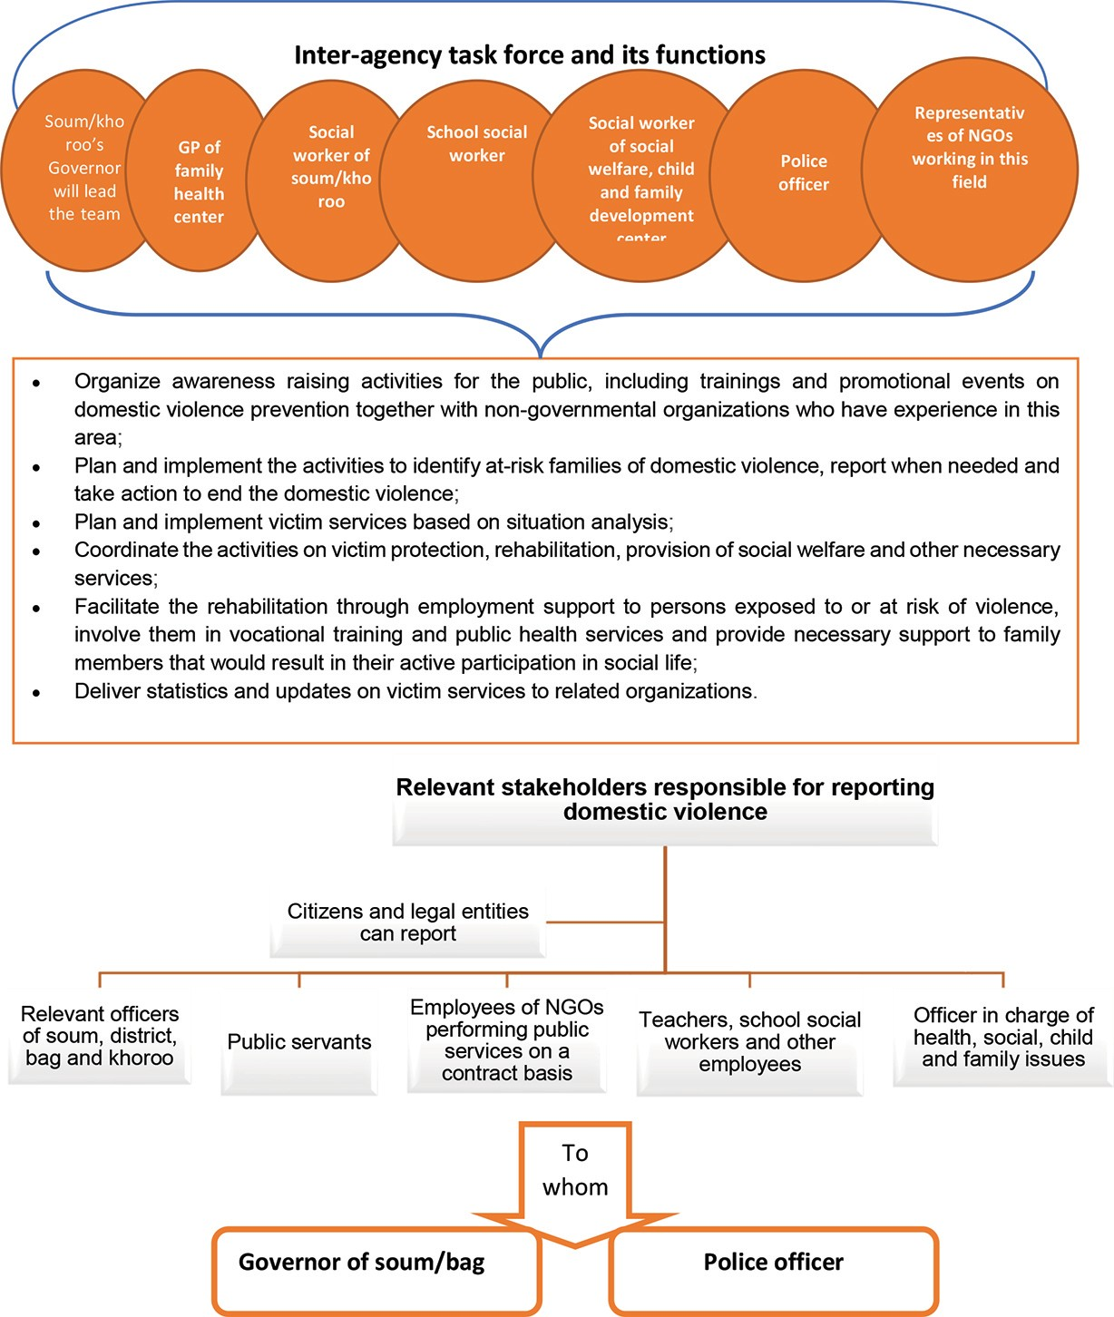

As of 2019, the police registered 985 cases of domestic violence criminal offences .
Year | Dornod | Sukhbaatar | Zavkhan | Khuvsgul | Bayan- khongor | Umnugovi | Ulaanbaatar | Other prov- inces | Total
2018 | 24 | 21 | 3 | 38 | 31 | 11 | 590 | 352 | 1070
2019 | 30 | 9 | 17 | 17 | 17 | 21 | 494 | 380 | 985

Please see a below table for statistics¹⁸ of victims of domestic violence under the article 11 .7 of the Criminal Code as decided by the first instance court of criminal procedure between 2018- 2019.

Table 1 .11 Statistics on cases of victims of domestic violence criminal offences decided by the first instance court (2018, 2019)
Victims of domestic violence |  |  |  |  | Forms of domestic violence
 |  |  |  |  | Physical |  | Psy- cho-log- ical |  | Sexual |  | Econom-  ic
Province and year | 2018 | Herder | 2019 | Herder | 2018 | 2019 | 2018 | 2019 | 2018 | 2019 | 2018 | 2019
Dornod | 9 | 2 | 3 | - | 6 | 2 | 2 | - | - | 1 | 1 | -
Sukhbaatar | 4 | - | - | - | 4 | - | - | - | - | - | - | -
Zavkhan | - | - | 2 | - | 1 | 2 | - | - | - | - | - | -
Khuvsgul | 7 | 2 | 7 | 2 | 7 | 7 | - | - | - | - | - | -
Bayan-khon-  gor | 7 | - | 4 | - | - | 4 | - | - | - | - | - | -
Umnugovi | 7 | 1 | - | - | 7 | - | - | - | - | - | - | -
Ulaanbaatar | 55 | - | 84 | - | 48 | 52 | 6 | 30 | 1 | - | - | 2
Other prov- inces | 42 | 7 | 60 | 5 | 44 | 55 | 4 | 5 | - | - | - | -
Nationwide total number | 131 | 12 | 160 | 7 | 117 | 122 | 12 | 35 | 1 | 1 | 1 | 2

From 2018-2019, 7,122 cases were decided by the court as breach of the Law to Combat Against Domestic Violence under the subsection 5 .4-4 of the Law on Infringement and it accounts to 39 .4 per cent of total infringement offences .

Chart 1 .12 Statistics of domestic violence offences registered with the police (2016-2019)
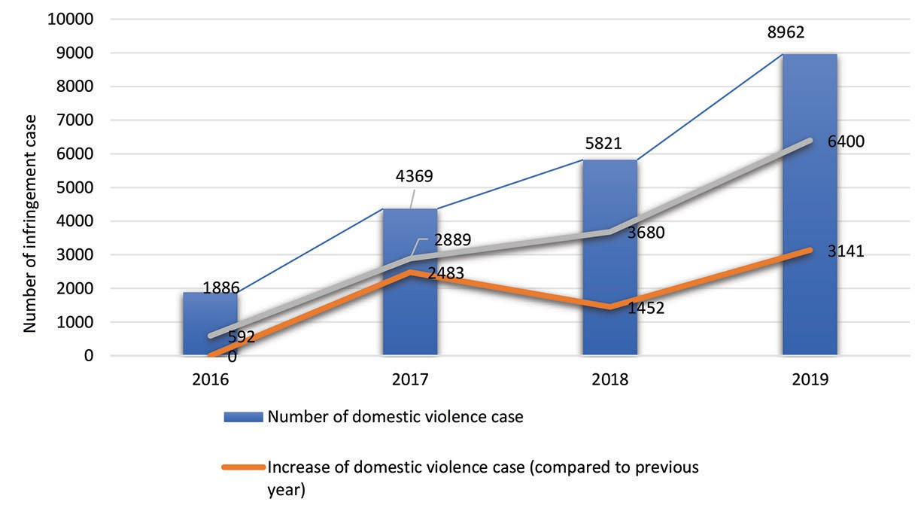
In 2019, 2,175,825 infringement cases were registered with the police and of them, 8,962 cases or 0 .4 per cent of them were cases of domestic violence . 6,634 people were fined with 29,735,000 MNT and 6,400 people were arrested on the grounds of committing offences. Also, the police officers conducted 10,238 domestic violence threat level assessments when responding to the reports of domestic violence cases.

Case 1 .21

There are many women out there, who experience a domestic violence daily, but used to it. I am also one of them. I did not know that I have been experiencing a domestic violence until I have received your information about domestic violence. We as women herder are in great need of training and information. Therefore, I would like to attend a training for the next time . . .
(Interview with a herder woman in Tarialan soum in Khuvsgulprovince)
As for the survey question on whether they express their own opinion freely, without fear of their husbands/partners, 88 6 per cent of them answered “yes, they freely express their own”, while 11 4 per cent of them answered that they do not freely express their opinion due to the fear of their husbands/ partners . When the survey questionnaire intended to seek whether the participants have experienced any form of violence, 24 3 per cent of survey participant herder women indicated they do experience a domestic violence. They provided the following answers as forms of domestic violence they experience .

Table 1 14 Forms of domestic violence identified by herder women
 | № | Forms of domestic violence |  | Answer |  | Percent- age
 | 1 | Physicial abuse (hitting, punching, throwing things and lashing with whips etc.,) |  | 53 |  | 34.2
 | 2 | Psychological abuse (insulting, threating, and kicking her out of house) |  | 72 |  | 46.4
 | 3 | Economic abuse (withholding money, re- stricting intakes of foods for her, and seizing her salary or pension money etc.,) |  | 15 |  | 9.7
 | 4 | Sexual violence (touched on sensitive body parts when unwanted, requested a partner to engage in sex or coerced her to engage in sex) |  | 15 |  | 9.7
Total |  |  | 155 |  | 100

70 per cent of those who experienced violence indicated “husband/partner”, 6 .3 per cent of them responded “boyfriend”, 12 per cent of them mentioned “relatives”, 6 .2 per cent of them answered “acquaintance”, 5 .5 per cent of them said “stranger” as a perpetrator of violence including domestic violence.

Case 1 .22

Since 2009, I have been living with my partner and we had three children. When I first moved in to live with him, I brought my own 20 sheep and goats. For the past ten years, I did not have any control over to spend any income derived from our livestock. Even I did not have a chance to receive or spend the child money allowance and maternity allowance. When I buy some foods, soaps and detergents from the neighborhood retailers on credit, my husband would get angry at me and we would fight over the issue.
I gave a birth right after another birth, so I went to see an OB- GYN in bag to have a contraception, but she said, “your mother- in-law asked me not to put you a contraception, she would scold me if I do so,” and she did not do it . Basically, I have been giving births since I married him. During these eight years of marriage, I have been herding the livestock and helping in taking care of my house and of my parents-in-law. My husband always gets jealous of me and insults me all the time. He doesn’t beat me because his mother told him, “don not physically harm her because the law is quite strict”. But he always emotionally abuses me and makes me economically dependent on him and wants to keep me socially isolated and have control over me. I could not bear all of them, so I took my youngest child with me and took the local transport and arrived in Ulaanbaatar I want to take my kids and divorce from him.
(Interview with a herder woman in a soum, Bayankhongor province)
When the survey questionnaire intended to know how many times they experience domestic violence per year, those who experienced domestic violence provided the following answers.
25 .4 per cent of them said “1-2 times”, 27 1 per cent of them answered “3-5 times”, 33 9 per cent of them answered “all the time”. During the individual and focus group interviews, it was noted that herder women who experienced a repeated violence tend to flee from their home or spend a night in the open steppe or at acquaintance’s place.

Under the Law on Combating Domestic Violence, the state should provide a temporary shelter house for victims of domestic violence or for those who are at risk of violence and or provide single-window service office to ensure the safety of live and health of those people. As of 2019, currently 14 shelter houses and 15 single-window service offices are operating nationwide. Of which, 13 shelter houses and 14 single-window service offices run by the state, whereas one shelter house and one single-window service office belong to a non-government organization .

Case 1 .23

It’s been 27 years since I started living with my partner without a marriage certificate as we didn’t register for it, and we have two children. My partner beats me a lot, and his siblings also abused and degraded me. I have eye impairments, lost 70 per cent of my eyes’ sights because my partner beat me. He poked my eyes with “uni” (the wooden poles that support the ceiling, measuring 1 .5-3 meters long) and at that time I was afraid of my partner and lied to a doctor that I fell from a horse. I used to forgive him for what he did to me as I didn’t want him to be imprisoned. Since we lived together, I and my partner herd the livestock of his brother from 1993 until 2012 for free of charge. Even his brother beats me and told me, “if you say anything about us, I can make you nobody here, we have fed you and your husband for 27 years, I will give you nothing” In fact, I can’t even afford to pay a rent of the apartment I am living now. I took a loan from my disability allowance. I don’t have any siblings. Out of despair, I am approaching your organization to protect my rights . . .
(During a process of a risk situational analysis of inter-agency task force upon her case, she was beaten again by her partner)
It was because Sukhbaatar province has no shelter house nor single-window service for victims of domestic violence…
(From the legal advice by the Commission to a herder woman in a soum,
Sukhbaatar province)
The Police Department of Sukhbaatar province in collaboration with Governor of Baruun-Urt soum have made an architectural plan of shelter house and submitted it to the Ministry of Justice and Home Affairs . Since the police divisions of 13 soum of the province have no sobering house, the police had to put drunk men or perpetrators of domestic violence in the neighborhood police outpost “koban”. For those victims of domestic violence living in remote soums such as Erdenetsagaan, Naran and Dariganga soums, around 200 kilometer away from the province center, it is troublesome for the police to go to those remote areas to take a perpetrator with them due to the lack of shelter house and limited budget for transportation and fuel .
Case 1 .24

I live with my husband and four kids by herding livestock. In winter of 2009, I was abducted by my husband and became his wife. Before abduction, I saw my husband only once. At that time, I was graduated from a university and returned to my hometown and working as a sales clerk. Because I couldn’t find a job that suits with my profession. One evening, I was walking home after finishing my work and then men with a vehicle stopped next to me and asked where I was going and said we will give you a ride since it is cold outside. So, I got in the car and we went on for a while, then suddenly a man sitting in back seat grabbed my hands forcefully. Then they forcefully brought me to my husband’s parents house in Bukhmurun soum, which is 190 kilometre away from the province center and made me pray for his own as well as his parents’ fire gods . Suddenly they brought me a new “deel” (traditional custom) and clothes and made me wear them; and his parents told me “women have no original home, marry our son and he is not a bad person. Tomorrow we will go and ask your parents’ permission for marriage”. Although I didn’t want to marry him, but somewhere I have heard from someone that if you reject this kind of marriage proposal, you will live unhappy and stay single forever, so I had to become his wife while I was crying . On that night, my husband coerced me to have a sex with him and soon after I became pregnant. In the beginning, I did not have a chance to get to know him well. Once I became his wife, I endured his all mean behaviors. But since that time, he has been beating and abusing me all the time. I have lodged complaints to the police for many times and they took some measures against him under the criminal and infringement acts. My husband severely injured me for two times and he was called as a defendant by police and a prosecutor launched legal proceedings to punish him and submitted his/her decision to the court . However, the court has dismissed his case. At that time, I said I had no grievance, which was my fault. I and my husband would always have a quarrel. I am now really sick of it. I wish to divorce from him and take my four children and some livestock and “ger- traditional accommodation” with me . . .
(From a legal advice by Commission to a herder woman in a soum, Uvs province)

Case 1 25
I have two children from my previous husband and became widow .Later I was married to someone and had three children from him .Now I have five children Since 2009, I and my husband are working for a family as their assistant herders. I have gotten to know more about my husband’s behavior since the time we got married. Even when he is sober, he still misbehaves, and I stand his behavior for the sake of my children. He gets angry for no reason and when he is mad, he physically hurts me and takes out knife and hits me with some iron item. One evening, he got pissed off at me because I talked wrongly and threw at me a bed pole, and when I ran out of “ger”, he chased me with motorcycle I couldn’t tell police about it because I thought about my children and pitied my husband. He was quite angry and called me one evening, out of fear, I took my children with me and we were planning to sleep in our car, but police stopped me and asked my driver’s license. But I forgot to take my license with me as I was in hurry to leave home before he gets home. The police got suspicious and asked me some questions and eventually found out my situation. After a decade of tolerating and not reporting to policy about my husband’s behaviors, finally I gave a statement to the police and my husband was arrested for seven days as a punishment for domestic violence. But I didn’t tell the police about my husband’ misbehaviors of the past 10 years, I only told a case that happened that evening. I am in constant fear of my husband and I got a heartache . . .
(Interview with a herder woman in a soum, Sukhbaatar province)
The Law on Combating Domestic Violence has been effective since 1 February 2017, passing over three years . The law clearly specified the duties and scopes of the statutory authorities to combat domestic violence, prevent and protect the victims. However, the relevant funds and structures of the police, court marshals, local administrations are not well positioned to implement the law.
For example, under the Law on Combating Domestic Violence, the police department shall have a division consists of professional personnel in taking account of population of that specific area and its criminal and social order and situation and this division shall involve psychologist, social worker and child rights specialist for ensuring the safety of victim and providing victim with necessary services. Currently the National Police Agency has established a domestic violence prevention unit and provides a professional and technical support to one to two officers working for the police department at community level. areas.
Currently the National Police Agency has established a
In addition, the Government of Mongolia has adopted the “Norms on the police structure, workforce, police vehicles, supply of special equipment and their usage”, by its resolution No .153 in 2011, taking into account of the common crimes and infringements in Mongolia, demography, density on urban transportation, geography, condition of transportation infrastructure and other characteristics of the country. However, the current police structure, numbers of work force and the police vehicles are insufficient due to the country’s economic constraints.
The police play a key role in fighting against domestic violence by preventing, detecting cases, protecting victims and addressing a violation until the end. The effectiveness of police work is not only dependent on police officer himself, but it also depends on technical advice, equipment provisions and collaboration with specialists from other organizations. Thus, it is vital to enable environment in which psychologist, social worker and child rights specialist can altogether collaborate with the police officers especially those police sergeants and detectives as inter-agency task force members.

Majority of the herder women answered that violence usually takes place in domestic area, and many victims prefer to stay silent in order to protect their image. Many also never report the incident to the police, hoping offenders will remedy themselves over time and they are scared of possible retaliation. When they become a victim of violence, they usually report it to relatives or friends instead of police.

Case 1 .26
I know a 30-year-old woman married to a local man and living with her three children. Her husband drinks and assaults her all the time. I once sheltered her and her children after she was subject to domestic violence. Since that incident her husband started to despise me. She attempted to commit a suicide by stabbing herself due to her husband’s chronic abuse. But she has never complained this issue to the police. Because her in-laws blame her for everything . . . .
(Interview with a herder woman in a soum, Khuvsgul province)
Reasons that herder women were not able to take primary medical assistance on timely basis are as follows: hiding injuries, lack of specialist physicians, living in remote areas, unavailability of police response, abuses taking place during night, alcoholism, lack of awareness over legal knowledge, fear of retaliation and economic dependence.

The Local Coordinative Council on Crime Prevention units need to regularly monitor performance, build the capacity of the inter-agency task force and increase the manpower of dedicated police and social personnel and hire a professional social worker\
In addition, it needs to take specific measures to combat domestic violence such as carrying out activities aimed at preventing domestic violence, protecting victims, decreasing risks of repetition rate of violence and organizing awareness raising campaigns about the law to combat domestic violence in easily readable formats to reach out those living in remote areas, those who are unable to access information or who are illiterate, or people with hearing or visual impairments.

All levels of governors need to focus on implementing relevant laws on domestic violence and protection of children’s rights in their respective local areas and appropriating sufficient funds for the overall effort from the local fund through proposing it to the Citizen’s Representatives Meeting.
Under the Law on Infringement, perpetrator of domestic violence shall be arrested and involved in a mandatory training, whereas under the Criminal Code, a culprit is subject to a mandatory training for behavior management without or with a punishment imposed to a crime he/she committed.
According to the Law to Combat against Domestic Violence, both court decision enforcement agency and police shall organize a mandatory training for behavior management for those offenders who are subject to incarceration and those who are subject to arrest and mandatory training .
A program and procedure of the mandatory training for behavior management was adopted by the order A/73 of the Minister of Justice and Home Affairs dated 4 April 2017 . With that, the training module and the guideline were developed and designated trainers are being trained . However, in reality, a number of trainers, training facilities, equipment and materials are insufficient .
However, the funding for organizing a mandatory training for behavior management, which requires dedicated trainers, resources, training facilities and equipment, by the police and the court decision enforcement agency is not addressed up to date.
For example, the Court decision enforcement agency has total 27 psychologists working nationwide and there is no single psychologist working in local areas except the court decision enforcement department in Khuvsgul province. The mandatory training for behavior management is conducted by social worker and psychologist of prisons, whereas places without prisons, enforcement officers organize this training for the offenders .
According to the “Procedure for defining a workload standard for officers of court decision enforcement agency” adopted by the joint orders A/247, A/167, 303 dated 29 September 2017 of the Minister of Justice and Home Affairs, Minister of Labor and Social Protection and Minister of Finance, one enforcement officer in charge of mandatory enforcement measures and punishments except imprisonment shall work on 120 ruling documents per month. However, in reality, a workload of those enforcement officers is doubled as they have to work on around 250-300 ruling documents per month, and not to mention that they have to organize a mandatory training for behavior management.
Thus, the state needs to address and allocate the funding for the court decision enforcement agency and police to organize a mandatory training, which requires professional personnel, training of trainers, training facilities including equipment, materials and training module, in an effective way.

1 .3 Sexual and reproductive health and rights of herder women.
The right to health care includes the sexual and reproductive rights and health and it is closely interconnected with numerous other human rights. The sexual and reproductive health and rights rest on the recognition of the basic right of all couples and individuals to decide freely and responsibly the number, spacing and timing of their children and to have the information and means to do so. It also includes their right to make decisions concerning reproduction free of discrimination, coercion and violence, as expressed in human rights documents.
Since the sexual and reproductive health and rights are closely related to women’s health, state parties shall take specific measures by reducing women’s health risks, particularly reducing rates of maternal mortality, protecting women from domestic violence, and eliminating any barriers interfering with access to health services as well as any harmful traditional cultural practices that deny their sexual and reproductive health and rights.
Up to date, girls and women in developing nations still face sexual and reproductive health problems, unwanted and/ or teenage pregnancy, suffer the consequences of unsafe abortion, and further risks their health and lives. From the international perspective, it is viewed that accessibility, availability and quality of sexual and reproductive health services are subject to domestic legal framework and its enforcement.
At the international level, it is recommended that states shall pay attention in providing those people living in remote regional areas with information on sexual and reproductive health and rights tailored to their needs in an accessible way .
When the questionnaire intended to seek to where they access to information on sexual and reproductive health and rights, 32 .2 per cent of them responded “specialists/ gynecologist”, 32 .8 per cent of them indicated “television and radio”, 14 .5 per cent of them said “family and friends”, 7 .8 per cent of them mentioned “newspapers and websites”, whereas 13 .4 per cent of them responded “can’t access to this kind of information at all”, 34 .6 per cent of them answered “have very limited access to relevant information”, while 40 .8 per cent of them indicated “have access to information on a moderate level”, and 11 .2 per cent of them answered “have a sufficient access to information”. Upon queried about assessing their self-knowledge on sexual and reproductive health and rights, 6 .9 per cent of them indicated “their knowledge is very good”, 38 .7 per cent of them responded “good”, 47 .4 per cent of them said “average”, 5 .8 per cent of them indicated “poor”, and 1 .2 per cent of them defined their knowledge on the topic is “very poor”.
The Government of Mongolia adopted a “National Program on Maternal, Child and Reproductive Health” by its resolution No .78 on 7th March 2017 and under this program, it states, “develop and implement a plan to reach out total population to provide them with information on maternal, child, sexual and reproductive health via social media in collaboration with non-government organization; and to organize training and promotional activities aimed at target groups to sensitize them about family planning, healthy birth, responsible use of medicines, infant care, oral health, pneumonia, diarrhea, abortion, sexually transmitted infections, incidents and injuries and behavior management to prevent from violence .”
Upon looking at the Social Indicator Sample Survey, 3 .7 per cent of women and 6 .1 per cent of rural girls under 18 were given a birth . When comparing a birth rate among girls in urban and rural areas as of three years, the birth rate among teenage girls in rural areas has been increased year by year. This indicates there is no substantial change in behavior and knowledge about reproductive health issues among rural youth and community in place .

Chart 1 .13 Comparison of birth rate among teenage girls living in urban and rural areas (2010, 2013, 2018, by coefficient variation)
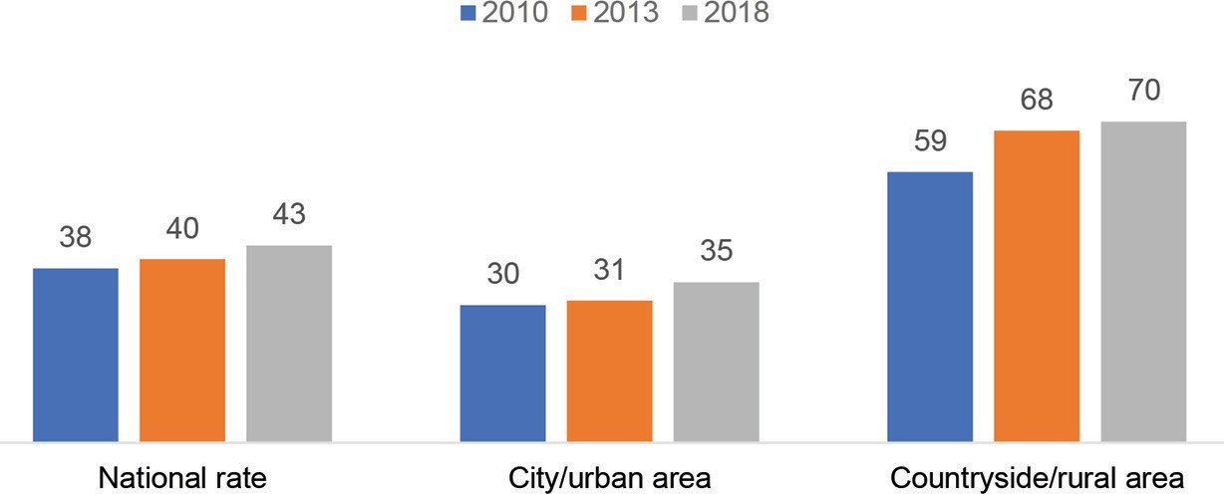

During the individual and focus-group interviews, the survey participants mentioned that training and/or event on sexual and reproductive health issues is organized in rural areas. However, usually men are involved in those kinds of events and women are left behind.

Case 1 .27

Soum community people receive information related to the family planning and reproductive health issues during any event and meeting organized at soum level. However, women have a limited access to those kind of information as men or husbands often come to these kinds of meeting. Although social workers provide some information related to domestic violence, it is difficult to know what is really happening around the neighborhood unless local people raise the issues by themselves. Thus, the state needs to ensure the quality, efficiency and accessibility of public services including the dissemination of public information.
(Interview with herder women of a soum, Umnugovi province)
The health education for communities living in remote rural areas is delivered without consistent basis and lacks adequate funding. A training and information on sexual and reproductive health is not adequate for daily lifestyles of herders and inaccessible for them. These constraints hinder herders to enjoy their rights to seek information including family planning counseling, which greatly impacts on their health and well- being.
When the questionnaire intended to seek, how often they go through a sexual and reproductive health related check-ups and screening, 44 .2 per cent of them answered “once a year”, 16 .6 per cent of them responded “twice a year”, and 11 .5 per cent of them indicated “once in every 2-3 year” and so on . Upon queried about where they would have a check-up and screening related to their sexual and reproductive health, herder women provided the following answers.
Table 1 .17 Places where herder women access to health check-ups and screening
№ | Places where herder women access to sexual and reproductive health check-up and screening | Cumulative number | Percent- age
1. | Soum health center | 375 | 58.5
2. | Province health center | 146 | 23.0
3. | Private hospital | 64 | 10.0
4. | Hospital in Ulaanbaatar | 24 | 3,7
5. | Hospital in different province | 22 | 3.4
6. | At home | 5 | 0.7
7. | I don’t often seek medical services as I wish to, only try to see visiting gynecolo- gists | 5 | 0.7
Total |  | 641 | 100

When the questionnaire intended to seek what kind of difficulties and challenges they face when accessing to sexual and reproductive health treatments and services, 21 .4 per cent of them indicated “behaviors and attitudes of health practitioners are poor and they are bad at keeping privacy of patients”, 19 .2 per cent of them answered “ long queues in seeing a doctor”, 17 .2 per cent of them responded “hospital environments are not accessible and unavailable”, 15 .2 per cent of them said “due to the lack of workforce for herding livestock at home, I don’t have a time to go to hospital as much as I wish to”.

Case 1 .28

I live with my 12-year-old daughter and 16-year-old son. I have few sheep and goats and also herd someone’s animal together with my own livestock. I got sick and went to a health center in Darkhan- Uul province and I begged my neighbor to look after my livestock and told them I will come back in the evening. But when I reached the hospital, they said there is no available time and only available time slot was after 20 days, so I couldn’t have a check-up there. My children come home during their school summer break and when my children at home I could allocate some time for myself to see a doctor, but during a summer time doctors are usually on annual leave or there is no available time. So, I had to see a doctor in private hospitals as I couldn’t have a check-up at public hospital for those reasons. Actually, I pay my social and health insurances on voluntary basis, but I can’t access to public hospitals…
(From interview with a herder woman of a soum, Darkhan-Uul province)
63 per cent of the survey participants use any birth control method, whereas 32 per cent of them do not use any of them and 5 per cent of them view that it is not necessary for them to use them. 46 .5 per cent of them answered they make their own decision to use birth control method, while 40 .3 per cent of them said they make a decision together with her husband/ partner to use contraception. Whereas, 3 .9 per cent of them responded they use a birth control method on request of her husband/partner, 2 .4 per cent of them answered they use a contraception based on advice from family members, while 6 .4 per cent of them answered they use birth control due to her health condition and/or doctor’s recommendation.

Case 1 .29

I am 34 years old. I have six children, they are five-month-old, two-year-old, five-year-old, seven-year-old, ten-year-old and 13-year-old. I gave a birth to my first child in 2007 after marrying to my husband and my youngest child was born in 2018. Doctors and my family members are not happy about I am giving a birth every other year. After giving a birth to my first two children, I had an intrauterine device (IUD) on me. But its complications and side effects were intolerable and my thighs were in pain and I couldn’t even walk. After having removed it, I had a contraceptive injection, but it also caused a pain in my legs and uterus infection. I was even hospitalized for three months and had a lot of treatments for it. I also tried contraceptive pill, but it also caused a pancreatitis. When I say to doctors that I become pregnant easily since most of the birth control methods don’t suit me, they say it is okay to give as many births as you can while you are young. But I get some pressures from my in-laws. I had to hide my last three pregnancies from my in-laws, but when my belly gets bigger, they eventually find out that I am already pregnant. When I go to hospital for prenatal visits, doctors scold me by saying “you are pregnant again because you are so reckless”. I am so afraid of conceiving again and afraid of what people would think of me and of having an intercourse with my husband. I ask my husband to use condom, but he doesn’t like it at all. I try to avoid having an intercourse with my husband, but my husband would get jealous of me and asks me “why you don’t like making a love with me? Or are you seeing someone else?”…
(Interview with a herder woman in a soum, Sukhbaatar province)

Upon looking at use of birth control methods among women involved in Social Indicator Sample Survey, use of birth control methods among women of reproductive age has been relatively decreasing. For example, in 2010 and 2013 survey, 55 per cent of women of reproductive age used birth control methods, whereas in 2018 it decreased to 48 per cent.
Chart 1 .14 Use of birth control methods among women of reproductive age involved in Social Indicator Sample Survey (compared by 2010, 2013, 2018)
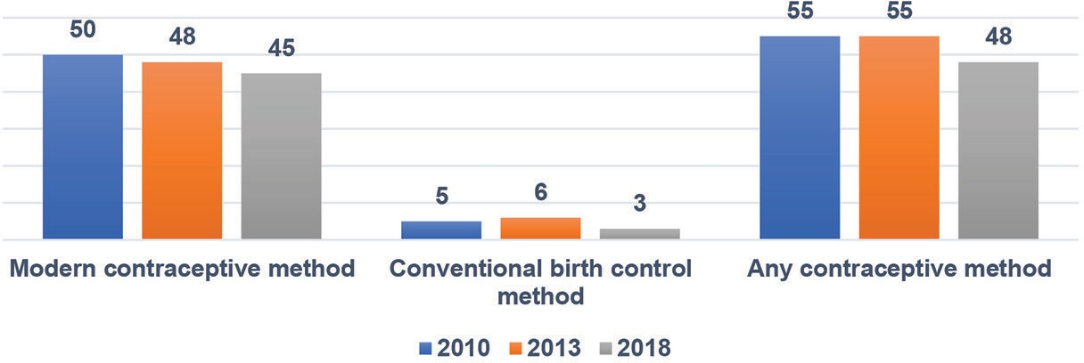

Upon queried about why they do not use birth control methods, 34 .3 per cent of them answered “I want to have a baby”, 25 .4 per cent of them responded “I don’t use it for my health condition”, 20 .4 per cent of them answered “I am not able to get pregnant”, 11 per cent of them said “I can’t afford to use contraception and I don’t get used to it” .

Upon looking at use of contraceptive methods among women (15-49 years) involved in Social Indicator Sample Survey, 51 .9 per cent of them responded they “don’t use any contraceptive method”, 26 .6 per cent of them answered “IUD”, 6 .7 per cent of them said “pill”, 4 .4 per cent of them responded “condom”, 2 .8 per cent of them said “tubal ligation”, 2 .6 per cent of them responded they use “period calendar” as contraceptive methods .

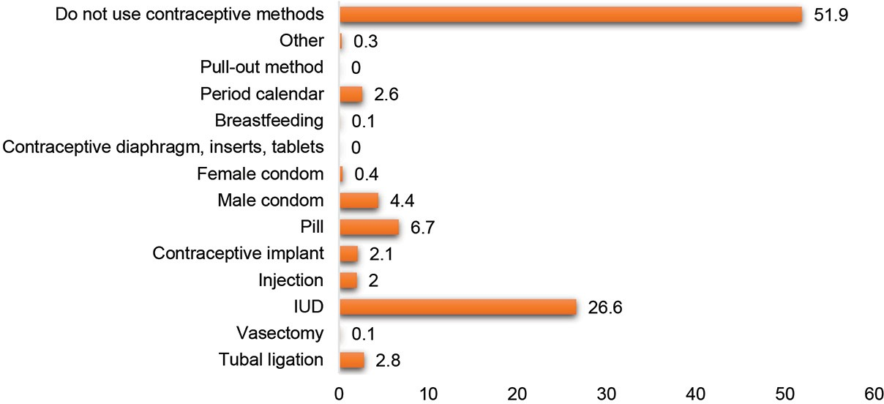
Chart 1 .15 Use of contraceptive methods among women (15-49 years) involved in Social Indicator Sample Survey (2018)
As for herder women, when they were queried upon what kind of contraceptive methods they use, 38 per cent of them use contraceptive pill and injection, 28 .7 per cent of them answered they use intrauterine device (IUD), 12 .8 per cent of them said they use “condom”, 7 per cent of them responded “they keep a period calendar”, 6 .2 per cent of them answered “ contraceptive implant”, 3 .3 per cent of them responded “a female sterilization”, 3 .5 per cent of them indicated they use “coitus interruptus (pull-out or withdrawal) method”, and 0 .2 per cent of them answered they use “patch” . Furthermore, 30 .9 per cent of the herder women indicated that doctors do not explain about the use of contraceptive methods.
In this case, 38 .7 per cent of them answered they seek information about contraceptive methods from “media outlets and advertisements” and 32 .3 per cent of them said they seek such information from their “mother, sisters and friends”, and 22 .6 per cent of them responded they seek information from “other health practitioners” when relevant doctors do not provide instructions for use of contraceptive methods.
When the questionnaire intended to seek whether they have prenatal check-ups on a regular basis, 71 .4 per cent of them answered they go for a prenatal visit on a regular basis. The World Health Organization advised pregnant women to have at least 8 times of prenatal check-ups and services, which include tests and physical exams such as measurement of weight, height and blood pressure, urine test to look for a bladder or urinary tract infection and preeclampsia, and full blood test for anemia and STIs including syphilis
According to the “Rules for prenatal and postpartum care” adopted by the Order No .338 of Minister of Health dated 20 October 2014, woman with normal pregnancy is advised to have a six prenatal check-ups and women with high-risk pregnancy is advised to have an eight prenatal check-ups and pregnant woman should have her first prenatal visit within 12 weeks of pregnancy.
When the questionnaire intended to know in which trimester she had prenatal check-ups in her last pregnancy, 69 .3 per cent of them answered they had the check-ups in her first trimester (1-3 month), 26 .9 per cent of them responded they had a prenatal screening in her second trimester (4-6 month), 3 .9 per cent of them answered they had the check-ups when they were 7-10 month pregnant or in their trimester. As for the number of prenatal care check-up visits, 12 .7 per cent of them answered “1-2 times”, 28 .7 per cent of them said “3-4 times”, 16 per cent of them answered “5-6 times”, 34 .2 per cent of them responded “more than 6 times”, while 8 .4 per cent of them answered “whenever Ob-Gyn calls” she would have prenatal care check-ups.

Case 1 .30

The prenatal care check-ups of herder women are problematic. Under the order No .338 of Minister of Health issued in 2014, pregnant women shall have a prenatal care first check-up within her first trimester. This prenatal check-up includes screening test for fetal abnormalities . But herder women don’t come for this prenatal care check-up.
For the second trimester, we also do screening which detects about woman’s risk of having a baby with birth defects . They also don’t come for this screening tests. Nowadays, it is rare to come across with a very healthy pregnant woman. Herder women with kidney infection, pelvic inflammatory disease or high blood pressures have been increased due to their poor health knowledge . .
(From interview with general practitioner of family health center in
a soum, Sukhbaatar province)
Upon looking at rate of prenatal care check-ups among women involved in Social Indicator Sample Survey, a rate of first visit for prenatal care check-ups among rural women is lower than of national average, though their inter-pregnancy interval is higher .

Table 1 .18 Percentage of prenatal care check-up among women involved in Social Indicator Sample Survey (2010, 2013, 2018)
Year | Early prenatal care check-ups (within first trimester) |  |  | Prenatal care check-ups for 4 or more visits
 | National  rate | City | Rural area | National  rate | City | Rural area
2010 | 77.2 | 80.1 | 72.7 | 81.2 | 82.4 | 80
2013 | 78.8 | 82.7 | 72.1 | 89.4 | 92 | 85.4
2018 | 83.8 | 85.1 | 80.8 | 88.5 | 89.7 | 85.9

When the questionnaire sought to know whether they face any difficulties in accessing to prenatal care check-ups, 17 .4 per cent of them indicated that behaviors and attitudes of doctors and health practitioners are poor and fail to keep the privacy of clients; due to the lack of workforce for herding livestock, they don’t have a time to go to hospital as much as they wish to; hospital environments are not accessible and unavailable; and some of them responded they didn’t know that they shall have prenatal care check-ups on a regular basis.

Case 1 .31

Citizen U lodged a complaint to the Commission by claiming that “his/her photo and health condition was published on a website of regional health diagnostic center without his/her consent”.
Upon studying the complaint, citizen “I” who has recently moved from soum on a temporary, since she hasn’t had her prenatal care check-up, health practitioners have her prenatal check- up involving ultrasound and admitted her to a hospital . Before admitting her to the hospital, health practitioners and washed her whole body and changed her clothes and brought “I” to the women’s department for the admission. This information was posted on the center’s website.
On the occasion of Nurses Day, health practitioners posted nursing activities on the webpage, but when they posted this information, they did not hide the client’s face and included her name in full. They apparently violated citizen ‘I’’s human rights including her dignity and privacy issues.
Thus, the Commissioner’s demand was issued and submitted to relevant authority to request them to have relevant health practitioners, who violated their client’s privacy rights and human dignity, to be held accountable for their action and to prevent from such incidences in the future…
(The Commissioner’s demand No .2/23, 2019)
Case 1 .32

There is not a single pregnant woman without any health problems. They would always have some kind of health issues. So, it increases a risk of any complications for pregnant women to give a birth in soum hospital. According to the order of Minister of Health, pregnant women shall have a prenatal care check-up for at least eight times. For example, only 15-20 per cent out of total 80 pregnant women give a birth without any health problems per year. The rest would have a sexually transmitted disease or other health problems or be at risk of giving a birth to child with birth defects. Under the order of Health Minister, we should take woman at 36 weeks pregnant to the hospital in province. In fact, we are not able to take those pregnant women to the hospital in province on time. We usually take woman at 38 weeks pregnant or as soon as woman shows signs of labor, we then take her to the province. Because there are not enough postpartum rooms for them.
(From interview with general practitioner of family health center in
a soum, Sukhbaatar province)

Case 1 .33

Our soum hospital has 15 beds for adults, only four beds for children, one gynecologist and two general practitioners. We always experience shortage of relevant medicines. Public services are not accessible /adequate because supply of hospital beds and medicines is distributed to soum hospital regardless of the soum population, be it 3,000 or 10,000 . Thus, it needs to take account of the proportion of soum population and provision of public services to ensure availability and accessibility of the medical services.
Another issue is that it used to allow pregnant women to give birth in soum hospital, but now it requires them to go to province hospital. However, this creates logistical difficulties for pregnant women to find commute to province center and accommodation. Also, there is only five bed for postpartum in province hospital. There was a recreational room for postpartum women in collective farm in old times. Since there is no accommodation for soum herder women giving birth in province, they rush to their home by hitchhiking. Some stay in province for few days, but still prefer to return to their homes as soon as possible. For example, a woman from another soum taking her newborn baby hitchhiked an extremely packed car. Unfortunately, the baby suffocated to death in the car. Thus, the state needs to allow pregnant women give birth in their local soum and increase the number of postpartum rooms and beds .”
(Interview with a public officer in a soum, Sukhbaatar province)
When the questionnaire intended to know where they gave birth, 49 per cent of them said, province hospital, 39 .8 per cent of them answered, soum hospital, 3 .8 per cent of them answered, maternity hospital in Ulaanbaatar, 2 .8 per cent of them said, in hospital of different province, and 1 .5 per cent of them indicated they gave birth in private hospital . This indicates a similar result with the Social Indicator Sample Survey .
Table 1 .19 Maternity places where women involved in the Social Indicator Sample Survey gave birth (2018)
Places where wom- en gave birth |  | Public hospital | Private hospital | At home | Other | Amount | Gave birth at hospital | Number of survey respondents who gave birth two years before the survey
Total |  | 95.6 | 2.8 | 0.7 | 0.9 | 100 | 98.4 | 2,195
Location | City | 96.2 | 2.2 | 0.3 | 1.3 | 100 | 98.4 | 1,515
 | Capital | 96.4 | 2 | 0.2 | 1.5 | 100 | 98.4 | 1,091
 | Province center | 95.6 | 2.7 | 0.8 | 0.8 | 100 | 98.4 | 424
 | Countryside | 94.3 | 4.1 | 1.4 | 0.1 | 100 | 98.4 | 681
 | Soum center | 95.8 | 3.9 | 0.3 | 0 | 100 | 99.7 | 269
 | Bag in country- side | 93.4 | 4.2 | 2.1 | 0.2 | 100 | 97.6 | 412

Case 1 .34

We recorded six cases of home births. Five of them were herder women. Ambulance can’t make it on time, because they give birth before ambulance responds. This is a precarious problem for those herder women living in border areas. Thus, it needs to deploy pediatricians and obstetricians to remote areas. While our province has 23 soums, only six soums have obstetrician. We are planning to deploy obstetricians to three more soums…
(Interview with a head of Khuvsgul Health Department)
Upon queried about whether they face any difficulties in giving birth, 91 per cent of survey participants said, they face no difficulties or challenges in giving birth, while 9 per cent of them responded they face the following difficulties in giving birth: poor communication and attitudes of obstetrician and health practitioners; poor protection of client confidentiality; shortage of postpartum rooms and beds; and it takes a long time to receive medical assistance. Moreover, 53 .6 per cent of the herder women answered “they did not use the postpartum room”, while 9 .6 per cent of them responded “they did not know that such room existed in the first place”.

Third fourth of maternal mortality is mainly caused by pregnancy or postnatal complications. Thus, it is essential to train health professionals in delivery and labor care and create a system where skilled birth attendant is present during an emergency situation.

Case 1 .35
We admitted a total of 42 pregnant women to our prenatal care unit in 2018 and 35 of them gave birth. We take women in their third month pregnancy to our prenatal care unit at our health center and from their eight months, we transfer them into a regional health center for further check-up and screening. Since there is no accommodation for pregnant women in province, we accommodate mothers in regional diagnostic center. They stay in until they give birth there. In the beginning of 2019, we transfer pregnant women to regional diagnostic center, but two women came back and gave birth in soum health center. Our soum has an obstetrician and mothers and babies are safe and sound. For the past two years, there is no record of new born baby with birth defects thanks to the prenatal care check-up and screening. By taking pregnant women into prenatal care check-up, it allows us to detect any birth defects in women in their fifth month pregnancy through screening.
(Interview with a general practitioner at family health center in a soum, Dornod province)

Case 1 .36

33-year-old woman of Khankh soum had an ectopic pregnancy and called an ambulance for emergency treatment on 8 September 2012. An ambulance left for the call as soon as possible. After receiving the emergency call, the ambulance reached the place after 16 hours, unfortunately the woman was dead 4 hours before the ambulance due to the hemorrhagic shock. The maternal mortality was caused by the delayed services as concluded by the autopsy . . .
Also, in September 2017, 29-year-old woman with twin pregnancy had her discharge in advance and the first stage of labor began. We wouldn’t have made it on time if we took her to the province hospital due to the poor infrastructure and road condition, instead we took her to the hospital in Tunken in the Russian Federation and saved both mother and baby . . .
It is 270 km from Khankh soum to the province center and the infrastructure is poor and the road has lots of up and down and mountain passes. So, when there is a complication in pregnant woman close to due date, we had to take her to a hospital in Tunken, Russia as it borders our soum. This has less risk and saves time to travel to hospital. However, it costs a lot both for family of woman and puts burden on health center in soum subject to the bilateral agreement . . .
(Interview with herder women in a soum, Khuvsgul province)
The study asked participants about whether they get a postpartum check-up for 40 days after giving birth, 67 7 per cent of them answered, “yes, I get regular postpartum check- ups,” while 32 .3 per cent of them answered they were not able to have a postpartum check-up . As for the postpartum difficulties and problems faced by herder women, the following problems prevail among them: since there is no home visit service for postnatal care of newborn, it is challenging for them to go to either province or soum hospital; not enough time to look after my baby due to the herding and chores.
The World Health Organization’s “Delivery of Health Care” program recommends to have a maternity and infant health care check-up within two days after immediate postnatal period. In Mongolia, newborn health check-ups are carried out while he/she is in hospital . In addition, mandatory three times of visit for maternal and infant health check-up should be done with the following sequences: 1) within 24 hours after birth; 2) 3rd day after birth; 3) 7th day after birth. When necessary, the health care check-ups shall be carried out regardless of given dates. For the past years, the Government of Mongolia has been implementing over ten policy documents related to maternal, infant health care as well as postpartum check-ups and services. According to the Social Indicator Sample Survey, coverage for postpartum care check-ups is above 90 per cent nationwide.

Chart 1 .16 Statistics on postpartum care check-ups among women involved in Social Indicator Sample Survey (2018, by percentage)

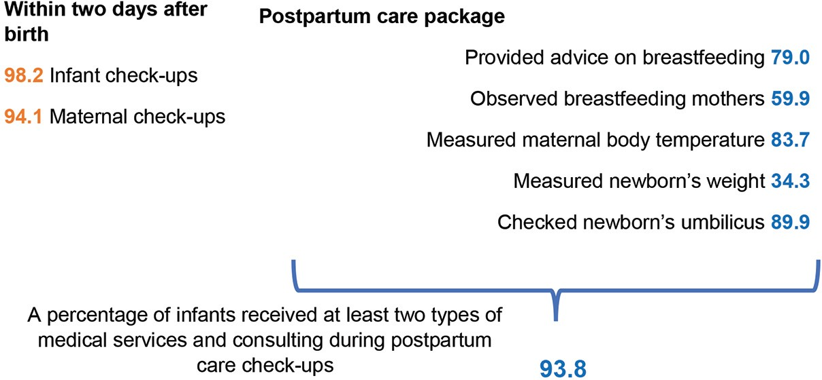
Among survey participant herder women, 21 .2 per cent of them had an abortion . Of which, 69 .7 per cent of them had it one time, 24 .2 per cent of them had it twice, 6 .1 per cent of them had abortion for more than three times. Of them, 11 .9 per cent of them had an abortion in soum hospital, 59 .6 per cent of them had an abortion in province hospital, 19 .3 per cent of them answered they had it done in private hospital, 2 .8 per cent of them answered they had it done at home, 5 .5 per cent of them had it in hospital in Ulaanbaatar and 0 .9 per cent of them answered they had it done in hospital of different province .
Women living in countries where abortion is illegal or abortion access and services are poor, risk their health and even lives by approaching to unprofessional places or by doing self-induced abortion . Most women go through abortion due to their unwanted pregnancies and 84 per cent of women in developing countries have unmet need for modern contraceptive methods and lack of awareness about reproductive health and family planning. In addition, a rate of abortion becomes one of the indicators to measure effectiveness of family planning programs.
Therefore, the state needs to reduce a number of unwanted pregnancies ends in abortion by implementing more effective family planning policy and programs especially targeting communities living in remote rural areas. In Mongolia, the abortion was legalized in 1989. Under the National Program on “Maternal, Child and Reproductive health” (2017-2021) adopted by the Government resolution No .78 dated 7 March 2017, it targeted to decrease abortion rate from 224 to 200 per 1,000 live births. It is commending that a rate of abortion has been decreased (18,316 in 2016, 17,530 in 2017, 15,822 in 2018) year by year on nationwide . Further, the government needs to raise public awareness about importance of family planning, eliminate misconception pertaining to modern contraceptive methods, provide post-abortion care and counseling on family planning and tighten the control over sales of abortion-inducing illegal medications.
Among survey participants, 12 .9 per cent of them accessed to infertility treatments and counseling services in mostly soum health centre and province hospital.

In 2018, 16,130 cases of STIs were registered nationwide, which accounted for 38 .3 per cent of total infectious diseases. Whereas in 2019, 17,865 cases of STIs were registered increasing by 1,735 cases compared to previous year . Upon looking at locations where STIs are registered, statistics on STIs of Bayankhongor, Dornod, Sukhbaatar and Khuvsgul provinces are higher than national average rate.
Table 1 .20 Statistics on sexually transmitted infections (2018, 2019)
Location | STIs in 2018 |  |  |  | STIs in 2019
 | Syphilis | Gonococcus | Тrichomonas | HIV/AIDS | Syphilis | Gonococcus | Тrichomonas | HIV/AIDS
Bayankhongor | 256 | 328 | 466 | 0 | 227 | 399 | 675 | 0
Dornod | 230 | 1,058 | 414 | 0 | 204 | 724 | 385 | 0
Zavkhan | 77 | 83 | 4 | 0 | 131 | 231 | 13 | 0
Umnugovi | 77 | 66 | 63 | 0 | 142 | 59 | 50 | 0
Sukhbaatar | 196 | 106 | 59 | 0 | 213 | 99 | 71 | 0
Khuvsgul | 612 | 878 | 176 | 0 | 469 | 823 | 139 | 0
Other provinces | 1,913 | 992 | 1,159 | 0 | 2,064 | 1,248 | 1,365 | 0
Ulaanbaatar | 2,802 | 1,950 | 2,147 | 18 | 3,645 | 2,189 | 2,282 | 18
Total nationwide | 6,163 | 5,461 | 4,488 | 18 | 7,095 | 5,772 | 4,980 | 18

When the questionnaire intended to seek whether the survey participant herder women face any obstacles and challenges in accessing to infertility treatments, counseling and services, the survey participants provided as follows.
Table 1 .21 Difficulties in accessing to treatments, consulting and information
№ | Difficulties in accessing to information or treat- ments for their sexual and reproductive health | An- swer | Per- centage
1 | Due to my herding and other chores I don’t get a chance to have a check-up as much as I needed | 43 | 24.0
2 | Doctors and health practitioners don’t keep the confidentiality | 31 | 17.3
3 | It is troublesome for me that you either have to go to soum health center or province hospital to get counselling services to access treatments. | 29 | 16.2
4 | I don’t know where to approach related to my health issues (STIs), so I don’t get a chance to seek a counselling or information on time | 48 | 26.7
5 | Medical treatments and services are inadequate and inaccessible (e.g. doctors, beds and medi- cines) | 23 | 13.0
7 | I don’t have any problems | 5 | 2.8
Total |  | 179 | 100

When the questionnaire asked where they receive treatment and services for sexually transmitted infections (STIs), 48 per cent of them answered they go to soum health center, 18 per cent of them responded they go to province hospital, 4 per cent of them indicated private hospital, 28 per cent of them answered they seek an advice from a pharmacist and do a home-remedy, and 2 per cent of them responded they go to a hospital in Ulaanbaatar.
Prevalence of increased cases of sexually transmitted infections among communities in rural areas is caused by many factors. For example, herders lack of awareness and information about prevention of and treatments for STIs, and have no time to visit soum or province center to see a doctor due to their busy engagement with livestock activities. There is a gender ratio gap among young herders, which negatively impacts on late marriage, decreased birth rate, and increased sexually transmitted diseases and migration. On the other hand, herders are not keen on having a health check-ups and screening.

Case 1 .37

Our soum has been experiencing an increased divorce. It also leads to the increased rate of STIs within soum. Recently, we have run a mobile-outpatient care services at own cost. We were able to include 2171 people for blood test out of 3800. As a result, additional 51 people were confirmed with a STI positive. Before, we had 87 cases with positive in STIs, now it is confirmed with more than 100 people with positive in STIs. 116 people are tested positive in syphilis. There are around 2000 people who should be tested for STIs including syphilis. So, a claim turned out to be almost true that a prevalence of syphilis is out of control. We have been putting a lot of efforts to include these people in the test. People ask us what are you going to do with my blood when we take their blood for the testing and suspect us for selling their blood or something.
(From interview with a public servant in a soum, Sukhbaatar province)
Everyone is entitled to sexual and reproductive health and rights without discrimination. However, herder girls and women’s lifestyle, geographical distances, and their economic condition hinder them to enjoy their rights . In addition, their poor health education coupled with lack of access to information and outdated management of services also contributes to their lack of enjoyment of their rights. Thus, it is required to implement policies aimed at supporting herder girls and women by empowering them, involving them in social activities and ensuring that health education and information services accessible and effective for them.
In addition, the state needs to pay attention to increasing use of modern contraceptive methods as well as increasing visits for early pregnancy check-up and decreasing teenage births and maternal mortality in soum and bag health centers. When it comes to allocating manpower and financial resources in health institutions, it consistently needs to increase the manpower of gynecologists, obstetricians and bag general practitioners, and furnish the soum health centers with modern diagnosis equipment and introduce new innovative ways to include herder women in soum and bag areas in prenatal care check-up and medical assistance .

National Statistics Office, Study for Workforce for 2019 (primarily statistic) Ulaanbaatar, 2020).
National Statistics Office, Agricultural Sector Introduction for 2019 (primarily statistic), (Ulaanbaatar, 2020), www.1212.mn
National Statistics Office, Agricultural Sector Introduction for 2018, (Ulaanbaatar, 2019).
National Statistics Office data portal www.1212.mn, National Statistics Office, Agricultural Sector Introduction for 2019, tentatively 2020
National Statistics Office, Agricultural Sector Introduction for 2019, (Ulaanbaatar, 2020).
Compilation of General Comments and Recommendations of UN Human Rights Treaties, UNDP, Ulaanbaatar, 2014
Part 5.1.1 of Article 5.1 of the Law to Combat against Domestic Violence
The National Police Agency created a database related to the domestic violence call, report, complaint, administrative offence and information on perpetrators under the project “Combating gender-based violence” supported by the UNFPA. Registered cases at the police (registered cases as of first eight months of 2019 in nationwide).
Statistical information of the Judicial Research, Information and Training Institute of the Judicial General Council. Official letter 04/210 dated 27 February 2020 of the Secretariat of the Judicial General Council.
The National Police Agency’s Preventive Unit’s Official letter 9/5964 dated 04 November 2019 and Statistics of National Police Agency, 2020.
The National Police Agency’s Preventive Unit Official letter 9/5964 dated 04 November 2019.
Official letter 45/742 of the Police department in Sukhbaatar province dated 10 May 2019
Part 25.2, 25.3 of Article 25 of the Law to Combat Domestic Violence
Article 4.5 of the Law on Infringement
Part 2.2 of Article 7.3 of the Criminal Code
Part 44.4 of Article 44 of the Law to Combat against Domestic Violence
National Center Against Violence, Swiss Development Agency and UNFPA, Monitoring report “Implementation of the police officers’ duties prescribed in the Law to Combat Domestic Violence”, (Ulaanbaatar, 2018).
According to Article 3 of the Law on the Procedures for Enforcing the Law on Enforcement of Court Decision, any arrest order by the court shall be executed by the court decision enforcement agency at capital and by the police at province and soum levels until the 1 January 2023 and the police will transfer its functions to execute the arrest order by the court to the court decision enforcement agency in specific phases within the aforementioned period.
Information from the General Executive Agency for Court Decisions.
General Comment 14 of the Committee on Economic, Social and Cultural Rights, Compilation of the General Comments and Recommendations of the Human Rights Conventions, UNDP (Ulaanbaatar, 2004)
(Chapter 7.3, Program of Action of the International Conference on Population and Development
Compilation of the General Comments and Recommendations of the Human Rights Conventions, page 81, UNDP (Ulaanbaatar, 2004).
Article 19 of the International Covenant on Civil and Political Rights states, “Everyone shall have the right to freedom of expression; this right shall include freedom to seek, receive and impart information and ideas of all kinds…”, and Article 10. (h) of the Convention on the Elimination of All Forms of Discrimination against Women states, “States Parties shall ensure access to specific educational information to help to ensure the health and well-being of families, including information and advice on family planning.
“Mongolia-Social Indicator Survey Sample-2018” report, National Statistics Office and UNFPA, UNICEF, Ulaanbaatar, 2019. (Birth rate among girls between 15-19 ages, three years before the survey, by urban and rural areas).
Mongolia-Social Indicator Survey Sample-2018” report, National Statistics Office and UNFPA, UNICEF, Ulaanbaatar, 2019. Note: Percentage of women between 15-49 age married or with partners use modern and traditional contraceptive methods (husbands or partners may use the contraceptive methods). Modern contraceptive methods include tubal ligation, vasectomy, IUD, contraceptive implant, injection, pill, male and female condom, diaphragm, inserts and tablets and use of breastfeeding. Traditional contraceptive methods include periodic abstinence (fertility awareness) method and coitus interruptus (withdrawal or pulling out) method.
“Mongolia-Social Indicator Survey Sample-2018” report, National Statistics Office and UNFPA, UNICEF, Ulaanbaatar, 2019.
WHO recommendations on antenatal care for a positive pregnancy experience. Geneva: WHO Press, World Health Organization, 2016. http://apps.who.int/iris/ bitstream/handle/10665/250796/9789241549912-eng.pdf?sequence=1.
Mongolia-Social Indicator Survey Sample-2018” report, National Statistics Office and UNFPA, UNICEF, Ulaanbaatar, 2019.
Mongolia-Social Indicator Survey Sample-2018” report, National Statistics Office and UNFPA, UNICEF, Ulaanbaatar, 2019. (By percentage of women between 15- 49 age gave birth two years before 2018 and by maternity places).
Lale Say et al., “Global Causes of Maternal Death: A WHO Systematic Analysis” page 332-333, Global Health 2nd volume, 6th edition, 2014. doi:10.1016/s2214- 109х(14)70227- x
42 It is a global main indicator for measuring preventable maternal mortality and also recommends it in “Global Strategy for Women’s Children’s and Adolescent’s Health 2016-2030” and “Every Newborn Action Plan”.
“Rules for prenatal and postpartum care” adopted by the order No.338 of Minister of Health dated 20 October 2014.
44 National Reproducitve Health Program (1997-2016 – 4 phases), “National Programme on Maternal, Child and Reproductive Health” (2017-2021), “Maternal Mortality Reduction Strategy” (2001-2004, 2005-2010), “National Strategy on Reproductive Health Commodity Security” (2009-2013), “Maternal and Newborn Health Strategy” (2011-2015), “Infant Care Strategy” (2014-2020), “Newborn Screening Program” (2014-2020).
Mongolia-Social Indicator Survey Sample-2018” report, National Statistics Office and UNFPA, UNICEF, Ulaanbaatar, 2019.
Guttmacher Institute, Adding It Up: Investing in Contraception and Maternal and Newborn Health, Fact Sheet, New-York: Guttmacher Institute, 2017.
Information from National Center for Health Development, 2019

