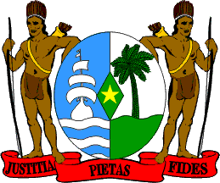

Joint Statement delivered by
Janice Alladin
Delegate of the Republic of Suriname
On behalf of 2 Small Island Developing States(SIDS) Beneficiary Delegates of the Technical Assistance Trust Fund to Support the Participation of LDCs/SIDS in the work of the Human Rights Council during the 48th Session of the United Nations Human Rights Council

General Debate, Item 10 - Technical Cooperation
Geneva, 07 October 2021

Madam President,

I am honored to deliver this joint statement on behalf of Saint Vincent and Grenadines and my own country the Republic of Suriname.

We as delegates are pleased to represent our respective countries and are committed to ensure the universal respect of the human rights of peoples. However, as LDC's/SIDS countries, it remains a challenge for us to participate annually in the Council sessions and the overall work in Geneva, due to not having permanent missions based here.

Hence, we appreciate and put great emphasis on Technical Cooperation afforded to our countries to participate in these sessions, which provides an opportunity for us to dialogue, engage and brief ourselves on new developments in Human Rights issues and to understand the work and good practices of other countries through the guidance of the Council.

Madam President
On behalf of the aforementioned countries, I express our appreciation to the support given to the LDC’s/SIDS Trust Fund and thank the donor countries for their generosity to the Fund which enables our participation.

We also take this opportunity to thank the Office of the High Commissioner for Human Rights for its continued support to the Technical Cooperation Program rendered to our countries and we look forward to new opportunities for further enhancement in the Council’s work.

I thank you

