**32nd special session of the Human Rights Council on the human rights implications of the ongoing situation in the Sudan.**

**Information note for NGOs**

***(Latest update: 3 November 2021 – Subject to change)***

Contents

Introduction 1

NGO Liaison Office 1

1) Dates and important information 1

2) Accreditation to the special session 2

3) Oral statements and lists of speakers 2

Recommended technical specifications for video messages 3

4) List of speakers on HRC Extranet 4

5) Reprisals 4

**ANNEX I – CHECKLIST FOR NGOs** 5

# Introduction

The purpose of this document is to provide information to civil society representatives participating in the forthcoming **32nd special session of the Human Rights Council on the human rights implications of the ongoing situation in the Sudan**, scheduled for **Friday, 5 November at 12.30 pm (Geneva time)**. This is based on information available at this moment.

**IMPORTANT: This document is subject to change.**

# NGO Liaison Office

Due to the COVID-19 situation, the NGO Liaison Office of the Human Rights Council Secretariat will remain closed. The Office will be available for any queries through the usual e-mail address: [ohchr-hrcngo@un.org](mailto:ohchr-hrcngo@un.org)

# Dates and important information

**The 32nd special session of the Human Rights Council on the human rights implications of the ongoing situation in the Sudan is scheduled to take place on Friday, 5 November at 12.30 pm (Geneva time)**.

Taking into account the current health context and the host country’s rules governing in-person meetings and related guidance from the United Nations Office at Geneva, which limit the participation in public meetings, **no in-person participation by NGO representatives will be possible during this session.**

Consequently, NGOs in consultative status with the ECOSOC and active Designations with UNOG wishing to participate in the special session will have to submit **pre-recorded** **video-statements through the online registration system** [**https://ngoreg.ohchr.org**](https://ngoreg.ohchr.org) **and fulfil all the relevant requirements** *(see Annex I for a complete checklist).*

**IMPORTANT:** In accordance with the minutes of the Bureau meeting of 2 November 2021, the Council would take a decision that NGOs in consultative status with the ECOSOC would be invited to submit pre-recorded video statements for the 32nd special session. In order to balance the importance of inclusivity and what is feasible in terms of time and resources, **the list of speakers for NGOs will be set to 22 speakers, in line with the average number of NGOs that had registered to deliver oral statements for the past three special sessions that have taken place in 2021**.

# Accreditation to the special session

Please note that NGO representatives wishing to deliver a video-message will have to register through INDICO to the special session in order to deliver video-messages, here: <https://indico.un.org/event/37080/>.

When submitting an accreditation request, NGO representatives will have the opportunity to indicate if they already possess an annual or temporary grounds pass at UNOG and upload a picture of your grounds pass in relevant field in INDICO platform.

# Oral statements and lists of speakers

The online registration system for the special session can be found on the usual website: <https://ngoreg.ohchr.org>. **The system opens on Thursday, 4 November at 2 p.m. (Geneva time).**

After signing up to the session, **NGOs can upload the video-message at a later stage**. It is not necessary to upload it at the moment of registration. **The deadline to upload the video-message is at 6 p.m. on the day prior to the session.** Video-messages received past this deadline will not be displayed.

NGOs will also have to enter the name of the speaker and upload the following files:

1. The transcript of the statement in accessible format (Word or Accessible PDF);
2. A scanned copy of the passport of the speaker;
3. The letter requesting the accreditation of the speaker;
4. The video file.

As decided by the Bureau of the Human Rights Council, with the exception of an official representative of a UN Member State speaking in front of the national flag and/or the official picture of the Head of State, **the background of video-messages should be neutral without any other flag, banner, flyer, picture or symbol.**

As mentioned above, the video and the accompanying files can be uploaded at a later stage. Please note that the video file has to **adhere strictly** to the speaking time limits of **1 minute and 30 seconds**.

**Captioning of the video is strongly encouraged** in order to ensure accessibility of persons with disabilities. In order to facilitate this procedure, NGOs are able to upload a specific file for subtitles directly in the online registration system. This is not a mandatory field and it can be left blank:

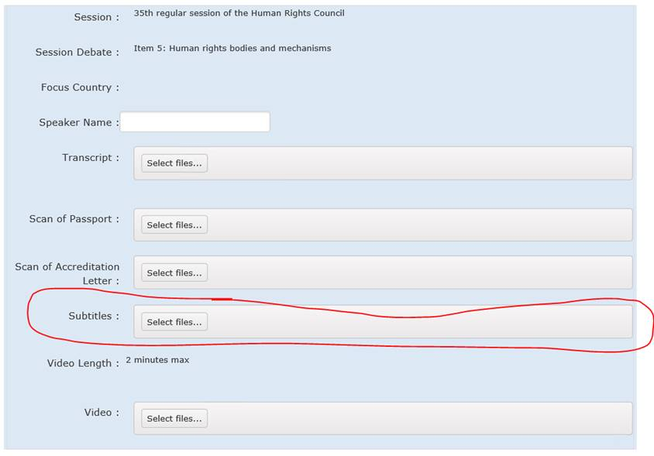

**Please remember that the accreditation through INDICO is mandatory.**

*By submitting a video statement to the HRC Secretariat for the purpose of screening it during an official meeting of the HRC, the video statement will become an official record of the HRC session and considered as a UN audio-visual asset that can be re-disseminated to media organizations worldwide on a non-commercial basis, in accordance with guidelines of the Department of Global Communications, and will be included in the webcast archive of the meeting on webtv.un.org.*

### Recommended technical specifications for video messages

1. **MP4**The MP4 or MPEG-4 file format is a digital multimedia container format most commonly used to store video and audio, but it can also be used to store other data such as subtitles and still images.
   * video encoding: **H.264**
   * audio encoding: **Min 44100Hz**
   * video resolution: **Min 640x480**

**Max 1920x1080**

**Frame rate 24, 30 fps**

1. **MOV**MOV is the Apple Inc. Quicktime multimedia container file that contains one or more tracks, each of which stores a particular type of data: audio, video, effects, or text (e.g. for subtitles).
   * video encoding: **H.264**
   * audio encoding: **Min 44100Hz**
   * video resolution: **Min 640x480**

**Max 1920x1080**

**Frame rate 24, 30 fps**

1. **AVI/WMV**Audio Video Interleaved (AVI) is a multimedia container format introduced by Microsoft that can contain both audio and video data in a file container that allows audio-with-video playback.

Windows Media Video (WMV) is a video compression format for several proprietary codecs developed by Microsoft.

* + video encoding: **WMV3** (Windows Media Video 9)
  + audio encoding: **Min 44100Hz**
  + video resolution: **Min 640x480**

**Max 1920x1080**

**Frame rate 24, 30 fps**

When using a smartphone, shoot the video in landscape (horizontal) mode.

Please note that no professional equipment is required to record video messages. Most modern consumer electronics (smartphones, laptops, etc.) are capable of recording video that complies with the specifications.

**All files will be played using VLC Media Player.** **Please note that the Secretariat does not bear responsibility if files that do not comply with the recommended specifications cannot be displayed in our audio-visual system. Depending on the quality of the video-statement, interpreters may stop interpretation.**

# 4) List of speakers on HRC Extranet

The lists of speakers will be made available on the HRC Extranet: <https://hrcmeetings.ohchr.org/HRCSessions/SpecialSessions/32session/Pages/default.aspx>

# Reprisals

Any act of intimidation or reprisal for cooperation in the context of the HRC session should be promptly reported to the HRC Secretariat.

***

For updated information, consult the website: <https://www.ohchr.org/EN/HRBodies/HRC/SpecialSessions/Session32/Pages/32ndSpecialSession.aspx>

# **ANNEX I – CHECKLIST FOR NGOs**

This checklist is designed to facilitate NGOs’ participation in the special session by summarizing the required mandatory steps to follow. Please note that failure in fulfilling any of these steps will result in the video-statement not being processed.

**Checklist:**

* Your NGO is in consultative status with ECOSOC (<http://csonet.org/>)
* Your NGO has duly accredited Designated representatives with UNOG for 2021 (<https://www.ungeneva.org/en/practical-information/civil-society>)
* You have signed up for the session through the online registration system (<https://ngoreg.ohchr.org>). Opening of the system is indicated at point n.3. You will also be able to check your position on the list of speakers on the HRC Extranet at a later stage, here: <https://hrcmeetings.ohchr.org/HRCSessions/SpecialSessions/32session/Pages/default.aspx>
* Your speaker is registered with a valid Accreditation letter (or copy of the Annual badge) in INDICO (<https://indico.un.org/event/37080/> ) and the registration was approved
* You have uploaded all relevant documents, alongside with the video statement, on the online registration system (<https://ngoreg.ohchr.org>) before the deadline of 6 pm of the day prior to the beginning of the session.
* You have made sure that your video statement(s) abide by the rules applicable for video statements, *i.e.* the background should be neutral without any flag, banner, flyer, picture or symbol but the one of your NGO, and the full official name of the NGO in consultative status with ECOSOC should be displayed in the video.