 |  | A/HRC/48/83
 | Advance Edited Version |  | Distr.: General  29 November 2021  Original: English
Human Rights Council
Forty-eighth session
13 September–1 October 2021
Agenda item 10
Technical assistance and capacity-building

Report of the Independent Fact-Finding Mission on Libya*, **

I. Introduction
1. Since the fall of the Gaddafi regime in 2011, the fragmentation of the State and the proliferation of weapons and of militias vying for control of territory and resources has severely undermined the rule of law in Libya. Libya has also been the theatre of near-uninterrupted armed conflicts. State and non-State actors alike, from Libya and abroad, are alleged to have taken advantage of this context to perpetrate violations and abuses of international human rights law and international humanitarian law against the most vulnerable, including women, children, members of ethnic minorities, migrants, asylum seekers and internally displaced persons. The violence has also had a dramatic impact on the Libyan economic fabric as well as on civic space, particularly for women. With the recent installation of the Government of National Unity, Libya has entered a phase of national dialogue and unification of State institutions. Nevertheless, the situation of human rights remains alarming and the process of holding accountable perpetrators of violations and abuses faces significant challenges.
2. The situation in Libya since 2011 has been the subject of investigations by two mechanisms mandated by the Human Rights Council. On 22 June 2020, at the request of the Government of Libya, the Council adopted resolution 43/39 requesting the United Nations High Commissioner for Human Rights to establish and dispatch a fact-finding mission to Libya. On 22 August 2020, the High Commissioner announced the appointment of Mohamed Auajjar, of Morocco, Tracy Robinson, of Jamaica, and Chaloka Beyani, of Zambia and the United Kingdom of Great Britain and Northern Ireland, as the members of the Independent Fact-Finding Mission on Libya, hereinafter referred to as the Mission, with Mr. Auajjar as Chair.
3. The Mission was mandated to establish, in an independent and impartial manner, the facts and circumstances of the human rights situation throughout Libya, to document alleged violations and abuses of international human rights law and international humanitarian law by all parties in Libya since the beginning of 2016, including any gendered dimensions, and to preserve evidence with a view to ensuring that perpetrators of violations and abuses are held accountable. The Mission was initially established for a period of one year and was requested to present a comprehensive written report to the Human Rights Council at its forty-sixth session. The Council subsequently decided to postpone the presentation of the report until its forty-eighth session to account for the persistent impossibility of recruiting the secretariat to support the work of the Mission. Despite the postponement of the report deadline, it was only in June 2021 that the secretariat became fully operational.
4. At this juncture, the Mission finds itself unable to submit a comprehensive report on the human rights situation since 2016. A full determination on the violations and abuses committed throughout Libya over almost the past six years, including the identification of potential perpetrators, requires significantly more time. Nevertheless, since it was established, the Mission has gathered hundreds of documents, interviewed more than 150 individuals, and conducted investigations in Libya, Tunisia and Italy. The present report summarizes the findings which the Mission was able to reach on the basis of the information gathered, within the word limit for reports submitted to the Human Rights Council.
5. As Libya is making progress towards peace, a fully-fledged fact-finding exercise is more than ever necessary. Past experience has shown that in post-conflict contexts, a comprehensive human rights investigation is an effective tool to foster accountability, deter further violations and promote long-term peace and security. The Mission therefore recommends the Human Rights Council to consider extending its mandate for a period of time commensurate with the mandate’s breadth.

1. Political situation
6. In the first months of 2016, the parties to the Libyan Political Agreement worked towards the establishment of the Government of National Accord, which the Security Council had decided it would support as the sole legitimate government of Libya. However, the Tobruk-based House of Representatives, with which the Libyan National Army and affiliated armed groups ostensibly aligned themselves, never agreed to the composition of the Government of National Accord. As a result of this political deadlock, the following years were characterized by parallel institutions exercising control over different parts of the country.
7. In January 2020, an international conference was held in Berlin, Germany, following which senior military officers from both the Government of National Accord and the Libyan National Army engaged in United Nations-facilitated discussions within the framework of the 5+5 Joint Military Commission. The discussions led to the conclusion of a ceasefire in October 2020. On the political front, a forum gathering representatives from all sides of the Libyan political spectrum adopted in November 2020 a road map providing for the establishment of a government of national unity and the holding of presidential and parliamentary elections in December 2021. In March 2021, the Government of National Unity was installed following a vote of the House of Representatives. At the time of submission of the present report, laws for parliamentary and presidential elections were being prepared.

2. Cooperation of the Libyan authorities
8. In its resolution 43/39, the Human Rights Council urged the Libyan authorities to grant the Mission unhindered access to all Libyan territory without delay and to allow it to visit sites, and to meet and speak freely and privately, when it so requested, with whomever it wished to meet or speak with.
9. With the cooperation of the Libyan authorities, the Mission was able to travel to Libya, held discussions with Libyan authorities, and visited sites. Yet, significant delays were experienced in obtaining the required visas, which interfered with planning and delayed the arrival of the Mission. During a meeting held in Tripoli in August 2021, the Minister of Foreign Affairs assured the Mission that the issuance of visas would be facilitated in the future. Special authorization procedures applicable to international organizations working in Libya impeded the Mission’s interactions with the authorities and also interfered with the Mission’s site visits. Also, some requests to visit sites, in particular prisons and detention centres for migrants, remained unanswered.
10. Furthermore, several Libyan-based non-governmental organizations (NGOs) were reluctant to interact with the Mission in view of the Presidential Council’s decree of 2019 regulating the work of NGOs in Libya. They felt that notifying governmental authorities about their intent to meet with the Mission would expose them to retaliation. Consistent with the investigative principle of “do no harm”, the Mission decided not to engage with NGOs based in Libya.
11. The recent installation of the Government of National Unity may, at least in part, explain the delays and other difficulties faced by the Mission in Libya. Should the Mission’s mandate be extended, it is of paramount importance that the investigations be appropriately facilitated by the Libyan authorities, including by granting access to all places and persons of interest. In particular, the Mission calls on Libyan authorities to ensure that anyone in Libya is free to approach the Mission, including NGOs. In this regard, the Mission invites Libya to review the decree regulating the work of NGOs in Libya.

3. Challenges
12. The Mission benefited from less time and resources than initially projected, which curtailed its ability to conduct a comprehensive investigation. The secretariat supporting the work of the Mission only became fully operational in June 2021, that is, three months before the deadline for the submission of the present report. The delay was mainly due to the United Nations regular budget liquidity crisis and the concomitant suspension of recruitment. The deployment of the secretariat to Tunis was also temporarily delayed due to the prevailing COVID-19 situation in Tunisia.
13. The Mission was also confronted with difficulties in the gathering of information. The investigations took place in a fast-changing environment, with incidents falling within the Mission’s mandate occurring as recently as September 2021. The current Libyan context was not conducive to witnesses freely sharing information. Indeed, even when a secure channel of communication existed, several individuals declined to engage with the Mission on account of fears of reprisals by State agents or militias. Furthermore, several victims preferred not to be interviewed to avoid reliving their trauma. In Libya, the security measures accompanying the Mission’s movements increased the investigators’ visibility on the ground and discouraged some witnesses from coming forward. For security reasons, the Mission was also unable to visit the south of Libya.

II. Methodology

A. Scope of investigations
14. As it was vested with a broad and general mandate (see annex I), the Mission was bound to circumscribe the scope of its investigations to the areas entailing the most serious violations and abuses. The Mission identified the following areas of investigation (see below): conduct of hostilities; extrajudicial killings; violations in the context of deprivation of liberty; sexual and gender-based violence; and the respective situations of internally displaced persons, migrants, refugees and asylum seekers, women, and children. The allegations of atrocity crimes committed in the town of Tarhuna warranted a particular focus.
15. The Mission documented certain trends and patterns and gathered information in relation to some incidents within each of the above categories. The Mission prioritized for investigation those incidents which appeared the most serious and/or the most representative of broader patterns of violations and abuses. Mindful of the fact that the situation has been under the scrutiny of other reporting or accountability mechanisms, the Mission also focused on incidents which have not been the object of prior public reporting or which the Mission could examine from a different legal perspective. In view of the evidentiary challenges related to passage of time, the report concentrates on more recent events.
16. The Mission’s findings are not exhaustive; they provide a basis that further investigations can build on with a view to comprehensively addressing the human rights situation since 2016. The Mission considered that future investigations should substantiate the overarching impact of the violations and abuses on, inter alia, the victims’ civil and political rights as well as on their economic, social and cultural rights.

B. Methodology
17. In keeping with resolution 43/39, in which the Human Rights Council requested the Mission to conduct its investigations in an independent and impartial manner, the Mission established its own investigative priorities. It did not seek approval or instructions from any external stakeholders at any stage of its work. The investigations also focused on all actors involved – domestic and foreign – without distinction.
18. Consistent with the approach taken by human rights investigations, the findings contained in the present report meet the “reasonable grounds to believe” evidentiary standard. The Mission found that an incident or a pattern of conduct had taken place whenever it obtained a reliable body of information, corroborated by at least one other independent source, which could lead a reasonable and ordinarily prudent person to believe that the incident or pattern had occurred. The nature of certain violations is such that the Mission could only rely on first-hand accounts of victims.
19. While the aforementioned evidentiary standard did not require findings to be made to the exclusion of other reasonable inferences, the Mission considered that the establishment of facts in a post-conflict context had to benefit, to the extent possible, from the perspectives of all parties to the conflict. The Mission began engaging with all sides, and the findings set out in the present report are made without prejudice to the receipt of further information.
20. While the “reasonable grounds to believe” standard established a minimum evidentiary threshold, there were circumstances where a higher level of certainty was warranted, in particular when a finding entailed a legal qualification that carried with it a higher degree of stigma due to its gravity, such as crimes against humanity and torture. In relation to such findings, the Mission exceeded the minimum evidentiary threshold.
21. The Mission considered information from a variety of sources – which included interviews with victims and other witnesses; summaries of accounts and analytical data included in reports of the United Nations and other reliable NGOs and media; investigators’ direct observations during site visits; domestic Libyan laws; information provided by the Libyan authorities, other States and reliable stakeholders working on Libya; authenticated satellite imagery and audiovisual material; and verified open-source material. Further to a call for submissions issued on 25 January 2021, civil society organizations and lawyers representing victims filed with the Mission information relevant to the areas under investigation.
22. The security situation did not provide for a safe space to hold in-person meetings with victims and witnesses. The Mission therefore conducted interviews using other means of communication through secure channels. In certain cases, the Mission covered expenses incurred for the travel to a safe location outside Libya, clarifying to the interviewee that the payment was not a compensation for testimony.
23. The Mission made its own assessment of the credibility and reliability of sources, even when they were introduced by reliable intermediaries. All sources relied upon in the present report were deemed to be credible and reliable. The Mission sought from each person or entity it met their informed consent to use the information in the report and/or share it with external stakeholders for accountability or assistance purposes. The report does not disclose the identity of the individuals interviewed by the Mission, except where consent was provided.
24. The Mission paid the utmost attention to the safety and well-being of the individuals with whom it interacted. In accordance with the well-established investigative principle of “do no harm”, the Mission ensured that their collaboration with the Mission did not put them in danger or retraumatize them. Where appropriate, the Mission directed victims and witnesses to existing protection and assistance programmes.
25. In keeping with the Mission’s mandate to preserve evidence for accountability purposes, the Secretariat kept a safe record of all the materials it gathered and developed a record-management system to streamline future investigations.

III. Violations, abuses and crimes under international human rights law, international humanitarian law and international criminal law

A. Conduct of hostilities
26. The period covered by the Mission’s mandate witnessed several armed confrontations that reached a sustained level of intensity and involved organized armed groups as well as State armed forces. The hostilities have been widely documented and there is little doubt that these confrontations amounted to non-international armed conflicts. The investigations indicated that the involvement of foreign States in the non-international armed conflicts was such that they were considered parties thereto. The involvement of a foreign State in a non-international armed conflict in support of a party to the conflict, rather than against the State, does not change the classification of the conflict. The investigations indicated that several parties to the conflicts violated international humanitarian law and potentially committed war crimes. The present section sets out the findings that the Mission reached, with a particular focus on: (a) the hostilities in Tripoli in 2019 and 2020; (b) the siege of Ganfouda in eastern Libya in 2016 and 2017; and (c) the military operations in southern Libya in 2019. The factual considerations underpinning the findings are without prejudice to evidence that may be later shared by other stakeholders.

1. Tripoli
27. From April 2019 to June 2020, the Government of National Accord and the Libyan National Army, as well as their respective affiliated armed groups, and with the support of foreign States, were engaged in an armed conflict in Tripoli and its surrounds. The findings below provide only a limited insight into these hostilities and further investigations are required to examine other alleged violations.
28. Health-related facilities and objects. At least 47 health-related facilities and objects were damaged during this period, with an immediate impact on health care (including access for women to specialized services), and there are reasonable grounds to believe that the following attacks amounted to violations of international humanitarian law and war crimes. The evidence established that in May 2019, in Twaisha, near Tripoli, a weapon struck an ambulance marked with the Red Crescent emblem on its door and seriously injured the driver. The ambulance was transporting health personnel and was not engaged in a hostile purpose. The investigations also established that in April 2020, Al-Khadra General Hospital, which was Tripoli’s main centre for COVID-19 patients, was hit three times in airstrikes. The hospital was functioning as such prior to the attacks and it was not used to commit hostile acts. Further investigations are required in order to establish the responsibility for these attacks and for other similar attacks.
29. Schools. Schools were also subject to extensive damage and destruction. The Mission investigated the damage to three schools (Bab Ben Ghashir, Alkhalidoon and Attalieaa) as well as the destruction of a warehouse storing millions of textbooks in April 2019. The information gathered did not allow the Mission to reach findings on whether the incidents constituted violations of international humanitarian law. Additional investigations should be conducted into this specific aspect of the hostilities, noting that attacks against education-related facilities impact on children’s right to education.
30. Hadaba Military Academy. On the evening of 4 January 2020, a group of students who had gathered in the courtyard of Hadaba Military Academy were hit by a missile, killing 25 students and injuring at least 20, including 12 seriously. Some reports attributed the attack to the Libyan National Army.
31. A corollary of the absence of combatant status in non-international armed conflicts is that no one may be attacked unless they are directly participating in hostilities. Although the recruitment and training of personnel is crucial to the military capacity of a party to the conflict, the causal link with the harm inflicted on the adversary will generally remain indirect. Only where persons are specifically recruited and trained for the execution of a predetermined hostile act can such activities be regarded as direct participation in hostilities. The evidence indicated that the students were undergoing general training as per the usual curriculum and the Mission received no evidence that they were undergoing preparations for a specific hostile act.
32. All feasible precautions must be taken in determining whether a person is a civilian and, if so, whether that civilian is directly participating in hostilities. In case of doubt, the person must be presumed to be protected against direct attack. In the current case, given that the students were undergoing a drill in the courtyard without weapons, as is characteristic of first-year students, there were sufficient indicators that would give rise to doubt as to whether they were training for a specific act. Their status and function as first-year students also indicate that they were not engaged in a continuous combat function. No evidence was found indicating that the building was used for other military purposes.
33. In light of the foregoing, there are reasonable grounds to believe that the attack may have constituted a serious violation of international humanitarian law and a war crime. Further investigations are necessary in order to ascertain the exact roles played by the Libyan National Army and any other State in the attack.
34. Qasr Bin Ghashir. On 3 June 2020, four consecutive drone strikes killed at least 12 people in the town of Qasr Bin Ghashir, south of Tripoli. Reports alleged that the attack could be attributed to the Government of National Accord.
35. The investigations established that those attacked were unarmed and included women and children. The weapons used were precise and were launched by a human-commanded unmanned aerial vehicle. The strikes were consecutive, they were aimed at the same group of unarmed people gathered in one location and they took place as the Libyan National Army was retreating from the area. The Mission inferred from this that the attacks were intentionally directed against individual civilians not taking direct part in hostilities, thereby potentially amounting to a violation of international humanitarian law and a war crime. There are also reasonable grounds to believe that the attack could be attributed to the Government of National Accord, given that: (a) a few days before the attack, the Government of National Accord had alerted civilians to leave the area of Qasr Bin Ghashir as shelling would take place; and (b) the weapons and the unmanned aerial vehicle from which they were launched had previously been used by the Government of National Accord in the same area. While the alert complied with the international humanitarian law obligation to give advance warning and may be regarded as a measure to minimize civilian losses, the prohibition against attacking civilians remained applicable even if civilians stayed behind after the warning was issued. There are reports that: (a) Turkey concluded with the Government of National Accord a memorandum of understanding on security and military cooperation; (b) the weapons and unmanned aerial vehicle used in the attack were manufactured in Turkey; (c) the unmanned aerial vehicle used in the attack had previously been spotted in Libyan military airbases to which Turkey had access; and (d) the distance between these bases and Qasr Bin Ghashir falls within the unmanned aerial vehicle’s range. Nevertheless, the exact role played by Turkey in this attack, if any, has yet to be ascertained.
36. Mercenaries. Another feature of the hostilities in Tripoli was the involvement of mercenaries supporting the parties to the conflict. As mercenaries are not outlawed per se in international humanitarian law, international human rights law or international criminal law, but only under treaty law or domestic law for some States (including Libya), the investigations were limited to documenting violations, abuses or crimes committed by mercenaries, private military companies and foreign fighters, in keeping with the Mission’s mandate.
37. The Mission found evidence that Syrian nationals took part in combat operations in support of the Government of National Accord. Syrian fighters interviewed by the Mission stated that they had been recruited by their superiors in the Free Syrian Army, that Turkish nationals had been actively involved in their deployment to Libya and that the incentive for them to deploy to Libya had been monetary gain. Investigations have yet to establish whether these Syrian mercenaries committed any violations.
38. A reliable body of information indicated that individuals associated with ChVK Wagner, a Russian private military company, had been present in Libya as mercenaries in support of the Libyan National Army. BBC News reported that in September 2019, Wagner personnel had killed persons not taking a direct part in hostilities, in southern Tripoli. The evidence gathered by the Mission confirmed that Wagner personnel had fired gunshots directly at the victims following their capture and detention. There are thus reasonable grounds to believe that Wagner personnel may have committed the war crime of murder.
39. Reliable sources also reported that civilians who had returned to their homes in southern Tripoli after the end of the hostilities in June 2020 had been killed or maimed by anti-personnel mines and that civilian houses had sustained damage. The investigations established that hundreds of landmines, most of which had been manufactured in the Russian Federation, had been planted in April and May 2020 next to houses and other civilian buildings, with no warnings or markings. The Mission confirmed that landmines and other unexploded ordnance had been found in the 35 locations marked on a tablet left behind by Wagner in Ain Zara (fig. 1). The investigations also established that these locations had been under the Libyan National Army’s control prior to the discovery of the mines and that Wagner personnel had been present in the area at that time. The loss of life, injuries and damage was therefore excessive, as there was no longer a military advantage associated with anti-personnel mines remaining in civilian areas following the cessation of hostilities. In these circumstances, there are reasonable grounds to believe that Wagner personnel and the Libyan National Army may have violated the international humanitarian law principle of proportionality as well as the customary international humanitarian law obligations to minimize the indiscriminate effects of landmines and to remove them at the end of active hostilities. By not engaging in mine clearance, Wagner personnel and the Libyan National Army may have also violated the right to life.

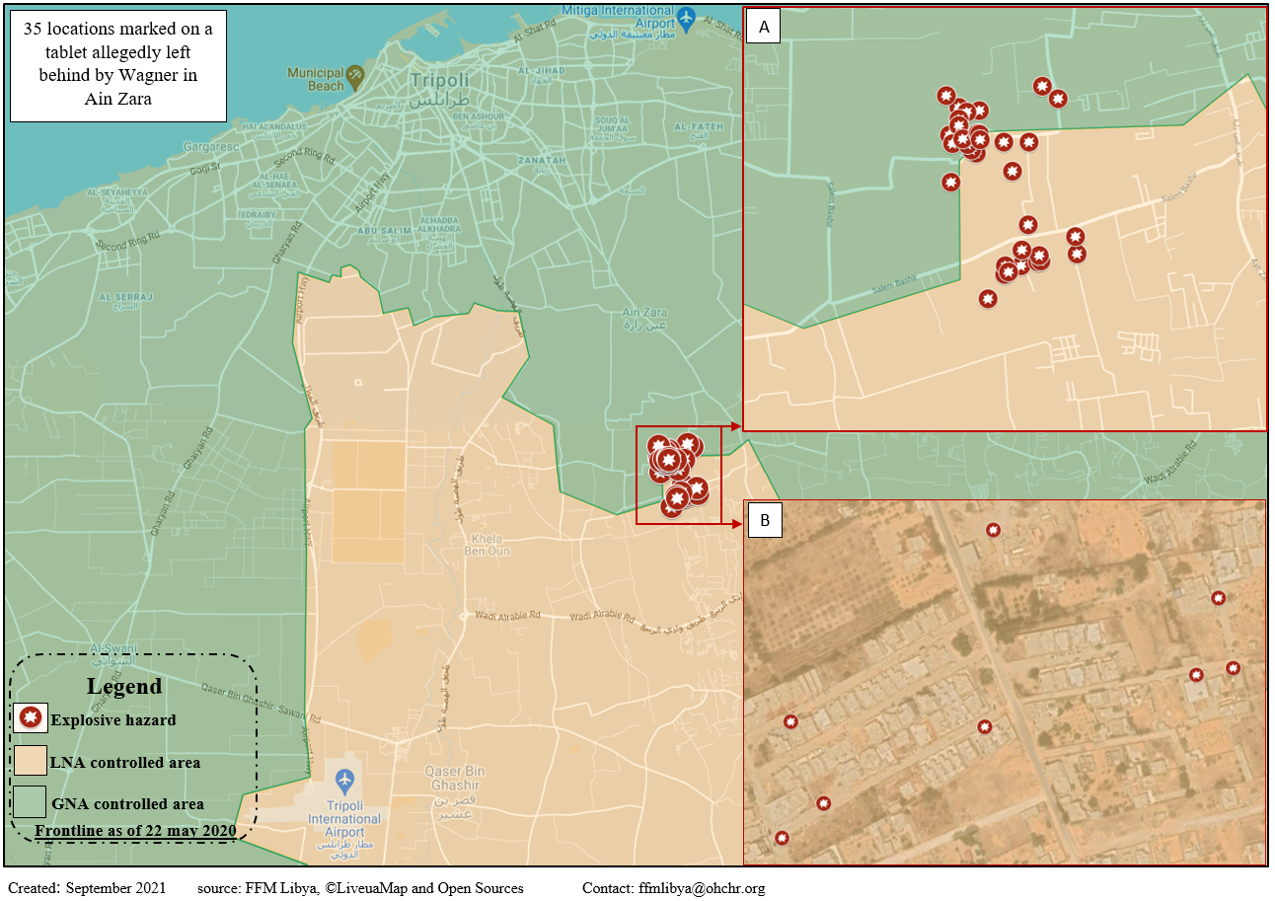
Figure 1

2. Ganfouda
40. From mid-2016 until March 2017, in the context of the non-international armed conflict between the Libyan National Army and a coalition of armed groups known as the Benghazi Revolutionaries Shura Council, the Libyan National Army and its affiliated armed groups surrounded the area of Ganfouda, near Benghazi. There are allegations that during the so-called siege on Ganfouda, civilians were killed and injured by strikes, civilian infrastructure was damaged, hundreds of civilians were trapped, without adequate access to water, food and medicine, and humanitarian aid was denied. There are also reports that in March 2017, the Libyan National Army did not allow the evacuation of males aged between 15 and 65. Attacks were launched against civilians fleeing Ganfouda, women were not allowed to wear the niqab to prevent men from escaping and some civilians were arbitrarily detained. The limited time available did not allow the Mission to ascertain the exact circumstances of all these incidents and additional investigations are required in order to comprehensively document the siege of Ganfouda.
41. The evidence established that in October 2016, in the area of Ganfouda, houses in which persons not taking a direct part in hostilities were living were struck by weapons launched by the Libyan National Army, resulting in injuries and deaths, including of women and children from different families. In view of the circumstances of the attacks, there are reasonable grounds to believe that the perpetrators were aware or should have been aware of the civilian status of the persons attacked. In conducting the airstrikes that resulted in civilian deaths and damage to civilian objects, the Libyan National Army may have violated the international humanitarian law principles of distinction, proportionality, and precautions in attack. The investigations also established that in March 2017, in the area of Ganfouda, corpses were desecrated and mutilated by fighters associated with the Libyan National Army. This conduct may amount to a violation of international humanitarian law and a war crime. The evidence established that the top leadership of the Libyan National Army directed forces under their control to show “no mercy” and to never consider “bringing a prisoner here”. The Mission considered that these orders and statements may amount to violations of international humanitarian law principles prohibiting denial of quarter as well as to a war crime.

3. Southern Libya
42. Tensions between the Al-Ahali and Tebu communities have been ongoing in southern Libya since 2011 and culminated in confrontations in 2019 between armed groups from both communities in the context of the broader non-international armed conflict between the Government of National Accord and the Libyan National Army. The Mission gathered credible indications that during this period, violations were committed against members of both communities, including abductions and mass killings. However, the evidence did not allow the Mission to reach definitive findings on all allegations and further investigations are needed in order to ascertain the exact circumstances of the incidents.
43. The investigations established that airstrikes conducted in August 2019 on a primarily Tebu residential area of Murzuq resulted in 42 civilian fatalities and a number of casualties. One airstrike hit very close to a civilian wedding location and was followed shortly afterwards by a second airstrike after first responders had attended. The building targeted was a government building in which more than 200 local dignitaries had gathered, none of whom were armed or directly participating in hostilities at the time of the attack. Two other airstrikes hit another district. It should have been obvious to the attackers that the area targeted was a civilian area and that striking a congregation of civilians at night was likely to result in a disproportionately high number of civilian casualties compared to any military advantage. The evidence provided reasonable grounds to believe that the strikes could be attributed to the Libyan National Army, noting that the exact role played by other actors remained to be ascertained. On the basis of the foregoing, the Mission considered that with regard to these airstrikes, the Libyan National Army may not have respected the international humanitarian law principles of distinction and proportionality and may not have taken appropriate precautions.

B. Extrajudicial killings
44. As part of the prevailing violence in Libya, State agents or affiliates routinely use killings non-compliant with the rule of law as a means of punishment or silencing. Such killings are a violation of the right to life, but they may also have a pervasive impact on other rights, such as the right to truth. The Mission noted that recently, a number of extrajudicial killings had targeted individuals suspected of involvement in serious human rights violations. In particular, the Mission investigated the killing in July 2021 of a suspect of and witness to atrocity crimes in Tarhuna, Mohammad al-Kani, who was shot during a raid on his residence in Benghazi by members of the Tarek Bin Ziad Brigade, a part of the Libyan National Army. There are reports that the Brigade was acting pursuant to an arrest warrant. Although Mr. Al-Kani appears to have been deliberately shot, investigations are ongoing into whether he was resisting arrest, or otherwise posed a threat to the perpetrators that would justify their use of lethal force. If evidence comes to light that the use of force was not justified, there may be reasonable grounds to find that the killing of Mr. Al-Kani was a case of extrajudicial killing. In any case, his killing, like others, deprives victims of violations of the opportunity to have the truth established. The Mission noted with concern that such incidents were taking place as Libya was making progress towards reconciliation. In the limited time available, the Mission faced challenges in the investigation of other extrajudicial killings. Further investigations are therefore warranted in order to comprehensively document the commission of extrajudicial killings since 2016.

C. Violations in the context of deprivation of liberty
45. Several reports have noted that many prisons in Libya are used by the State and/or armed groups to arbitrarily detain people considered to be a threat to their interests or views, and that violence is widely and systematically used against these people. The prisons investigated by the Mission in the limited time available included the following official and unofficial detention facilities: Mitiga and Ghniwa (in the Tripoli area), Al-Koweifya, Gernada and Tarik Bin Ziyed (in the Benghazi area), and Seket (ex-Ministry of Defence) and Al-Jawyah (ex-Ministry of Justice) (in the Misrata area). In addition to having reviewed reports from reliable sources, the Mission interviewed 31 men and 1 woman who had been detained at different times in these prisons, as well as 6 relatives of detained persons.
46. The evidence established that large numbers of people ended up in the above-listed prisons after having been abducted. Most of these prisoners have never been charged, convicted or sentenced to imprisonment following a fair and public hearing. Many are detained incommunicado, some in secret prisons that officially do not exist, sometimes for years without any prospect of release. The families of prisoners are not informed of the fate of their family member. Torture is an established feature of the prison system. The conditions of detention are characterized by a lack of hygiene, of adequate food and of medical care, as well as no separation between children and adults. The Mission documented several cases of deaths through summary execution, torture, starvation, unsanitary conditions and denial of medical care. Sexual violence is prevalent, particularly during interrogations, and takes different forms, including rape, the threat of rape, or coercion into engaging in sexual abuse against other inmates. Women find themselves particularly vulnerable, and the evidence also indicated that men were not spared from sexual violence.
47. The investigations established that the inhumane acts referred to above are committed against anyone considered to be a threat to the leadership of the State or to the interests and ideologies (including the religious or moral views) of militias. The victims are mostly civilians. The acts that they suffer within the prisons are not random incidents that can be traced back to individual guards or particular facilities. Rather, violence is systematically used against prisoners. Reliable reports indicate that thousands of inmates are held in the above-listed prisons, and it can reasonably be inferred from the testimonies received by the Mission that large numbers of prisoners are victims of violence. Based on the testimonies gathered by the Mission, as corroborated by reliable reports, there are reasonable grounds to believe that the prisons listed above and many others located across the country constitute a core element of a systematic and widespread attack against anyone opposing the interests of those running the prisons.

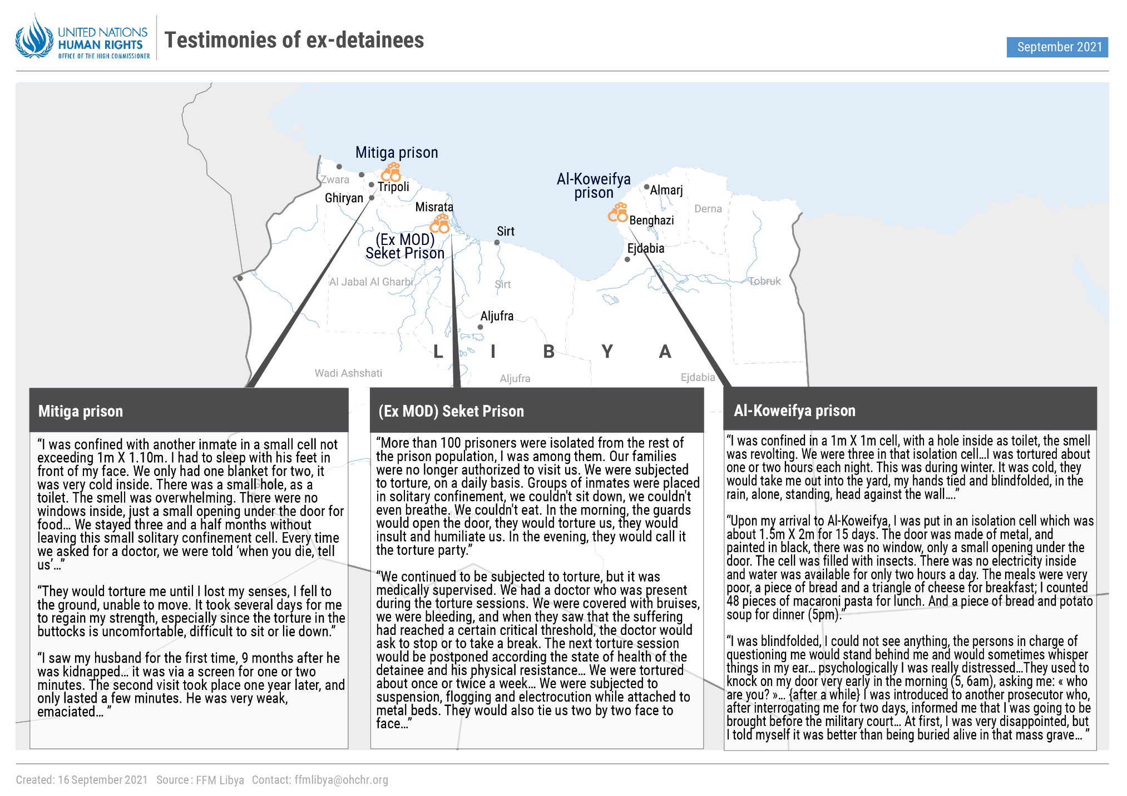
Figure 2

48. The Mission received information indicating that some of the above-mentioned prisons were controlled by the State via networks of militias. Some prisons appear to operate independently and others cooperate within informal networks. Regardless of the level of coordination between prisons, those managing them all implement within their walls a pattern of widespread and systematic use of violence. In addition to having participated directly in the commission of inhumane acts, Libyan authorities have abstained from holding perpetrators accountable for their conduct. Libya conceals violations in these prisons and many others from its population and the international community. It can reasonably be inferred from this deliberate failure to take action that the State acquiesces in the commission of torture in the prisons.
49. There are thus reasonable grounds to believe that acts of murder, torture, imprisonment, rape and enforced disappearance committed in the above-mentioned Libyan prisons are committed on such a scale, and with such a level of organization, that they amount, in and of themselves, to a systematic and widespread attack against the civilian population. As such, these acts may amount to crimes against humanity. Further investigations are required in order to establish the responsibility for these crimes.
50. In addition to the above, the Mission documented the presence of prisoners who had been captured from the frontlines by the State army or armed groups. The evidence established that these conflict-related prisoners were subjected to torture and other ill-treatment, sometimes on a daily basis, especially during the interrogation phase. Given that conflict-related prisoners no longer take direct part in hostilities, there are reasonable grounds to believe that the harm they suffered may amount to the war crimes of cruel treatment and torture.

D. Sexual and gender-based violence
51. Gender-based violence is any form of violence directed towards, or disproportionately affecting, someone because of their gender or sex. The investigations looked into the entire spectrum of gender-based violence in Libya, noting that such violence was deeply rooted and often hidden. The present section is concerned with sexual violence as a prominent form of gender-based violence. Other forms of gender-based violence are addressed in section G below.
52. As detailed elsewhere in the present report, vulnerable populations, such as migrants, asylum seekers, refugees and prisoners, are particularly at risk of sexual violence. Beyond the detention environment, there are credible indications that sexual violence is also used by State agents or members of militias as a subjugation or humiliation tool to silence those perceived to speak against their interests or appearing to challenge social norms or acceptable gender roles. Illustrative of this, the Mission received several reports that rights activists had been abducted and subsequently subjected to sexual violence to deter them from participating in public life. A certain idea of sexual and gender “normality” also appears to drive violence directed against people who identify themselves with a different sexual orientation or gender identity, as evidenced by cases of beatings and rape of LGBTQI people reported to the Mission. The evidence indicated that sexual violence took different forms: in addition to rape, women or men may be forced to strip naked, engage in sexual acts with others or witness others engaging in rape. Sexual violence is compounded by laws that criminalize rape as a crime against honour, or same-sex relations.
53. Unveiling sexual violence in the Libyan context is a trying task. Libya is a patriarchal society, whose culture overlaps with deeply rooted ideas of masculinity, militarism and elements of religious conservatism. As a corollary, sexuality is taboo and sexual violence carries with it social stigma. Perpetrators appear to abuse this to humiliate their victims. Survivors of sexual violence are scared or ashamed – and sometimes both – to report their case to the authorities or share their experience with others. Despite credible reports received by the Mission, the limited time available did not allow the Mission to reach definitive findings on cases and patterns of sexual violence outside the context of detention. Further investigations are required in order to fully document sexual violence in Libya.

E. Internally displaced persons
54. The prevailing insecurity in Libya has led to the internal displacement of hundreds of thousands of people who have ended up in areas ill-equipped to accommodate large population movements. For the present report, the Mission considered the situation of the Tawerghan community. Internal displacement also affects other communities, such as the Tebu and the Al-Ahali in southern Libya. The Mission received accounts that between February and August 2019, confrontations between the two latter communities had resulted in the displacement of the majority of inhabitants of Murzuq. An extension of the Mission’s mandate would allow investigations into these allegations and the addressing of internal displacement as a whole, following the report of the Special Rapporteur on the human rights of internally displaced persons.
55. Reports indicate that by mid-2011, the entire population of Tawergha, around 40,000 people, had fled attacks directed against them by militias of Misrata. The people of Tawergha, who belong to the ethnic group of the same name, were perceived to be pro-Gaddafi. The majority of Tawergha sought refuge in informal settlements around Tripoli and Benghazi. Full return to Tawergha has not yet materialized, despite an agreement reached to that effect between the Tawerghan and Misratan communities.
56. The evidence established that internally displaced Tawerghans faced dire living conditions in camps where they were hosted. They lack access to adequate medical care, food, water and sanitation, and their children have limited schooling opportunities. The investigations also established that in the camps where they stay, Tawerghans are subject to acts of violence (including killings, beatings, death threats, abductions, arbitrary detention and destruction of property) and that conditions for their return to Tawergha have not been met. Allegations of sexual violence and early marriages remain to be investigated. The Mission inferred from the enduring nature of the Tawergha situation that the State tolerates, acquiesces in and fails to provide protection from violence and abuses in camps. The Mission noted that the State had still not taken adequate measures to ensure the safe return of Tawerghans to their homes and that Tawerghans were still awaiting compensation for the destruction of their town. The Mission also found that the Tawerghans were persecuted, as the acts of violence described above had been motivated by a discriminatory purpose, due to the perceived association of Tawerghans with the Gaddafi regime as well as to the fact that they were Black Libyans. In the light of the foregoing, there are reasonable grounds to believe that Libya failed to guarantee the rights of internally displaced Tawerghans under international law.

F. Migrants
57. Libya has long been both a destination country and a departure point for those fleeing violence or poverty. Reports indicate that the human rights situation of migrants, asylum seekers and refugees in Libya has deteriorated since 2016. The evidence gathered by the Mission, which included interviews with 50 migrants, established that from the moment that migrants entered Libya destined for Europe, they were systematically subjected to a litany of abuses. However, in view of the time and resource constraints, the Mission focused on violations and abuses committed in Libya. The present report documents, in particular, the pattern of interceptions by the Libyan Coast Guard to ensure that disembarkation takes place in Libya, and the associated pattern of detaining migrants in detention centres run by the Department for Combating Illegal Migration (fig. 3), where they face intolerable conditions calculated to cause suffering and the desire to utilize any means of escape, including by paying large sums of money to militias, criminal gangs, traffickers and smugglers who have links to the State and profit from this practice.
58. Libyan law criminalizes irregular entry, stay and exit. The investigations established that a migrant’s journey to Europe would normally start with the migrant paying money to a smuggler, and subsequently boarding a boat. The Libyan Coast Guard would later proceed with an interception that was violent or reckless, resulting at times in deaths. There are reports that, on board, the Libyan Coast Guard confiscates belongings from migrants. Once disembarked, migrants are either transferred to detention centres or go missing, with reports that people are sold to traffickers. Interviews with migrants formerly held in detention centres of the Department for Combating Illegal Migration established that all migrants – men and women, boys and girls – were kept in harsh conditions, some of whom die. Some children are held with adults, placing the children at high risk of abuse. Torture (such as electric shocks) and sexual violence (including rape and forced prostitution) are prevalent. Although the detention of migrants is founded in Libyan domestic law, migrants are detained for indefinite periods without an opportunity to have the legality of their detention reviewed, and the only practicable means of escape is by paying large sums of money to the guards or engaging in forced labour or sexual favours inside or outside the detention centre for the benefit of private individuals. Several interviewees recounted that they had endured the same cycle of violence, in some cases up to 10 times, of paying guards to secure their release, taking part in an attempt at crossing the sea, being intercepted and subsequently being returned to detention in harsh and violent conditions, all while under the absolute control of the authorities, militias and/or criminal networks. There is also evidence that most of the migrants detained are sub-Saharan Africans and that they are treated in a harsher manner than other nationalities, which suggests discriminatory treatment.
59. Migrants form an identifiable group of individual civilians defined by their vulnerability and absence of legal status within Libya. The commission of the above acts has been long-standing and on a massive scale. Based on reports of reliable organizations, the Mission established that since 2016, some 87,000 migrants had been intercepted by the Libyan Coast Guard, and that there were currently close to 7,000 migrants in detention centres of the Department for Combating Illegal Migration, including large percentages of children. Furthermore, the acts referred to above are not isolated incidents that can be attributed to rogue elements: they form part of a pattern characterized by dangerous operations at sea followed by a systematic transfer to a detention centre where migrants are kept for an indefinite period of time and where they are subjected to intolerable conditions that cause suffering and prompt them to utilize any means of escape, including paying money.
60. Since the inception of boat pullbacks in the Mediterranean Sea, Libyan authorities have been on notice regarding the widespread and systematic nature of the reckless interceptions at sea and the abuses within the centres. Rather than investigating incidents and reforming practices, the Libyan authorities have continued with interception and detention of migrants. The absence of accountability for abuses against migrants evidences a State policy encouraging the deterrence of sea crossings, extortion against migrants in detention, and subjection to violence and discrimination. Militias (some of which manage detention centres), criminal networks, traffickers and smugglers contribute to the implementation of this policy.
61. The foregoing provides reasonable grounds to believe that acts of murder, enslavement, torture, imprisonment, rape, persecution and other inhumane acts committed against migrants form part of a systematic and widespread attack directed at this population, in furtherance of a State policy. As such, these acts may amount to crimes against humanity. This finding is made notwithstanding the responsibility that may be borne by third States, and further investigations are required in order to establish the role of all those involved, directly or indirectly, in these crimes.
62. The Mission also investigated two incidents endangering the life of migrants. In May and July 2019, during the non-international armed conflict in Tripoli, a detention centre located next to the headquarters of the Daman Brigade in Tajoura was struck twice. Dozens of deaths were reported and the authorities failed to take any action after the first strike. By failing to remove the prisoners from the vicinity of a potential military objective, the Daman Brigade and the Government of National Accord (with which the Brigade was affiliated) may have violated their international humanitarian law obligation to protect civilians under their control from the effects of attack. The latter may have also violated the right to life of the migrants, by preventing them from seeking shelter following the first airstrike. Furthermore, there are reasonable grounds to believe that the party responsible for the airstrikes may have violated the principles of distinction and proportionality as well as the obligation to take precautions in attack. On 20 June 2021, an accidental explosion in what was believed to be an ammunition depot in close proximity to the Abu Rashada detention centre in Gharyan caused the death of dozens of detained persons. Given that the guards prevented migrants from fleeing the building following the explosion, thereby preventing them from seeking safety, there are reasonable grounds to believe that the right to life of the migrants may have been violated.

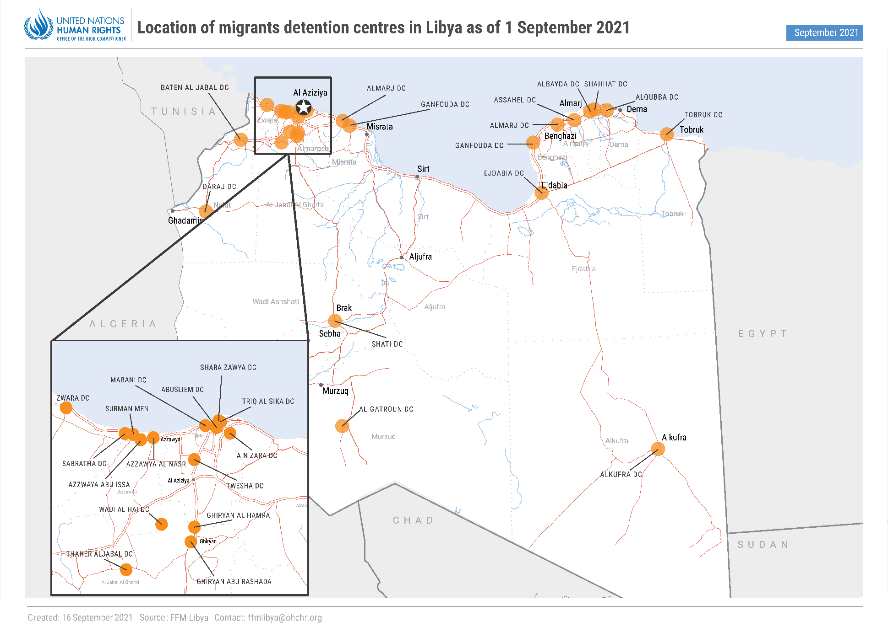
Figure 3

G. Women
63. Women in Libya have been disproportionately affected by the continuing conflict and the proliferation of militias. While women contribute positively to public life in Libya, there have been several attempts to silence prominent women figures through violence (including through online incitement to violence), which have had a chilling effect on women’s engagement in civic space at a time where the future of Libya is being shaped. Libya has failed to prevent and punish violent acts against women, an obligation which is incumbent on it even for a private act. Two cases falling within the Mission’s mandate have had a particular resonance: the disappearance of Sihem Sergiwa and the killing of Hanan al-Barassi. These cases appear to be part of a continuing pattern of singling out criticism coming from women as intolerable, however diverse their views are.
64. On 17 July 2019, Sihem Sergiwa, a member of the House of Representatives, was abducted at her home by uniformed men. The evidence indicated that she had been abducted by either the Libyan National Army or affiliated armed groups, and that the latter had failed to provide information on her fate. The Mission received conflicting reports as to her fate, but it was unable to verify such claims. Ms. Sergiwa’s abduction and the circumstances surrounding it have removed her from the protection of the law, placing her life at serious and constant risk. In these circumstances, there are reasonable grounds to believe that she is a victim of enforced disappearance. Furthermore, there was no evidence that the relevant authorities had conducted an effective investigation into Ms. Sergiwa’s disappearance or that they had adequately apprised the family of the efforts undertaken to find her, which had caused anguish and distress. Likewise, there was no evidence that the relevant authorities had provided effective protection for Ms. Sergiwa, whose life was at risk due to her profile and as a result of specific threats. The Mission therefore found that the relevant authorities had failed to protect Ms. Sergiwa’s life, to protect her family from cruel and inhuman treatment, to protect her from arbitrary arrest, to ensure her right to be recognized as a person before the law and to protect her and her family from unlawful interference with their privacy.
65. On 10 November 2020, Hanan al-Barassi, a lawyer who was critical of the Libyan National Army, among others, was gunned down in broad daylight in Benghazi by two unidentified masked men. No one has claimed responsibility for her killing. The evidence did not lead the Mission to establish who the perpetrators had been and whether they had acted in an official capacity. Nevertheless, prior to her killing, her life was at risk because of her profile and as a result of specific threats received a few days before her killing. The interior ministry of the government in the east of the country (Benghazi) ordered all security agencies to identify the perpetrators and the justice ministry of the Government of National Accord announced that the authorities would open an investigation. However, the investigation is not progressing and no one has been held accountable. The Mission noted with concern that Ms. Al-Barassi’s daughter had been detained from 25 March to 28 June 2021 by Libyan National Army-affiliated forces on allegations of involvement in the assassination of Mahmoud al-Werfalli. In these circumstances, there are reasonable grounds to believe that the State may have failed to meet its obligations under the International Covenant on Civil and Political Rights and the Convention on the Elimination of All Forms of Discrimination against Women by failing to provide effective protection for Ms. Al-Barassi and by not conducting, to date, an effective investigation and prosecuting those responsible for her murder.

H. Children
66. Children of all ages have been impacted in different ways by the violence in Libya since 2016. Children have been killed in hostilities, many schools have been destroyed and some children have to live without the presence of parents who have been abducted. Violations and abuses suffered by children in Libya often remain unseen. The present report focuses on two areas: the alleged recruitment and use of children by parties to conflicts, and the arbitrary detention of children in hostilities. Other violations or abuses against children will be the subject of future investigations.
67. The evidence established that from late 2019, Turkey facilitated the recruitment of Syrian children between 15 and 18 years of age (which was evident based on their appearance) to fight alongside the Government of National Accord against the Libyan National Army in exchange for payment. These child mercenaries were utilized for different functions, including in combat units, and with some in support roles, such as guards. Many were confined if they disobeyed, and some of them were wounded. There are reasonable grounds to believe that Libya may have failed to comply with its obligations under the African Charter on the Rights and Welfare of the Child, which prohibits both the recruitment of children and the direct participation of children in hostilities, including into groups not part of the State’s armed forces. There are also reasonable grounds to believe that Libya may have failed to comply with its obligations under the Optional Protocol to the Convention on the Rights of the Child on the involvement of children in armed conflict, which mandates States parties to take all feasible measures to ensure that children under their jurisdiction who are used in hostilities are demobilized or released from service. Furthermore, both Libya and Turkey may have violated their obligations, under the Optional Protocol to the Convention on the Rights of the Child on the involvement of children in armed conflict, to prevent the recruitment and use of children to take part in hostilities. The Mission came across further allegations of child recruitment and direct participation in hostilities, but additional time would be required for investigations.
68. In the course of its investigations into the Libyan prison system, the Mission paid particular attention to the fate of children held in detention, including children of parents associated with the Da’esh group, many of whom had been arbitrarily detained since 2016, due to, inter alia, the refusal of their country of origin to accept them back. The evidence established that across Libya, children were detained together with adults (thereby increasing risks of violence, including sexual violence), were subjected to the same harsh conditions of detention (with an impact on their growth), and suffered beatings and torture. Several children have been held for prolonged periods without charge or trial. Some have also been denied regular contact with their mothers held in the women’s wing. Such treatment may amount to violations of the principle of the best interests of the child, and of a number of provisions of the Convention on the Rights of the Child relating to the arbitrary detention of children, to the prohibition of torture and to separation from adults, as well as violations of the United Nations Standard Minimum Rules for the Treatment of Prisoners (the Nelson Mandela Rules) and the United Nations Rules for the Treatment of Women Prisoners and Non-custodial Measures for Women Offenders (the Bangkok Rules).

I. Tarhuna
69. Several reports have emerged regarding crimes committed in recent years in the town of Tarhuna (south-east of Tripoli), which have included widespread abductions, systematic torture and mass murders, including of women targeted for their family links. These reports implicate members of the family who ruled the town until recently, the Al-Kaniyat. The Al-Kaniyat led an armed faction, which first aligned with the Tripoli government (in 2014–2018) and subsequently with the Libyan National Army (in 2019 and 2020). Some leading figures of Al-Kaniyat have been reported dead, as documented above in paragraph 53.
70. The Mission considered the events of Tarhuna to be a priority area of investigation. It conducted a site visit in July 2021, interviewed first-hand witnesses and gathered documentary evidence, including forensic reports and satellite imagery. The information collected revealed an extremely complex setting. The period that witnessed the alleged crimes spanned many years and also coincided with the armed confrontations that took place in the broader Tripoli area in 2019 and 2020. The Mission received credible indications that the crimes had resulted in a high number of victims, including women and children. In the context of a patriarchal society, several families continue to suffer from the absence of relatives reported missing, with women having become heads of households and breadwinners and children bearing the loss of their parents. The motivations underlying the crimes appear to be multifaceted and must be understood against the backdrop of the shifting alliances of Al-Kaniyat.
71. The Mission documented a number of disappearances, including that of Abubaker Naama, who was abducted in November 2019 by men linked to Al-Kaniyat. His whereabouts remained unknown to his family until recently when Libyan forensic experts identified his body buried in what appeared to be a mass grave. The Mission independently reviewed the forensic report and found reasonable grounds to believe that Mr. Naama had been blindfolded and summarily executed. In connection with this, the Mission identified seven sites in the area of Tarhuna where there appeared to have been soil disturbance for short periods of time towards the end of 2019 and in the beginning of 2020 (fig. 4), which strongly suggests the digging of graves. The Mission received information indicating a number of disappearances during the same time frame. It also obtained information regarding other potential mass grave sites.
72. The Mission collected detailed accounts of persons who, following their abduction by Al-Kaniyat associates, had been kept against their will in places where they had endured severe beatings and lived under harsh conditions. The Mission additionally gathered information regarding abductions and killings of children and the recruitment of children to directly participate in hostilities.
73. While the above provides credible indications that widespread and systematic human rights violations were committed in Tarhuna, further investigations are needed in order to establish the exact circumstances of the incidents and identify the perpetrators. Libyan authorities are currently investigating the Tarhuna events, and the situation has also garnered the attention of other reporting and accountability mechanisms. The gravity of the allegations calls for concerted investigative efforts on the part of the international community.

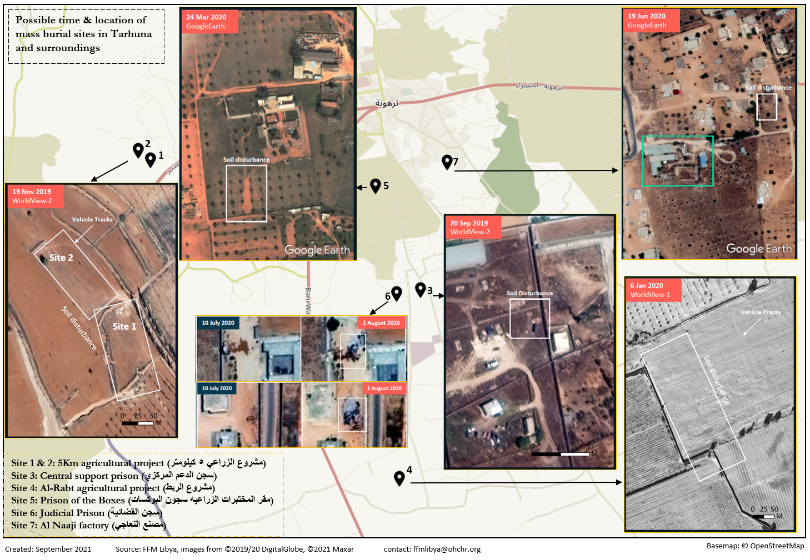
Figure 4

IV. Accountability
74. The Mission engaged with Libyan judicial authorities – civil and military – with a view to reporting on the efforts of Libya to ensure accountability for violations of international human rights law and international humanitarian law. The Mission noted that a number of arrest warrants had been issued in respect of violations, abuses and crimes committed since 2016, evincing an intent to bring alleged perpetrators to justice. Yet, political considerations appear to hamper the enforcement of these warrants. Moreover, when asked whether they had laid complaints, several victims expressed fears for their safety and that of their families.
75. Challenges in ensuring accountability are also structural. Divisions between governmental and security apparatuses in the west and the east, a security vacuum in the south, the presence of criminal groups throughout the country, and the Government’s lack of capacity and limited reach outside of western Libya, have severely weakened the judicial system and have inhibited the ability of Libya to prosecute human rights violations. The Mission also noted that in certain cases, the civil and military judicial authorities claimed concurrent jurisdiction over the same incidents, thus leading to overlaps and duplication of efforts.
76. Furthermore, accountability encompasses the right to an effective remedy for human rights violations. Although the Constitutional Declaration of 2011 provided the right to recourse to the judiciary for each Libyan citizen, the Libyan judicial system still does not have the capacity to provide citizens with access to civil remedies for human rights violations.
77. With the recent installation of the Government of National Unity, the time is ripe for accountability to become effective. Libyan authorities have advised the Mission that they are in need of technical assistance and cooperation to increase their capacity to prosecute human rights violations and international crimes.

V. Conclusions
78. The violence which has plagued Libya since 2011, and which has continued almost unabated since 2016, has enabled the commission of serious violations, abuses and crimes, including crimes against humanity and war crimes, against the most vulnerable. The Mission noted with concern that several incidents had taken place since it had been established in June 2020. For the present report, the Mission focused its investigations on certain incidents representative of broader trends and patterns of violations and crimes. Despite the limited scope of the Mission’s investigations to date, the findings unveil a dire human rights situation, some aspects of which are rooted in causes beyond the armed conflicts. A comprehensive investigation into the human rights situation by the Mission as a whole is urgently needed.
79. Mindful of the need to ensure justice for victims, the Mission has identified individuals and groups (both Libyan and foreign actors) who may bear responsibility for the violations and abuses under investigation. In view of the complexity of the situation, additional time and resources are required in order to establish individual and State responsibility for all violations occurring since 2016.

VI. Recommendations
80. The Mission calls upon Libya to:
(a) Ensure that: (i) all reported cases of enforced disappearance are investigated effectively; (ii) families are apprised of the whereabouts of their relatives who have been reported missing; (iii) missing persons are released; (iv) perpetrators are held accountable; and (v) victims and families are compensated for the damage they have suffered;
(b) Ensure that: (i) internally displaced persons can safely return to their places of origin; (ii) internally displaced persons benefit from support in the areas they have been displaced to; (iii) perpetrators of violations against internally displaced persons are held accountable; and (iv) internally displaced persons have access to compensation for property losses;
(c) Ensure that operations at sea are conducted in accordance with international law; amend the law criminalizing illegal entry, stay and exit; release all migrants arbitrarily detained and explore non-custodial alternatives to detention of migrants; ensure that migrants are protected from all forms of violence, including sexual violence; and ensure that the perpetrators of violations against migrants are held accountable;
(d) Ensure that everyone is protected from sexual violence; hold to account perpetrators of sexual violence; and remove legal impediments preventing survivors from reporting incidents;
(e) Hold to account perpetrators of killings and enforced disappearances of women; and ensure protection for human rights defenders, journalists and activists;
(f) Ensure that: (i) the management of all prisons falls under the responsibility of the State; (ii) prisoners can have their detention reviewed in accordance with the law; (iii) prisoners are held in dignified conditions and protected from violence; and (iv) perpetrators of violations committed against prisoners are held accountable;
(g) Immediately end the arbitrary detention of all children in Libya; release from detention, and facilitate, to the extent possible, the voluntary return of women and children allegedly associated with Da’esh; criminalize the recruitment and use of children by armed groups; prevent the recruitment and use of child mercenaries; and ensure that no children take direct part in hostilities;
(h) Provide effective remedies to victims, including reparations;
(i) Ensure that perpetrators of violations of international humanitarian law and war crimes are prosecuted;
(j) Ensure compliance with international humanitarian law during the conduct of hostilities, by all parties;
(k) Ensure that all those present in Libya as mercenaries or foreign fighters are held accountable for violations they have committed; and refrain from further recruitment and use of mercenaries, in keeping with the international treaty obligations of Libya;
(l) Ensure that: (i) all anti-personnel mines and booby traps are removed; and (ii) all those who have violated international humanitarian law with respect to such weapons are held accountable;
(m) Take steps to ratify the International Convention for the Protection of All Persons from Enforced Disappearance, the Convention relating to the Status of Refugees, of 1951, the Anti-Personnel Landmines Convention, of 1999, and the Rome Statute of the International Criminal Court; and ensure that national legislation is aligned with their provisions;
(n) Reform the Penal Code to encompass violations of international humanitarian law and war crimes; and revise the decree regulating the work of NGOs;
(o) Ensure that accountability forms part of the reconciliation process.
81. The Mission additionally calls upon the members of the international community to:
(a) Bring to justice all individuals under their jurisdiction who are suspected of having committed violations in Libya, including mercenaries and foreign fighters;
(b) Provide technical support to the Libyan authorities in the prosecution of violations, including in particular the Tarhuna crimes;
(c) Ensure that all agreements with Libyan authorities comply with international human rights law and international humanitarian law, particularly on the issue of migration.
82. The Mission finally urges the Human Rights Council to:
(a) Consider extending the Mission’s mandate for a period of time commensurate with the mandate’s breadth; and encourage Libya to continue to fully cooperate with the Mission.

Annex I

Mandate
1. Ratione materiae: The Human Rights Council (“Council”) requested the Mission to investigate violations and abuses of both international human rights law (“IHRL”) and international humanitarian law (“IHL”). Resolution 43/39 made no mention of crimes under international criminal law (“ICL”); however, IHRL and IHL underpin this body of law, and the Mission considered it crucial to the fulfilment of its mandate to additionally investigate crimes punishable under ICL (A/HRC/12/48, para.286; A/HRC/38/CRP.1, para.8). In this regard, the Mission noted that the Office of the Prosecutor of the International Criminal Court (“ICC”) has investigated the situation in Libya since 15 February 2011 further to a referral by the United Nations Security Council and that its investigations extend to events falling within the Mission’s temporal mandate.
2. Ratione temporis: The Council mandated the Mission to focus on alleged violations and abuses “since the beginning of 2016”. The Mission considered that its mandate also encompassed the investigation of continuing violations and abuses that commenced before 2016.
3. Ratione loci: Resolution 43/39 provided that the Mission should document violations and abuses committed “in Libya”. The Mission interpreted this to mean that it had a mandate to investigate, first and foremost, violations and abuses committed on Libyan territory, which includes its territorial sea. Noting the methodology adopted by previous fact-finding mechanisms (A/HRC/25/CRP.1, para.20 and fn.8), the Mission considered that its mandate also extended to the documentation of acts that commenced beyond Libyan borders but continued inside Libyan territory.
4. Ratione personae: Resolution 43/39 referred to violations and abuses committed by “all parties”. In view of this, the Mission considered that its investigations should cover the conduct of both State and non-State actors, including foreign State and non-State actors.
5. Noting that the Council called on the Mission to preserve evidence “with a view to ensuring that perpetrators […] are held accountable”, the Mission considered it part of its mandate to identify those who could bear responsibility for the violations and abuses under investigation. Additionally, the mandate allowed for a focus not only on individual responsibility but also on State responsibility, as the latter remains at the forefront of IHRL.
6. Finally, the Council requested the Mission to document the gendered dimensions of the violations and abuses under investigation. Gender analysis strengthens human rights investigations in making visible violations and abuses that are otherwise invisible due to the persistence of gendered discrimination or stereotypes, in uncovering the deeper roots and effects of violence, and in formulating recommendations that are tailored to the needs of those impacted by violations by virtue of their gender or sexual orientation. The Mission applied a gender sensitive approach to all aspects of its work, giving due regard to the fact that the root causes of violence may be multifactorial.

Annex II

Applicable law

General legal framework
1. International human rights law (“IHRL”) is the body of international law, stemming from treaties or custom, which requires States to respect, protect and fulfil human rights at all times. Libya is party to twelve of the eighteen core human rights treaties as well as to a number of regional instruments (Annex III). Some soft law instruments also assist in delineating human rights obligations (Annex IV). While IHRL obligations apply to States in the first instance, the Mission concurred with the approach of the International Commission of Inquiry on Libya, which examined human rights violations by non-State actors noting that “it is increasingly accepted that where non-State groups exercise de facto control over territory, they must respect fundamental human rights of persons in that territory” (A/HRC/17/44, para. 62).
2. International humanitarian law (“IHL”) is the body of international law, stemming from treaties or custom, that regulates the conduct of all parties engaged in an armed conflict. Libya is a party to the instruments listed in Annex V. Given that the alleged violations of IHL all took place in the context of either an armed conflict opposing the Libyan state’s armed forces against a non-State armed group, or an armed conflict involving two or more non-State armed groups, the Mission considered customary and treaty rules of IHL as applicable to non-international armed conflicts.
3. International criminal law (“ICL”) establishes individual criminal responsibility for categories of conduct constituting international crimes, such as genocide, crimes against humanity and war crimes. These crimes descend from IHRL and/or IHL and are notably defined in the Rome Statute of the International Criminal Court (“ICC”). As noted in the report, the Libyan situation is currently investigated by the Office of the Prosecutor of the ICC. Considering the convergences between the ICC’s jurisdiction and the Mission’s mandate, the Mission rooted its analysis of potential international crimes in accordance with the Rome Statute and the ICC Elements of Crimes.

Crimes against humanity
4. The crime of murder under ICL requires unlawfully causing the death of a person. The perpetrator must either act with the intent to cause such death or serious injury or with awareness that death will be the consequence of his/her conduct. Murder may encompass executions, but also deaths resulting from torture, starvation, unsanitary conditions and denial of medical care.
5. Enslavement is understood to be the exercise of any or all of the powers attaching to the right of ownership over a person and includes the exercise of such power in the course of trafficking in persons, in particular women and children.
6. Imprisonment in violation of fundamental rules of international law includes detention that fails to respect the basic principles of due process. These principles are enshrined in Articles 9 and 14 of the International Covenant on Civil and Political Rights. The requisite level of gravity is reached when persons are detained for long periods of time without ever being brought before an independent judge or being charged, tried or duly convicted for any crime.
7. The Rome Statute defines torture as the intentional infliction of severe pain or suffering, whether physical or mental, upon a person in the custody or under the control of the perpetrator. Intentionally subjecting persons to extremely inhumane conditions of detention with the intention of intimidating and punishing them may reach the threshold of torture.
8. The Rome Statute criminalizes rape, sexual slavery, enforced prostitution, forced pregnancy, enforced sterilization, or any other form of sexual violence of comparable gravity.
9. Persecution requires the conduct to have been committed in connection with another crime against humanity and that the perpetrator targeted the victims on political, racial, national, ethnic, cultural, religious, gender or other grounds that are universally recognized as impermissible under international law.
10. ICL defines enforced disappearance as the arrest, detention or abduction of persons by or with the authorization, support or acquiescence of a state or a political organization, followed by a refusal to acknowledge that deprivation of freedom or to give information on the fate or whereabouts of those persons, with the intention of removing them from the protection of the law for a prolonged period of time.
11. The category of ‘other inhumane acts’ requires the same threshold of the other listed crimes in terms of nature, scale and gravity. The Mission considered that actions preventing migrants to leave Libya, which infringe on the internationally recognized right to leave and may cause great suffering, may be categorized as other inhumane acts within the meaning of article 7 of the Rome Statute. The Mission adopted a similar view regarding omissions in rendering assistance to migrants in distress at sea, which highlight a failure to comply with the duty to protect the lives of individuals under the State’s control and may result in great harm to the victims.

Mercenarism
12. Two specific mercenary international conventions regulate ‘mercenarism’: the International Convention against the Recruitment, Use, Financing, and Training of Mercenaries (to which Libya accessed in September 2000) (“UN Mercenary Convention”) and the Convention for the Elimination of Mercenarism in Africa (to which Libya accessed in May 2005) (“African Mercenary Convention”). The purpose of these conventions is not to regulate the behaviour and status of mercenaries but to eliminate them via criminalization. Under the UN Mercenary Convention, a ‘mercenary’ is a person who: (i) is specially recruited locally or abroad in order to fight in an armed conflict; (ii) is motivated to take part in the hostilities essentially by the desire for private gain; (iii) is not a national of a party to the conflict; (iv) is not a member of the armed forces of a party to the conflict; and (v) has not been sent by a State which is not a party to the armed conflict on official duty as a member of its armed forces. The African Mercenary Convention additionally requires direct participation in hostilities.

Extrajudicial killings
13. An extrajudicial killing occurs when: (1) a public official or other person acting at the instigation of or with the consent or acquiescence of a public official or other person acting in an official capacity; (2) whose acts were intentional or negligent; and (3) resulted in one or more deaths; and (4) who knew or should have known that death may result from their acts; and (5) who failed to comply with any relevant standards regarding the use of force, including the principles of necessity, distinction, proportionality, and precaution; and (6) whose acts were not authorized by legal process or complied with the rule of law.

Enforced disappearances
14. Libya is not party to the International Convention for the Protection of All Persons from Enforced Disappearance. However, it is party to the International Covenant on Civil and Political Rights and the Convention against Torture, which protect a number of rights that are constitutive of enforced disappearance. The Covenant and the Convention impose a duty on Libya to criminalize, investigate, prosecute, punish, and provide reparation and remedies for such violations. While the Covenant does not explicitly use the term “enforced disappearance” in any of its articles, enforced disappearance constitutes a unique and integrated series of acts that represents a continuing violation of various rights, such as the right to life, the right not to be subjected to torture or other cruel, inhuman or degrading treatment or punishment, and the right to liberty and security of person. The Mission applied the following definition of ‘enforced disappearance’: (1) the arrest, detention or abduction of persons; (2) by, or with the authorization, support or acquiescence of, a State or a political organization; (3) followed by a refusal to acknowledge that deprivation of freedom or to give information on the fate or whereabouts of those persons; (4) with the intention of removing them from the protection of the law for a period of time. De facto authorities whose authority is comparable to governmental authorities exercising effective control over a territory may be considered potential perpetrators of enforced disappearances under IHRL.

Violence against women
15. In a recent case concerning a Libyan woman, the Committee on the Elimination of Discrimination against Women (“Committee”) recalled that under article 2-e of the Convention on the Elimination of All Forms of Discrimination against Women, States parties may also be responsible for private acts if they fail to act with due diligence to prevent violations of rights or to investigate and punish acts of violence, and for providing compensation (CEDAW/C/78/D/130/2018, para. 6.3). The Committee further expanded that “[t]he failure of a State party to take all appropriate measures to prevent acts of gender-based violence against women in cases in which its authorities are aware or should be aware of the risk of such violence, or the failure to investigate, prosecute and punish perpetrators and provide reparations to victims/survivors of such acts, provides tacit permission or encouragement to perpetrate acts of gender-based violence against women. Such failures or omissions constitute human rights violations” (ibid.).

Migrants, refugees and asylum seekers
16. Consistent with the methodology of the Office of the United Nations High Commissioner for Human Rights (“OHCHR”), the Mission used the expression ‘migrant’ to cover the categories of migrant, refugee or asylum seeker, as well as any person who is outside a State of which s/he is a citizen or national, or, in the case of a stateless person, his or her State of birth or habitual residence, trafficked persons, smuggled migrants, and other categories, unless specified otherwise (“Desperate and Dangerous: Report on the human rights situation of migrants and refugees in Libya”, 20 December 2018, available at: https://www.ohchr.org/Documents/Countries/LY/LibyaMigrationReport.pdf (last accessed on 6 October 2021)).

Annex III

List of instruments of international human rights law which Libya is a party to
1. International Convention on the Elimination of all Forms of Racial Discrimination (since 1968);
2. International Covenant on Civil and Political Rights (since 1970);
3. OAU Convention Governing the Specific Aspects of Refugee Problems in Africa (since 1981);
4. Optional Protocol to the International Covenant on Civil and Political Rights (since 1989);
5. International Covenant on Economic, Social and Cultural Rights (since 1970);
6. African Charter on Human and Peoples’ Rights (since 1986);
7. Convention on the Elimination of All Forms of Discrimination against Women (since 1989);
8. Optional Protocol to the Convention on the Elimination of All Forms of Discrimination against Women (since 2004);
9. Convention against Torture and Other Cruel Inhuman or Degrading Treatment or Punishment (since 1989);
10. Convention on the Rights of the Child (since 1993);
11. African Charter on the Rights and Welfare of the Child (since 2000);
12. Optional Protocol to the Convention on the Rights of the Child on the Involvement of Children in Armed Conflict (since 2004);
13. Optional Protocol to the Convention on the Rights of the Child on the Sale of Children, Child Prostitution and Child Pornography (since 2004);
14. International Convention on the Protection of the Rights of All Migrant Workers and Their Families (since 2004);
15. Convention on the Rights of Persons with Disabilities (since 2018).

Annex IV

List of “soft law” instruments of international human rights law which guided the Mission
1. Declaration on the Protection of Women and Children in Emergency and Armed Conflict (1974);
2. Cairo Declaration on Human Rights in Islam (1990);
3. Basic Principles on the Use of Force and Firearms by Law Enforcement Officials (1990);
4. Declaration on the Protection of all Persons from Enforced Disappearance (1992);
5. Guiding Principles on Internal Displacement (1998);
6. Declaration on the Right and Responsibility of Individuals, Groups and Organs of Society to Promote and Protect Universally Recognized Human Rights and Fundamental Freedoms (Declaration on Human Rights Defenders) (1999);
7. Protocol to Prevent, Suppress and Punish Trafficking in Persons Especially Women and Children, supplementing the United Nations Convention against Transnational Organized Crime (2000);
8. Protocol against the Smuggling of Migrants by Land, Sea and Air, supplementing the United Nations Convention against Transnational Organized Crime (2000);
9. Updated Set of Principles for the Protection and Promotion of Human Rights through Action to Combat Impunity (2005);
10. Basic Principles and Guidelines on the Right to a Remedy and Reparation for Victims of Gross Violations of International Human Rights Law and Serious Violations of International Humanitarian Law (2005);
11. United Nations Rules for the Treatment of Women Prisoners and Non-Custodial Measures for Women Offenders (the Bangkok Rules) (2010);
12. United Nations Standard Minimum Rules for the Treatment of Prisoners (the Nelson Mandela rules) (2015).

Annex V

List of instruments of international humanitarian law which Libya is a party to
1. Convention for the Protection of Cultural Property in the Event of Armed Conflict (since 1954);
2. Convention (I) for the Amelioration of the Condition of the Wounded and Sick in Armed Forces in the Field (since 1956);
3. Convention (II) for the Amelioration of the Condition of Wounded, Sick and Shipwrecked Members of Armed Forces at Sea (since 1956);
4. Convention (III) relative to the Treatment of Prisoners of War (since 1956);
5. Convention (IV) relative to the Protection of Civilian Persons in Time of War (since 1956);
6. Protocol for the Protection of Cultural Property in the Event of Armed Conflict (since 1957);
7. Protocol for the Prohibition of the Use of Asphyxiating, Poisonous or Other Gases, and of Bacteriological Methods of Warfare (since 1971);
8. Protocol Additional to the Geneva Conventions of 12 August 1949, and relating to the Protection of Victims of International Armed Conflicts (Protocol I) (since 1978);
9. Protocol Additional to the Geneva Conventions of 12 August 1949, and relating to the Protection of Victims of Non-International Armed Conflicts (Protocol II) (since 1978);
10. Convention on the Prohibition of the Development, Production and Stockpiling of Bacteriological (Biological) and Toxin Weapons and on their Destruction (since 1982);
11. Convention on the Prohibition of the Development, Production, Stockpiling and Use of Chemical Weapons and on their Destruction (since 2004);
12. Second Protocol to the Hague Convention of 1954 for the Protection of Cultural Property in the Event of Armed Conflict (since 2011).

* The present report was submitted after the deadline so as to reflect the most recent developments.
** The annexes to the present report are circulated as received, in the language of submission only.
Human Rights Council resolutions S-15/1, para. 11; 17/17, para. 14; and 28/30, para. 18.
The applicable legal framework is detailed in annex II.
See https://extranet.who.int/ssa/Index.aspx.
Arts. 11 and 12 of Protocol II Additional to the Geneva Conventions of 1949.
Art. 8 (2) (e) (ii) and (iv) of the Rome Statute.
A twenty-sixth student committed suicide after the incident.
Common art. 3 to the Geneva Conventions of 1949; and art. 13 (2) and (3) of Protocol II Additional to the Geneva Conventions of 1949.
Art. 8 (2) (e) (i) of the Rome Statute.
Art. 13 (2) of Protocol II Additional to the Geneva Conventions of 1949.
Art. 8 (2) (e) (i) of the Rome Statute.
Customary International Humanitarian Law – Volume I: Rules, pp. 62–65 (rule 20).
Annex II, para. 12.
See https://www.bbc.com/news/world-africa-58009514.
Art. 8 (2) (c) (i) of the Rome Statute.
The principle of proportionality in attack is inherent to the principle of humanity, as enshrined in the preamble to Protocol II Additional to the Geneva Conventions of 1949. See also art. 3 (8) (c) of the Protocol on Prohibitions or Restrictions on the Use of Mines, Booby-Traps and Other Devices (Protocol II as amended on 3 May 1996) annexed to the Convention on Prohibitions or Restrictions on the Use of Certain Conventional Weapons Which May Be Deemed to Be Excessively Injurious or to Have Indiscriminate Effects. The Russian Federation is party to both the Convention and its Additional Protocol.
Customary International Humanitarian Law – Volume I: Rules, pp. 280–283 (rule 81) and pp. 285–286 (rule 83).
Art. 6 of the International Covenant on Civil and Political Rights, read in conjunction with art. 4 (2).
Art. 13 (1) and (2) of Protocol II Additional to the Geneva Conventions of 1949. The principle of proportionality can be derived from the principle of humanity enshrined in the preamble thereto.
Common art. 3 to the Geneva Conventions of 1949; and art. 8 of the Protocol II Additional to the Geneva Conventions of 1949.
Art. 8 (2) (c) (i) and (ii) of the Rome Statute.
Art. 4 of Protocol II Additional to the Geneva Conventions of 1949; and Customary International Humanitarian Law – Volume I: Rules, pp. 311–314 (rule 89).
Art. 8 (2) (e) (x) of the Rome Statute.
Art. 13 (1) and (2) of Protocol II Additional to the Geneva Conventions of 1949. The principle of proportionality can be derived from the principle of humanity enshrined in the preamble thereto.
Annex II, para. 13.
Art. 7 (1) (a) of the Rome Statute; and annex II, para. 4.
Art. 7 (1) (f) of the Rome Statute; and annex II, para. 7.
Art. 7 (1) (e) of the Rome Statute; and annex II, para. 6.
Art. 7 (1) (g) of the Rome Statute; and annex II, para. 8.
Art. 7 (1) (i) of the Rome Statute; and annex II, para. 14.
Art. 8 (2) (c) (i) of the Rome Statute.
The International Organization for Migration had accounted for 212,593 internally displaced persons by 30 June 2021.
See A/HRC/38/39/Add.2.
Guiding Principles on Internal Displacement, principles 10–23, 28 and 30.
Annex II, para. 16.
The discrepancy between the number of migrants intercepted at sea since the beginning of 2021 (close to 23,000 as of August 2021) and the number currently detained in centres run by the Department for Combating Illegal Migration (about 7,000) raises serious concerns that significant numbers of migrants may have been returned to smugglers and traffickers or are in the hands of armed groups who further abuse them.
Art. 7 (1) (a) of the Rome Statute; and annex II, para. 4.
Art. 7 (1) (c) of the Rome Statute; and annex II, para. 5.
Art. 7 (1) (f) of the Rome Statute; and annex II, para. 7.
Art. 7 (1) (e) of the Rome Statute; and annex II, para. 6.
Art. 7 (1) (g) of the Rome Statute; and annex II, para. 8.
Art. 7 (1) (h) of the Rome Statute; and annex II, para. 9.
Art. 7 (1) (k) of the Rome Statute; and annex II, para. 11.
Customary International Humanitarian Law – Volume I: Rules, pp. 68–71 (rule 22).
Art. 6 of the International Covenant on Civil and Political Rights.
Art. 13 (1) and (2) of Protocol II Additional to the Geneva Conventions of 1949. The principle of proportionality can be derived from the principle of humanity enshrined in the preamble thereto.
Art. 6 of the International Covenant on Civil and Political Rights.
See https://unsmil.unmissions.org/women-peace-and-security-libyan-context.
Annex II, para. 15.
Ibid., para. 14.
Regarding Ms. Sergiwa, see art. 2 (3) of the International Covenant on Civil and Political Rights, read in conjunction with arts. 6, 7, 9 and 16. Regarding her family, see art. 2 (3), read in conjunction with arts. 7 and 17.
Art. 6.
Art. 2 (e).
Arts. 4 (2) and 6 (3). A substantially similar obligation applies to Libya under the African Charter on the Rights and Welfare of the Child.
Art. 4 (2).
Arts. 3 (1) and 37 (b).
Art. 37 (a).
Art. 37 (c).
See the UNOSAT satellite imagery-based analysis of disturbed earth near Tarhuna, at https://www.ohchr.org/Documents/HRBodies/HRCouncil/FFM-Libya/UNOSAT.pdf.
See https://www.state.gov/wp-content/uploads/2021/03/LIBYA-2020-HUMAN-RIGHTS-REPORT.pdf.
Ibid.

