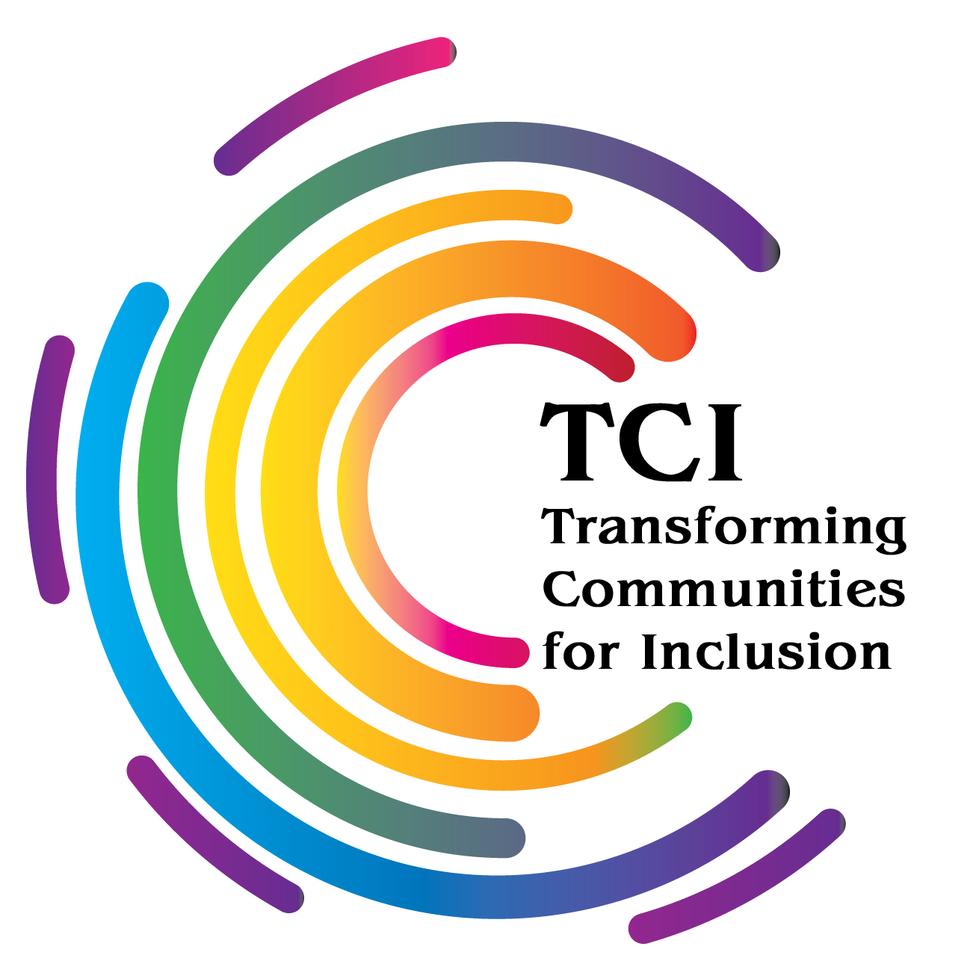
Statement by Bhargavi Venkatasubramaniam Davar
Transforming Communities for Inclusion

At the OHCHR: Consultation Mental Health & Human Rights HRC RES 43 13
Mon, 15 November 2021, 10:00-12:00 & 15:00-17:00; room XVII

TCI is a global organization of persons with psychosocial disabilities and stands for “Transforming Communities for Inclusion”. TCI advocates for the full Inclusion of persons with psychosocial disabilities in communities, fostering a community of practice around support systems and inclusive neighbourhoods, to allow persons with psychosocial disabilities to live independently with choice and dignity.
Only doing “mental health” or “peer support” or “recovery” does not result in inclusion; When we say “inclusion” we mean, “inclusive of mental health but not exclusively so”. We welcome MH reformative practices, but it is only one part of the “bigger picture”. We are grateful for the present momentum of DI emerging within the UN.
“Mental health” is an area where the adage of “There is a lot to do” is disturbingly and tragically endless. It has been over a century of intergenerational trauma, torture and pain caused by the collective oppression of a specific disability group by a care system. But, when we obsess about it, scream about it, write about it, scratch on the walls about it, we run the risk of being called ‘crazy’ all over again, rendered invisible or punished.
My daughter is 22 years old and I turn 60 next year. Our lives are still woven around the intergenerational trauma of my mother and her grandmother, who was relentlessly persecuted and incarcerated in asylums; neither I nor my daughter have been able to exorcise those virulent memories passing from generation to generation. Stopping the violence within a care system is not enough; not enough to bring just amelioration into a system that continues to multiply archaic policy designs inherently against life and wellbeing.
Full inclusion in society goes beyond offering good quality mental health services: Intersectoral co-operation on our inclusion is impossible if the care system guards our access to various other services (for example, housing and insurance if medication compliant). It is not even enough if governments and services systems stop the violence, abuse, torturous treatments and coercion. The past harms must be redressed, too! For us persons with psychosocial disabilities lifetimes have been spent, and sacrificed to give visibility to a system, that has repeatedly and relentlessly abused and tortured. As there was with racism, indigenous people and other oppressed people, there must be a recognition and legitimacy to experiences of the normative victimization and cruelty done to a particular group, based on our disability status. Several civil society groups of users and survivors of psychiatry, mad persons, persons with a disability and other neurodiverse identities, are asking for a public reparation mechanism from states parties and the professional lobbies, for this colossal wrongdoing.
Movements of persons with psychosocial disabilities aspire for life and not just care. Our movement, in collaboration with the cross disability movements worldwide, are using the CRPD to de-colonize, de-economize and de-psychiatrize their lives by creating excellent opportunities for participation in integrated community engagement and contributing to its development. A community of practice around inclusion, rather than ‘good treatment’ has emerged, involving families, support groups and services, and other circles of care. The movements of persons with psychosocial disabilities are happy to continue to co-operate on reforming mental health care as a harm reduction measure. But our aspiration lies elsewhere, where resizing the role of “ mental health” must be a policy matter – interagency actions for support on housing, employment, sports, grooming, self care, relationships, leisure, family, etc. Health care towards inclusion, and not towards exclusion! Thank you, ladies and gentlemen. “
TCI started as a response to amplify the commonsense view that like all persons, with and without disabilities, persons with psychosocial disabilities enjoy our freedoms, self worth, likes and dislikes, friendships, understanding, companionship, relationships, hobbies, games, Twitter and FB … other than employment worthy of our time and merit, decent housing, sports and grooming, etc.
Intersectoral efforts, on equal basis with others, the availability of social, economic, cultural and political inclusion, would bring hope, fulfilment and could save millions of lives of persons with psychosocial disabilities. Zero hunger, justice, peaceful communities, housing, clean water, are all part of an enabling psychosocial ecosystem; Creative art is so; Spiritual pursuits are so; etc. Community support systems are a part of a person’s social capital, not a “mental health service”. Gate keeping of such support systems is intrusive and violative of privacy and choice. Resizing “mental health” and maintaining respectful boundaries, while offering a variety of life affirming and specific psychosocial supports, will give us a sense of breathing freely and of not being invaded now and again by forces beyond our ken.

