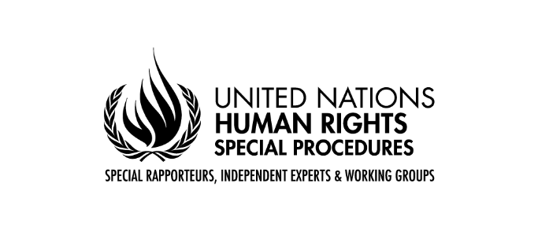
Statement at the conclusion of the official visit to Malaysia
by the Special Rapporteur on the human rights to safe drinking water and sanitation, Mr. Léo Heller

Kuala Lumpur, 27 November 2018
As the United Nations Special Rapporteur on the human rights to safe drinking water and sanitation, I address you today at the conclusion of my official visit to Malaysia, which I undertook at the invitation of the Government from 14 to 27 November 2018.
Firstly, I would like to thank the Government of Malaysia for the invitation and organization of the visit. I would like to thank the Ministry of Water, Land and Natural Resources (KATS) for coordinating the government meetings at the federal, state, municipal and division level. During the visit, I also met representatives of the vibrant civil society including indigenous rights defenders, lesbian, gays, bisexual, transgender and intersex rights defenders (LGBTI), environmental activists as well as other representatives and experts. Most importantly, my heartfelt appreciation goes to the residents, particularly the Temiar-Orang Asli community in Kuala Betis, Gua Musang district of the State of Kelantan; residents of Tampayasaa and nearby villages in Penampang district of the State of Sabah; and of Bakong and Menok villages in Baram District, the State of Sarawak who welcomed me to their villages and took the time to explain to me how they access drinking water, water for washing and cooking and how they urinate and defecate.
At the outset, I would like to mention that this statement outlines my preliminary findings. My final and complete report will be presented to the United Nations Human Rights Council at its 42nd session in September in 2019.
* * *
I would like to introduce my preliminary findings from the two-week visit through the following three questions that I used as an analytical framework to understand the situation of the human rights to water and sanitation in the country:
- Is water and sanitation provision a concern in Malaysia?
- Who is left behind?
- How can Malaysia move forward?

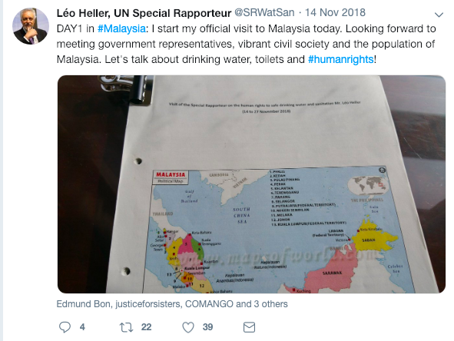
From a human rights perspective, water and sanitation are still a concern in Malaysia
I start first by addressing the question “is water and sanitation provision a concern in Malaysia?”
Malaysia is blessed with a rich availability of water resources with 971 billion m3 rainfall per year. I visited the country during the monsoon season during which I saw sporadic rainfalls and blue tanks to collect rainwater in both urban and rural areas.
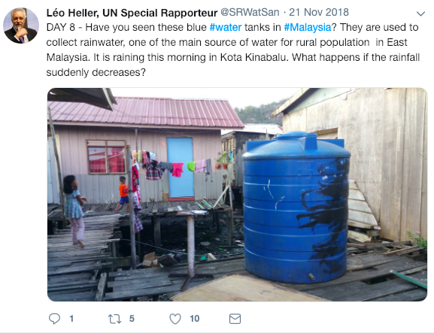
In terms of access to adequate water and sanitation services, my overall observation is that Malaysia has achieved high performance. The accessibility of water and sanitation services is truly impressive. According to the global monitoring report (WHO/UNICEF Joint Monitoring Programme report), in 2015 - the first monitoring after the adoption of the Sustainable Development Agenda - 92 per cent of the population of Malaysia have access to safely managed water services and 82 per cent to safely managed sanitation services. In simple terms, most Malaysians have access to a piped and central water supply and an adequate sanitation facility, whether a sewerage connection, a safe septic tank or a latrine. Similarly, the WHO/UNICEF Joint Monitoring Programme estimates almost universal access to water, sanitation and hygiene services in schools. These figures are remarkable even when we compare Malaysia with other countries with similar level of development.
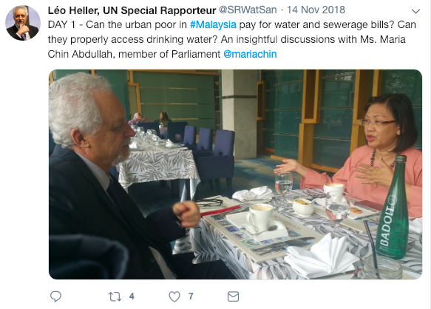
A small proportion of the population in Malaysia collect drinking water from surface water such as rivers and streams or rely on rainwater and, according to official figures, no one defecates in the open. During my two-week stay, I could observe that these numbers reflect the actual situation in urban areas and I am happy to confirm the positive situation of access to water and sanitation services in the country. I would like to commend the government and the population of Malaysia for these achievements, the result of a historic commitment to the provision of public services to the population.
As for affordability of water and sanitation services, Malaysia has financially accessible tariffs for both water and sewerage provision. In some States, there is a universal provision of Government subsidized water until a certain consumption, usually 20 cubic meters per month, and in some others, this subsidy is applied to a targeted population, with less economic resources. For desludging of septic tanks, in some States such as Sarawak the service is subsidized and is charged in the house assessment fees.
To properly answer the question that I posed, it is important to dig deeper and, for this, I would like to refer to four agendas that many Malaysians are aware of: (1) the Sustainable Development Goals (SDGs), (2) the new Pakatan Harapan Government’s pledge in its election Manifesto (“Election Manifesto of the Government”), (3) Malaysia’s 11th’s Development Plan and (4) last, but most importantly, the framework of the human rights to safe drinking water and sanitation.
The underlying principle of the Sustainable Development Goals is “leaving no one behind”. Another way to say ‘leaving no one behind’ is to have ‘everyone on board’ and to be able to keep track of how the Sustainable Development goals and targets are met for ‘everyone in all contexts’, especially for people who are non-existent in national surveys and fall off the radar.
Malaysia has explicitly committed to achieving SDG Goal 6 - ensure availability and sustainable management of water and sanitation for all - particularly by aligning its Eleventh Development Plans with the 2030 Sustainable Development Goals. The Eleventh Plan for 2016-2020 based on the theme “anchoring growth on people” explicitly notes that: “The people economy will be given priority, reinforcing the Government’s commitment to bring further development to the people by enriching their lives, providing people dignity, and uplifting their potential to partake in the prosperity that is generated. All segments of society must benefit from the country’s economic prosperity in order to create an advanced economy and inclusive nation by 2020.”
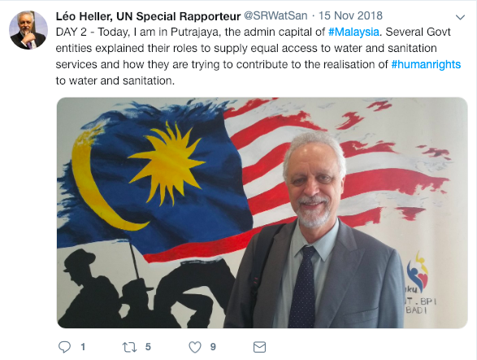
I would also like to refer to the promise that the current Government has made under the “Manifesto”, promise no. 34 (Enhance the income of majority): “Pakatan Harapan will defend the fate of all Malaysians, irrespective of their race, religion and creed, especially those who need our help. Pakatan Harapan’s key strategy is to boost economic development to create more job opportunities, while at the same time provide a social security network for the lower income group.” [emphasis added]
Most important in the context of my visit, I should mention that Malaysia has voted in favour of the first UN General Assembly resolution A/64/292 recognizing the human right to water and sanitation in 2010. In resolution 72/178, the UN General Assembly recognized both the human right to water and the human right to sanitation: “the human right to safe drinking water entitles everyone, without discrimination, to have access to sufficient, safe, acceptable, physically accessible and affordable water for personal and domestic use, and [that] the human right to sanitation entitles everyone, without discrimination, to have physical and affordable access to sanitation, in all spheres of life, that is safe, hygienic, secure, socially and culturally acceptable and that provides privacy and ensures dignity, while reaffirming that both rights are components of the right to an adequate standard of living.” [emphasis added]
Malaysia is one of the founding members of the Association of Southeast Asian Nations (ASEAN). ASEAN adopted in 2012 its own Human Rights Declaration, which recognizes the right to safe drinking water and sanitation (Article 28(e)). Malaysia has also ratified three international human rights treaties that have an explicit provision on drinking water: article 24(c) of the Convention on the Rights of the Child; article 14(2)(h) of the Convention on the Elimination of All Forms of Discrimination against Women and article 28(2)(a) of the Convention on the Rights of Persons with Disabilities.
To make Malaysia’s commitment to SDGs tangible and for Malaysia to reach universal access to water and sanitation for all, we need to aim for a higher rate of progress for disadvantaged and marginalized groups. I would like to stress that, while meeting SDGs goals 6.1 and 6.2 is a pathway to realize the human rights to water and sanitation, it is only a proxy to human rights. Ultimately, Malaysia must strive to meet its human rights obligations and exercise regional leadership on this field.
With these four agendas in mind, let me now return to the first question. During my visit, I saw that there are a number of groups with poor or lack of access to water and sanitation services. This leads me to answer: “yes, water and sanitation provision is still a concern in some aspects and for some population in Malaysia, even if they are not the majority of the population”. After having answered the first question in positive, I ask “who are left behind and what are the human rights gaps?”

Several groups are left behind and there are still gaps for the realization of the human rights to water and sanitation
A more in-depth review of the way the population of Malaysia enjoy their human rights to water and sanitation and looking from how institutions are oriented by the framework of those rights, a number of gaps emerge, particularly related to marginalized groups. And those gaps are in the opposite direction from the legal and political commitments reiterated in the four agendas that I have introduced.
I would like to emphasize that the adoption of a comprehensive approach to implementing the human rights to water and sanitation will guide Malaysia to identify those who are left behind and to reach the Government’s commitments. Everyone is entitled to equal access to drinking water and sanitation and for the rights of individuals there are prohibited grounds of discrimination, such as “race, colour, sex, language, religion, political or other opinion, national or social origin, property, birth or other status” (article 2 of the Universal Declaration of Human Rights). The last words of this sentence – “other status”– have frequently been employed to expand the list of people specifically protected.
In this connection, I would like to share my views on some particular groups that deserve a closer attention and follow-up actions from the Government.

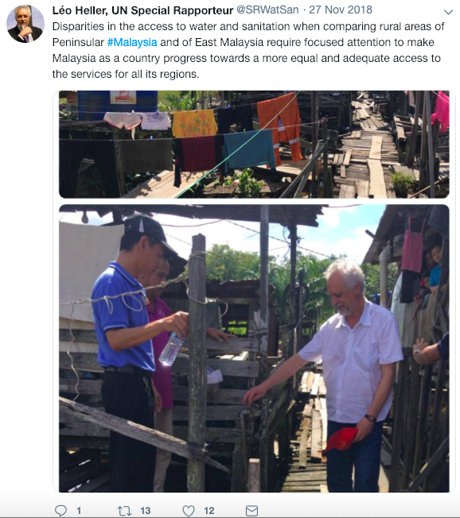
Orang Asli indigeous peoples
Peninsular Malaysia is home to 215,000 Orang Asli indigeous peoples, where they are the minority population. I spent two days in the Gua Musang district and visited seven villages where Temiar-Orang Asli people live. I had the pleasure to spend time with them, to have a meal together and to see and experience their way of living. I was able to see how Orang Asli villages have been resettled and regrouped after being displaced by flooding and due to mega-projects including logging, palm oil and rubber plantation, and dam construction, which implies the loss of their traditional lands, the majority of which not officially protected. It was explained to me that, for Orang Asli, losing their lands means destruction of their way of life, including the possibility to transmit rituals, beliefs, knowledge and practices. During my short yet valuable time with the indigenous community, I could learn and see that the rivers next to each indigenous community are used for several purposes: as the water source for washing and as a place in lieu of toilets.
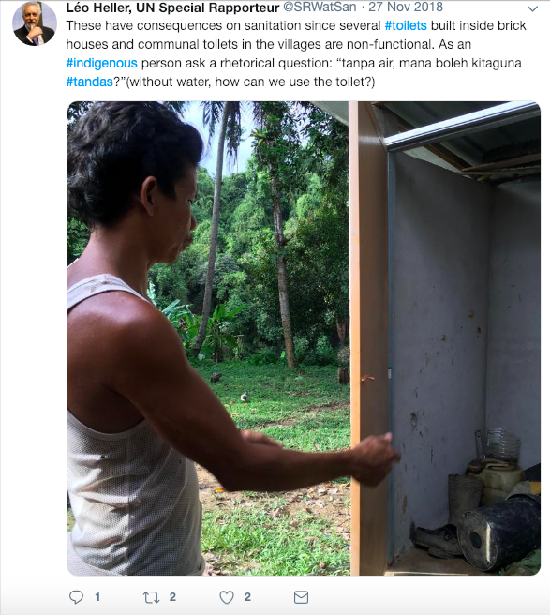
The Department for Orang Asli Development (JAKOA) is a dedicated governmental agency responsible for ensuring “the administration, welfare and advancement of the aborigines” (article 4 of the 1954 Aboriginal Peoples Act). From the beginning of the 2nd Malaysia Plan to the 11th Malaysia Plan, the Ministry of Rural Development constructed several water facilities in the Orang Asli villages, with a target of 90 per cent of coverage. According to the Ministry, to date, 701 (82 per cent) of the 853 Orang Asli settlements have been provided with water supply. The efforts to address the access to water for the indigeous peoples was illustrated with the emphasis that there is no one-size-fits-all solution, based on some lessons learned after identifying problems with the implementation of water systems.
I saw these problems in person when I visited the villages. I saw several water treatment facilities installed by the Ministry of Rural Development and managed by JAKOA at the entrance of the communities. They were all sophisticated technology that requires proper maintenance and operation, which is beyond the capacity of the villagers without adequate training. In addition to the inappropriateness of the level of technology, there is a gap related to outsourcing contracts for operation and maintenance of those facilities and, as a result, what I saw was a series of non-functioning facilities, leaving the residents to find water sources on their own.
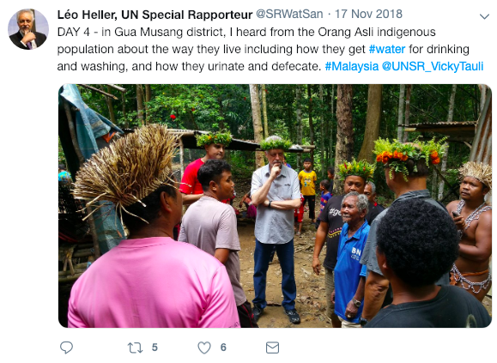
Due to this context, the Orang Asli people rely on water collected directly from rivers and streams, transported in bottles, supplied by gravity-fed water systems with low sustainability, or in systems connected to the central grid with scarce water availability. These have consequences on sanitation, since several toilets built inside brick houses and communal toilets in the villages are non-functional. Asking to an indigenous person about the situation of sanitation, he replied with a rhetorical question: “tanpa air, mana boleh kitaguna tandas?” (without water, how can we use the toilet?).
I refer to Promise 38 of the Government’s Election Manifesto: to “advance the interests of Orang Asal in Peninsular Malaysia”. I hope to see more resources allocated to upgrade and maintain the water infrastructure of the Orang Asli villages, so that the communities are no longer marginalized. I would like to point out that those solutions should be sustainable in terms of operation and continuous usage.
Further, technical solutions would benefit from a participatory process involving the community for key decision-making related to their water supply and sanitation facilities. As the government rightly pointed out, “one solution does not fit all” and solutions need to be contextualized.
I am pleased to learn that the Government of Malaysia has accepted the visit of my colleague, the UN Special Rapporteur on the rights of indigeous peoples. I strongly believe that this visit will be an essential element of effective follow up to the recommendations made by myself during this visit and also my colleagues who have visited Malaysia before me.

Population affected by megaprojects
Mega-projects such as large-scale dams can affect the human rights to water and sanitation of the population both before and after its construction.
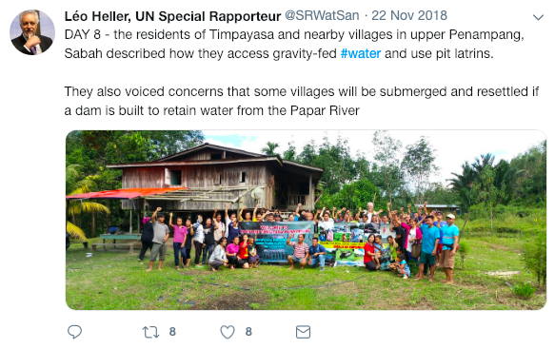
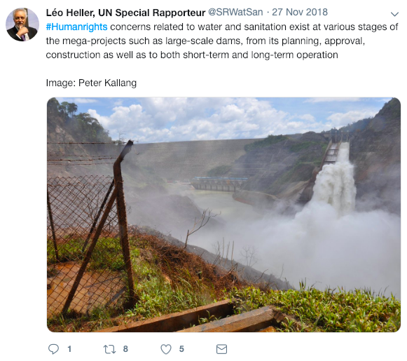
Prior to the construction of dams, the residents living in villages to be affected are subjected to low attention from the Government, anticipating that those villages will no longer exist once the dam is constructed. For instance, in Timpayasa and surrounding villages of Penampang District in the State of Sabah, which will be impacted by the proposed Kaiduam Dam, I heard complaints that those villages are no longer receiving government support for their basic needs because if the project goes ahead, four villages will submerge and another five would need to be relocated for other reasons.
I urge the Government to develop a careful comparative studies examining different technical options to ensure water security for all population, before deciding to implement mega-projects for water supply. This analysis as well as the final decision must be carried out together with the communities involved, both those impacted and those who benefit from each solution. The decisions need to be taken together and any development project should not move ahead without the free, prior and informed consent of the affected indigenous peoples.
After the construction of dams, careful monitoring of the livelihood, particularly access to water and sanitation of the population displaced as well as those remaining is required. As a result of the construction of the Bakun hydro-electric dam, in 1998, around 10,000 people were resettled in 15 different villages with the promise of certain acres of land, free housing and other support to sustain their livelihood in a new home. Sungai Asap is now home to those displaced and, after almost two decades, the villagers still do not have proper access to safe water and are facing the problem of quality of self-supplied water.
There are human rights concerns related to water and sanitation at various stages of the mega-projects such as large-scale dams, from its planning, approval, construction, as well as to both short-term and long-term operation. I urge the Government to carry out human rights impacts assessment at each stage, with meaningful participation of those affected and in a transparent manner, facilitating easy access to information.
During the visit, I learned that several other interventions of large magnitude have also been affecting the access of populations to safe drinking water, such as logging projects, the massive palm oil plantations and palm oil processing, and other agribusiness with systematic use of pesticides and fertilizers. I will submit a report focused on the impact of mega-projects on the human rights to safe drinking water and sanitation to the UN General Assembly in 2019, an important issue to Malaysia related to the access to water for all its population.

Population living in informal settlements
Throughout my visit, particularly in East Malaysia, I saw several types of informal settlements, whether occupied by Malaysian nationals, stateless, undocumented population or others with irregular status.
In Sandakan, informal settlements are often in clandestine areas where they are undetectable or attached to factories or other economic activities where people can work and earn wages. The groups rely on self-provided water from rivers, the factories or gravity-fed from a near hill. In some coastal villages, the access to water is non-existent and some residents had to travel by boat to another village in order to collect water.
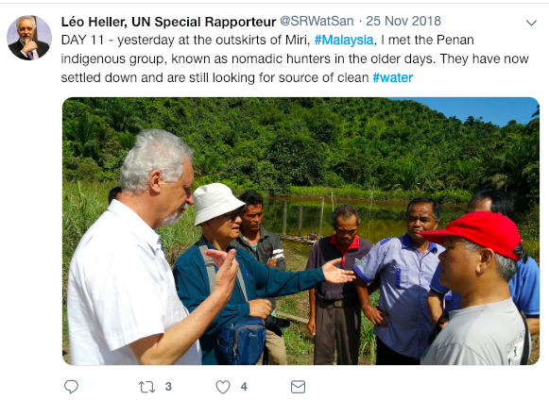
The outstanding figures of Malaysia’s access to drinking water unfortunately do not include those living in coastal villages, traditional style houses, known as “long houses”, and other forms of informal settlements. Seeing the sparse distribution of villages on the small islands, along the coast, the mountains and inner rural areas, I can understand the challenges in identifying the number of population and to monitor whether they, both Malaysian citizens and non-citizens, are ensured adequate access to water.
In one village, there are three informal water providers that set up their own system from the mountains with self-installed checkpoints to control the water quality. The informal providers play the role of monitoring water quality, not supplying water when it looks muddy or its colour changes. The fees were 1 Malaysia Ringgit (USD 0.25) for 10 minutes supply of water that would feed up to three tanks.
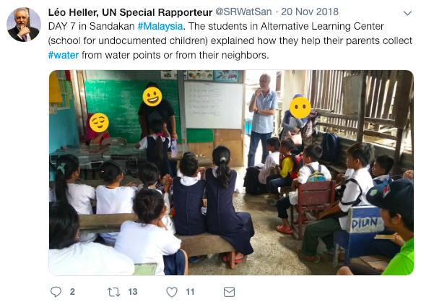
I accidentally met the son of an informal provider who also at times manages turning the tap on and off and collects the tariff. When I asked him about a theoretical situation of people who are too poor to pay for water, the boy immediately said: “I give them water but don’t tell my father. Recently, a fisherman came on his boat with two buckets. I did not charge him”. I am sorry to make this secret between the young boy and myself now open but I do so in order to point out the simple underlying principle of human rights. This boy does not have a professional background in human rights and does not have experience in policymaking. But his gut instinct told him that, for people who cannot afford, he should use different standards.
Despite occasional good practices like this, the approximately 900 households of the village have discontinuous water supply, through those unregulated informal providers, that charge the service without any control of a mandated public agency, which is inadequate from the human rights point of view.
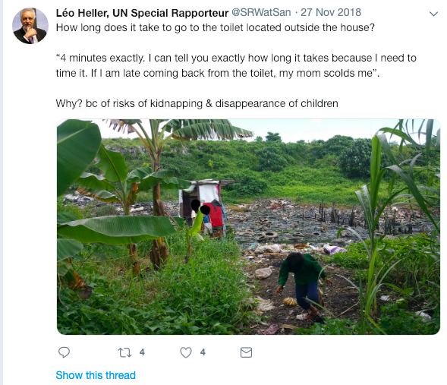
I visited two Alternative Learning Centres operated by NGOs, where non-citizen children attend but which is not registered with the Ministry of Education. I spoke to two sets of approximately 40 to 50 students, ages varying from 10 to 15. In both Centers, some children help their parents collect drinking water from the water fountains (boreholes) or the neighbour each morning or sometimes after school.
In one of the villages, I observed a complex water management that involves the use of four different sources: a well, rainwater, a gravity-fed system and a river. The other rely on water supply from nearby factory that charges the users. The lack of a State presence in villages where undocumented population live usually requires the villagers themselves to find their own solutions for water supply, sometimes costly, unsafe and with low availability.
In one Centre, half of the children had access to toilets inside or few steps away from their houses. However, the other half had to walk outside of the house in order to use toilets. When I asked how long it takes, one girl specifically said “4 minutes”; she continued “I can tell you exactly how long it takes because I need to time it. If I am late coming back from the toilet, my mom scolds me”. It was explained to me that there are risks and fears of kidnapping and disappearance of children in the area.
I was happy to hear from water providers that they do not discriminate supplying to registered or unregistered households and that in some States, such as Sabah, the Government requested the water department to look into and devise a solution to this. I recommend that the Government implement feasible solutions for water and sanitation for the undocumented population so that they can access those services.

Refugees and asylum seekers
As of October 2018, 161,454 refugees and asylum-seekers are registered with UNHCR in Peninsular Malaysia, the majority from Myanmar, mainly Rohingya. Most of these populations live in Kuala Lumpur area or other urbanized environments where they can secure work in the informal market economy. With no right to remain in Malaysia lawfully, refugees cannot work legally, which impacts their livelihood and particularly the human rights to water and sanitation. The low income of households and exclusion from Government policies, programmes and remedies negatively impact the ability of the refugees and asylum-seekers in Peninsular Malaysia to fully enjoy their rights to water and sanitation.
Most refugees rent housing where multiple families or extended family members reside together, leading to disproportionate availability of toilet and washing facilities. One woman explained that the rent of her house is 600 Malaysian Ringgits (USD 140) per month and the rent together with other expenses including water bills are covered by her husband’s monthly income of 900 Malaysian Ringgits (USD 215). I could understand that overcrowding in those houses has become the norm, due to the vulnerable financial situation of the refugees. In this connection, I would like to reiterate the promise 35 of the Election Manifesto to legitimize the status of refugees and to ensure their right to work.
In addition to issues of affordability of access to water, I learned that refugees and asylum seekers are often detained in detention centres and in prisons. I spoke to three men who were detained and also was put in a prison. Their stories indicate the very poor and almost inhumane conditions of access to water and toilets in those settings.
I would like to highlight that the Immigration Regulation of Malaysia no.16 states that “Every detainee may be allowed to take a bath at least once daily”. I regret that the regulation does not have any reference to water and sanitation rights of the detainees.
I would like to stress, as I wrote in my thematic report to the Human Rights Council (A/HRC/39/55), that forcibly displaced persons - refugees, asylum seekers, undocumented populations and migrants in vulnerable situations - are rights holders at par with the citizens of Malaysia, and are equally entitled to enjoy access to adequate drinking water and sanitation services.
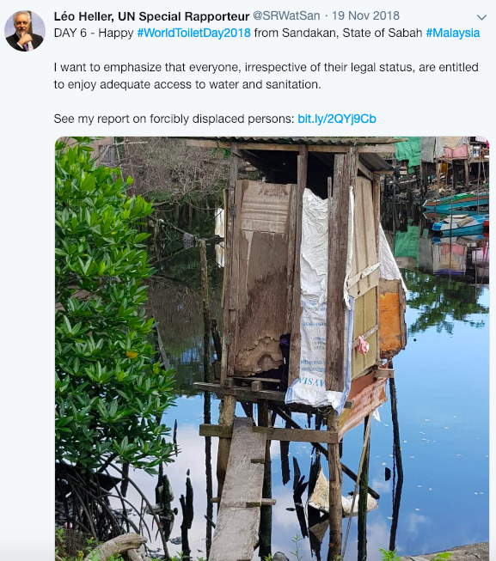
I will be visiting a prison in the afternoon today after the press conference in order to examine the situation of access to water and toilet facilities, provision of soap and other hygienic products. My observations from the visit will be reflected in my full report to the UN Human Rights Council.

Transgender and gender non-conforming persons
Lesbian, gays, bisexual, transgender and intersex (LGBTI) persons in Malaysia face structural and systemic discrimination. Particularly under the civil and state administered Syariah laws, there are many laws that criminalize persons based on sexual orientation, gender identity and gender expression. I would like to refer to my report on gender inequality where I emphasized that restrictive gender recognition laws not only severely undermine transgender peoples’ ability to enjoy their rights to basic services, but also prevent them from living safely, free from violence and discrimination (para. 9 of A/HRC/33/49, thematic report on gender equality). Moreover, water and sanitation facilities must be safe, available, accessible, affordable, socially and culturally acceptable, provide privacy and ensure dignity for all individuals, including those who are transgender and gender non-conforming (para. 9 of A/HRC/33/49, thematic report on gender equality).
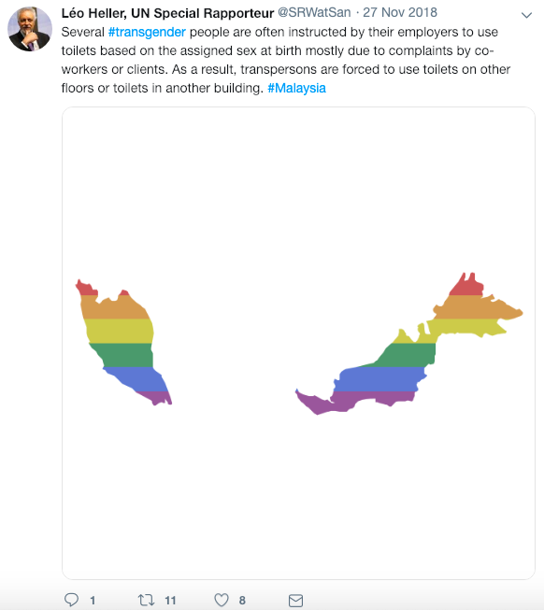
According to a 2017 online survey on access to toilets by transgender people in Malaysia by Justice for Sisters, 40 out of 97 transgender respondents have encountered discrimination of some form when using public toilet and 26 out of 97 experienced restriction of access to toilets at the workplace. Fifteen of the transgender respondents reported as having had experienced being forced to use toilets based on sex assigned at birth.
Restricted access to toilets and other facilities based on gender at the workplace is a discriminatory conduct. I heard that several transgender people are often instructed by their employers to use toilets based on the assigned sex at birth mostly due to complaints by co-workers or clients. As a result, transgender people are forced to use toilets on other floors or toilets in another building.
Working in such environments not only adds stress, anxiety, isolation, amongst others, but also increases health risks, such as urinary tract infections, due to restricted use of toilets. In the above-mentioned survey, 42 per cent of the respondents feel emotional stress about using the toilet, whereas 39 per cent of them battle with self-esteem issues because of discriminatory experiences encountered when going to the toilet. In many cases, workplaces do not have policies that are inclusive of diversity.
Furthermore, I am concerned about the sexual harassment and violence that transgender people face in educational institutions. Several transgender people recalled their experience being teased by other boys in the toilet during their school years.
I recommend the Government of Malaysia to monitor how gender inequalities, including among lesbian, gay, bisexual, transgender, intersex and gender non-conforming persons, manifest themselves in extra-household settings (para. 72 of A/HRC/33/49, thematic report on gender equality).

Sabahans and Sarawakians are lagging behind
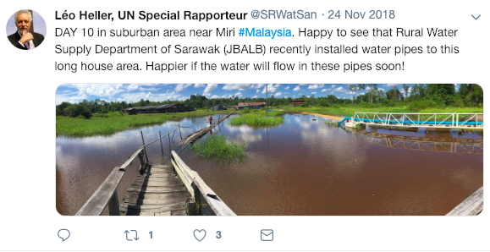
As of 2016, approximately 88 per cent of the Sabahans and Sarawakians had connection to central piped water services. This is a different picture compared to Peninsular Malaysia, where in most states, except Kelantan, the rural population enjoy near universal access to water supply. These figures include only Malaysian national population, suggesting that the disparities are even higher when considering the significant presence of undocumented population in the States of Sabah and Sarawak.
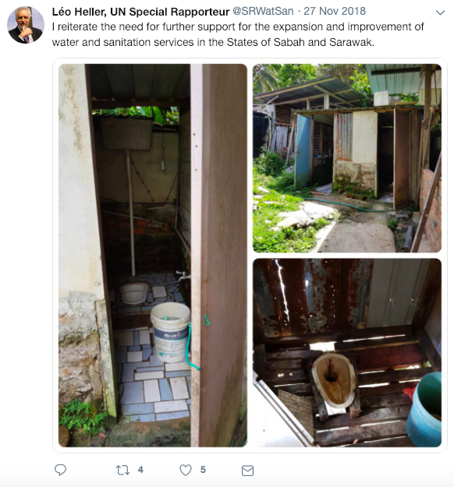
The States of Sabah and Sarawak decided not to be part of the new institutional architecture of the water sector of the reform in 2006, through the amendments of the Constitution. Due to this historical background, the federal mechanisms for the provision, funding and regulation of water and sanitation services and bodies such as Water Asset Management Company (PAAB) custodian of water assets only cover Peninsular Malaysia. Indah Water Konsortium (IWK) and National Water Services Commission (SPAN) only cover Peninsular Malaysia and the federal territory of Labuan. The two States in East Malaysia retained their own institutional framework.
This context creates an environment with weak presence of the Federal Government in the region, which gives room for a limited federal support to bridge the gaps between East and Peninsular Malaysia, regarding the access to water and sanitation services and the full enjoyment of their human rights by all. The Federal Government supports the two States for urban water and sewerage interventions through loans, often soft loans, while this is not the standard procedure applied to most of the States in Peninsular Malaysia, that often receive grants and involve leasing. At the same time, my impression from interacting with some interlocutors in the two States is that the budget allocation for those services is low, particularly considering their high needs. Disparities in the access to water and sanitation when comparing rural areas of Peninsular Malaysia and of East Malaysia require focused attention to make Malaysia as a country progress towards a more equal and adequate access to the services for all its regions.
In this regard, I refer to Promise 41 of the Manifesto that states: “To ensure the prosperity of the people of Sabah and Sarawak by enhancing the states’ economic growth: Good infrastructure is key to economic development […]. Government will [ensure] that the nation’s prosperity is shared by all. Greater allocation of resources will be channelled to […]: Ensure supply of clean water and clean energy to urban and rural areas”. Similarly, I reiterate the need for further support for the expansion and improvement of water and sanitation services in the States of Sabah and Sarawak.

Malaysia must move forward for the progressive realization of the human rights to water and sanitation
I would like now to present my views and preliminary recommendations for the consideration of the Government of Malaysia, aiming at accelerating the progressive realization of the human rights to water and sanitation.

The institutional framework should provide concrete responses to the challenges
The sector reform implemented in 2006 reorganized the institutional framework at the federal level and reached some States. Progresses on the access to services have been observed since then, particularly for sanitation. Currently, the institutional actors at the federal level have been consolidated to ensure provision, regulation and funding for both water and sanitation.
However, referring to the several groups that I introduced just now, I can affirm that more needs to be done in this field, in order to reach those people invisible for public policies. The persistence of this situation indicates that the Government needs to have more targeted policies in order to include the neglected and those living in harder to reach areas. Moreover, it is fundamental to attain an equal standard of services across the country, particularly between Peninsular and East Malaysia.
In this respect, I would like to share some recommendations for the consideration of the Government:
First, I find the regulatory strategy currently in place at the federal level adequate: the development of three-year plans by service providers and the further performance monitoring attached to the delivery of institutional support. However, this procedure is not present for all water and sanitation services, as observed in East Malaysia and in States in Peninsular Malaysia where SPAN does not have a role. I encourage the Government of Malaysia, in a dialogue with State governments, to harmonize water and sanitation service regulation in the country, through bodies that are independent from the service provider.
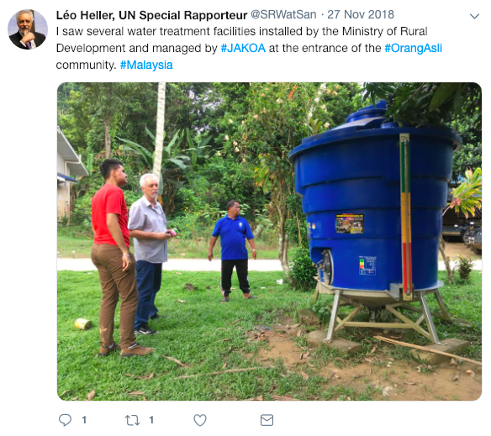
Second, Indah Water Konsortium handles sewerage and wastewater treatment in Peninsular Malaysia except for States of Kelantan, two districts in Johor, Sabah and Sarawak. It is essential that the Federal Government assesses whether the absence of a federal body attached to the provision of sanitation services in those States has impacted the quality of services. This assessment should be the fundamental guideline for a stronger support to services of sewerage and individual sanitation solutions in East Malaysia and States of Kelantan and Johor.
Third, level of services in the States of Sabah, Sarawak and Kelantan are lower than in the rest of the country. In order to bridge this difference, the Federal Government of Malaysia must implement focused policies that include sufficient and sustainable funding for those States. Those three States would benefit if the Federal Government allocates more financial resources specifically dedicated for the improvement of their water and sanitation services in the modality of grants until they reach a certain level of services and coverage.
Fourth, there is a need for a targeted policy for the proper inclusion of indigenous peoples in the access to water and sanitation services. In Peninsular Malaysia, the capacity of JAKOA needs to improve, ensuring that Orang Asli indigenous receive appropriate services, compatible with their cultural values, and that the services are sustainable. In East Malaysia, indigenous peoples living in rural areas also require particular attention from the Government, in order to improve their access to water and sanitation services and to ensure sustainability.
Fifth, refugees, asylum-seekers, undocumented population and those in irregular situations require a very special attention. They must be entitled to receive the same level of services as citizens of Malaysia. I strongly recommend the Government to create a coordination body at the federal level to assess the best legal, political and budgetary strategies that include undocumented, stateless populations and those in irregular situations to provide access to adequate public services of water and sanitation. This assessment must include the conditions of toilets and access to water at the detention centres.

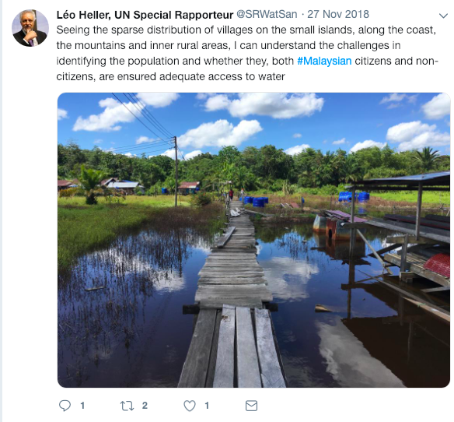
Malaysia must know who is left behind
Apart from the largest groups of Malays, Chinese, Indigenous and Indians, Malaysia is home to a number of minorities and indigeous peoples, including the Negrito, the Senoi and the Proto-Malay in peninsular Malaysia (generally referred to as Orang Asli), the Kadazan Dusun, the Bajau and the Murut mainly in Sabah, and the Iban, the Bidayuh, the Melanau and the Orang Ulu predominantly in Sarawak. Within the two-week stay, I was not able to meet all these different groups but I had the pleasure to interact with Malaysians from different ethnicities and indigenous peoples.
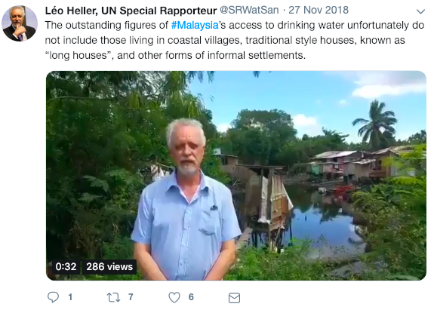
During my meetings with the representatives of the Government, many answered that there is no data available to several of my questions related to the disparities in the access to adequate services by specific groups, such as indigenous versus nonindigenous; different religions, ethnicities, regions and wealth levels. It is essential that Malaysia urgently take action in collecting adequate data that allow disaggregation of the access to water and sanitation services by relevant groups, particularly based on race, colour, sex, language, religion, political or other opinion, national or social origin, property, birth or other status. It seems only logical to me that no Government can come up with an adequate policy if there is no information. Simply put, “We cannot have adequate policies for what we do not know!”
There is also a lack of information or data keeping by the Government regarding the enjoyment of human rights to water and sanitation by asylum-seekers and refugees. Those groups have generally been excluded from Malaysia’s development agenda, including from discussions around the development of Malaysia’s Sustainable Development Goal Road Map, as well as resulting targets and policies. I urge the Government to start a baseline survey in order to improve the availability of data on population affected by statelessness in East Malaysia including the Bajau Laut, descendants of Indonesian and Filipino migrant workers and various minority ethnic indigeous peoples.

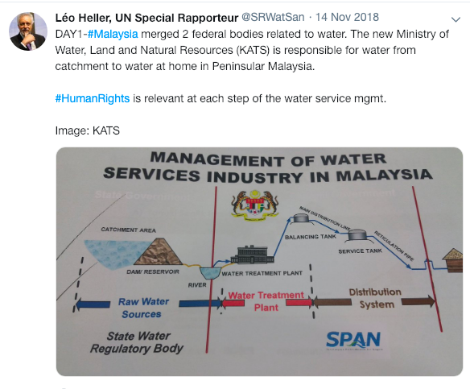
Financial sustainability and affordability must come together
I learned that the National Water Services Commission (SPAN) is undertaking studies to restructure the tariff scheme, which might include a joint billing for water and sewerage services and an updating of tariff values. From the human rights perspective, it is key to ensure the financial sustainability of services. Unsustainable services, even with a safe source of subsidies, are vulnerable and in the long term puts the quality of services at risk.
For the restructuring of water and sanitation tariff, I would like to provide a few elements to make this exercise in line with human rights.
First, from a human rights perspective, it is important to reconcile the financial sustainability of the water and sanitation services with affordable access to those services by the population in vulnerable situations. The Government must be mindful of the needs of those with low capacity to pay.
Second, in order to guarantee that those financially more vulnerable are not denied access to water and sanitation services, I recommend the Government to implement mechanisms of social tariffs and/or different types of cross-subsidization, including from non-residential consumers to residential users (A/HRC/30/39, thematic report on affordability). The current procedure of providing 20 cubic meters free implemented by some States is a way to address affordability, but may not be fair when universally applied, irrespective of the number of persons living in the house and the household income, because can benefit rich households that consume low volumes of water at home and damage large poor families. The target of these mechanisms should be the B40 group and other marginalized groups. To identify those groups in need of subsidy, I reiterate my earlier point that data should be collected and disaggregated.
Third, all this discussion is inseparable of the practice of disconnections due to the inability to pay. Currently, there are 24,000 disconnections per month on average for the entire country in the total of 6.9 million domestic connections. Although low in proportion, it is possible that a new tariff setting can aggravate this trend. I encourage the Government to carry out a survey looking into the reasons for disconnections as a preventive measure and encourage all service providers to monitor the reasons for disconnections and the following measures taken. Given that the disconnection due to inability to pay is a violation of the right to water, I urge the Government to set up legal mechanisms to prohibit the practice.

Improve record of ratifying international human rights treaties
The situation of access to drinking water and sanitation for all population in Malaysia with emphasis on those left behind would paint a different picture if water and sanitation are legally recognized as human rights in Malaysia and if Malaysia explicitly has the human rights obligation to realize those rights. Further, I find that it is essential for Malaysia, as mentioned in the promise no.26 “Make our human rights record respected by the world” of the Election Manifesto, to improve its record on the ratification of international human rights treaties, as well as their implementation.
Firstly, I need to remark on my disappointment with the Government’s announcement three days ago not to ratify the International Convention on the Elimination of All Forms of Racial Discrimination (ICERD). The principles of this treaty is very much aligned with several concerns raised in this statement.
Secondly, I welcome the intention of the Government to ratify the International Covenant on Economic, Social and Cultural Rights, which stipulates the right to an adequate standard of living, protected under article 11. In its General Comment No. 15, the Committee on Economic, Social and Cultural Rights clarified that the human right to water means that everyone is entitled to sufficient, safe, acceptable, physically accessible and affordable water for personal and domestic uses. I look forward to the actual ratification in due course.
Thirdly, I would like to encourage the Government, in line with its support for the adoption of the United Nations Declaration on the Rights of Indigeous peoples, to consider ratifying the International Labour Organisation Indigeous peoples Convention (C.169), which spells out that rights of ownership and possession of indigeous peoples over lands which they traditionally occupy shall be recognised. Furthermore, I recommend the Government to ratify the 1951 Refugee Convention and its 1967 Protocol; the 1954 Convention relating to the Status of Stateless Persons and the 1961 Convention on the Reduction of Statelessness.
I understand that the procedure of ratifying an international treaty takes times and requires coordination. In the meantime, I strongly encourage the Government to consider my recommendations introduced today and to take urgent actions in the national framework as an interim measure to address the situation of access to water and sanitation of the groups and population that are currently left behind in Malaysia.

Additional ways forward
After the visit, I will gather further information, provide an analysis of and recommendations to the issues that I have mentioned today, together with other issues. I am intending to further elaborate on subjects such as: (1) enhanced participation, (2) strategies for rural water supply and sanitation, (3) access to public toilets, (4) situation of water and sanitation in detention centres and prisons, (5) accountability of actors in the institutional framework, (6) private participation in service provisions, (7) urban poor, particularly those living in low-cost flats, (8) access to water and sanitation in education facilities in rural or suburban areas and (9) water quality surveillance.
* * *
Once again, I would like to congratulate Malaysia for reaching wide coverage of water and sanitation services in urban and sub-urban areas. At the same time, I wish to emphasize that efforts need to be made to ‘leave no one behind’.
I reiterate and urge again that leaving no one behind requires implementing solutions from a human rights perspective and that Malaysia should align human rights in its continued efforts to improve water and sanitation services for all. For this, I will be at the disposal of the Government of Malaysia to a continued and constructive engagement regarding the findings and recommendations from my visit.
I would like to mention that I am conducting follow-up analysis of all my country visits undertaken. Visit to Malaysia will also be part of that analysis and, in the near future, I will be following up to examine how Malaysia has progressively realized the human rights to water and sanitation.
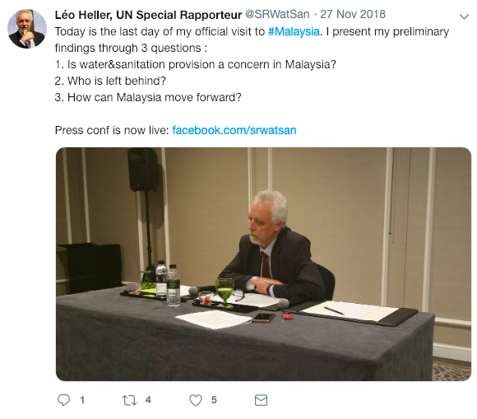
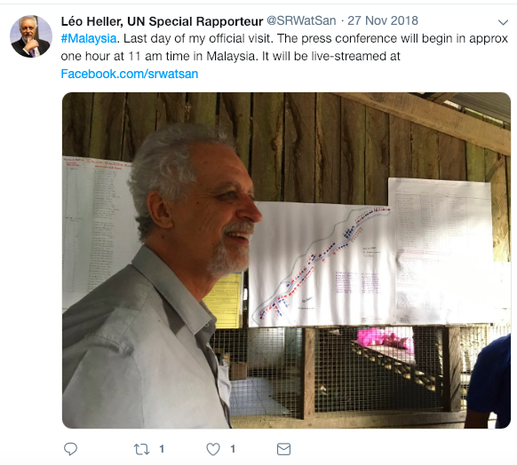
ENDS

Information about the Special Rapporteur
Mr. Léo Heller (Brazil) is the Special Rapporteur on the human rights to safe drinking water and sanitation, appointed in November 2014. He is a researcher in the Oswaldo Cruz Foundation in Brazil and was previously Professor of the Department of Sanitary and Environmental Engineering at the Federal University of Minas Gerais, Brazil from 1990 to 2014.
Learn more: http://www.ohchr.org/SRwaterandsanitation
Follow the Special Rapporteur on Twitter (@srwatsan) and Facebook (facebook.com/srwatsan)
Special Rapporteurs are part of what is known as the Special Procedures of the Human Rights Council. Special Procedures, the largest body of independent experts in the UN Human Rights system, is the general name of the Council’s independent fact-finding and monitoring mechanisms that address either specific country situations or thematic issues in all parts of the world. Special Procedures’ experts work on a voluntary basis; they are not UN staff and do not receive a salary for their work. They are independent from any government or organization and serve in their individual capacity.
Information about the visit
Meetings: At the federal level, I met with the Ministry of Foreign Affairs (KLN), Ministry of Water, Land and Natural Resources (KATS), Ministry of Housing and Local Government (KPKT), Ministry of Education (KPM), Ministry of Home Affairs (MOHA or KDN), Ministry of Health (KKM), National Water Services Commission (SPAN), Malaysian Water Association (MWA), Ministry of Rural Development (KPLB), Ministry of Housing and Local Government (KPKT), Department of Environment (DOE or JAS), Department of Orang Asli Development (JAKOA). In the State of Sabah, I met with the Sabah State Water Department and its Sandakan district office; In the State of Sarawak, I met rural water supply department and sewerage department of the District of Miri and water utility company such as LAKU, Kuching Water Board and Sibu Water Board; In the Peninsular Malaysia, I met Air Selangor (State of Selangor) and Indah Water Konsortium (IWK). I also met the Human Rights Commission of Malaysia (SUHAKAM) in Kuala Lumpur and in Kota Kinabalu.
Site visits: At Gua Musang district of the State of Kelantan, I visited several Temiar-Orang Asli population near Kuala Beatis in Gua Musang district: Peralong, Langsant; Jias; Podek; Angkek; Jenut and Kelaik; At Sandakan district of the State of Sabah, I visited Bahagia village and other informal settlements; At Penampang district of the State of Sabah, I visited Timpayasa village where I met with residents from several villages: Buayan, Terian, Tiku, Bisuan, Mondolipau and Bolotikon. In Baram district of the State of Sarawak, I visited Lapok and Sungai Luton.

WHO/UNICEF JMP, Progress on drinking water, sanitation and hygiene: 2017 update and SDG baselines.
WHO/UNICEF JMP, Drinking Water, Sanitation and Hygiene in Schools, Global baseline report 2018.
Buku Harapan, ‘Rebuilding our nation, fulfilling our hopes’, available from: https://iamjaychong.com/download/manifesto-pakatan-harapan-ph-english-version/
The survey findings were reported in the Symposium: access to public facilities for trans people in Penang in January 2017
National Water Service Commission, Number of Connections: Year 2015-2016

