Check against delivery
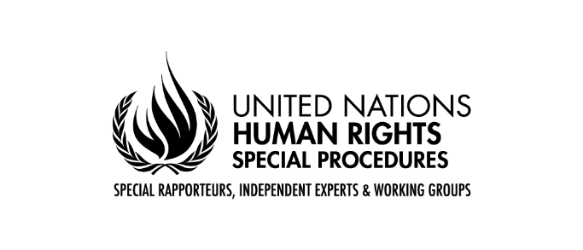
Statement by Claudia Mahler
Independent Expert on the enjoyment of all human rights by older persons
Panel discussion on the human rights of older persons
in the context of climate change
47th session of the Human Rights Council

Madame President,
Madame High Commissioner,
Madame Special Representative,
Excellences,
Ladies and Gentlemen.

Thank you very much for inviting me to this high-level event and giving me the opportunity to speak. I am participating as the United Nations Independent Expert on the Enjoyment of all Human Rights by Older Persons.
The man-made climate change poses specific challenges for the heterogeneous group of older persons. Due to the interaction of ageism, age discrimination and climate change, they can be particularly disadvantaged and discriminated against. Age is still missing as a specific ground of discrimination in the current international human rights system. This is already one aspect which explains the invisibility and insufficient protection of older persons on the international as well as national level.

My mandate pays particular attention to different groups of older persons, including older persons whose rights are threatened and violated by the impacts of climate change. Intersectional factors need to be taken into account as they often significantly shape the way older persons experience the impacts of climate.
In particular, I wish to highlight that older women, older persons with disabilities, ethnic minorities and indigenous people face specific challenges in realising their rights in relation to the impacts of climate change. For example, older women experience higher rates of poverty and face other economic hardships that are aggravated by climate change. And older persons with disabilities disproportionately experience poor housing conditions, which increase the risk related to emergencies and disasters. I would like to encourage you all to pay special attention to these groups.
During many country visits, my predecessor pointed out that climate change already has a disproportionate impact on the rights of older persons in different parts of the world, for example in Georgia, Costa Rica, Namibia, Mauritius, Mozambique, and New Zealand. For instance, in Georgia, floods often cause harm to residential areas and agricultural land which particularly affects older persons as 84 per cent of people aged 65 years or older work as subsistence farmers.
Moreover, the rights of older persons to life, health, and safety may be violated by climate change and the lack of action to mitigate it. Older persons are more likely to die from natural disasters caused or exacerbated by climate change, such as heat waves, typhoons, hurricanes, volcano eruptions or floods. They may face specific challenges to reach safety, for example because of reduced mobility or if information about evacuation and services is not made available in diverse and age-friendly formats.
I urge governments to systematically consider older persons when assessing the impact of climate change, implementing policies to adapt to and mitigate climate change and to adopt a policy of climate resilience that takes into account the specific needs of older persons. States should adapt national legal frameworks to protect the rights of older persons in the context of climate change, building up on existing standards. The voices and perspectives of older persons must be included at all stages of developing, implementing and monitoring such policies. We also have to highlight the important contributions of older persons to climate change mitigation.
Persistent ageism, age discrimination, and the lack of an international convention on the rights of older persons make it more difficult for older persons to claim their rights and fundamental freedoms in many contexts, including in relation to climate change.
From my perspective the Covid-19 pandemic clearly showed us that older persons cannot enjoy their human rights on equal basis with others because international human rights law does not provide a coherent and explicit guidance in this respect. This results in the specific human rights concerns and challenges faced by older persons being overlooked and not prioritized. Older persons’ dignity and human rights are at stake and action is needed to move closer to an international binding instrument on the rights of older persons.
Thank you very much for your attention. I am looking forward to the contributions by my fellow panellists and wish us all a fruitful discussion.

