Check on delivery

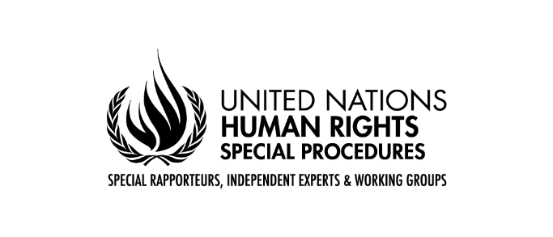

Fifty-second Session of the Human Rights Council
General debate under item 5

Statement by Víctor Madrigal-Borloz
On behalf of the Coordination Committee of Special Procedures

Geneva, March 23, 2023

Madam Vice-President,
Excellencies,

I have the honor to present the report on the activities of the Special Rapporteurs, Independent Experts and Working Groups in 2022, during which we continued our collective and individual work.

The report reflects the rich contribution of the special procedures to the global human rights agenda, and the dedication of my colleagues to the delicate task given to them by this Council.

During 2022, we addressed cross-cutting issues: armed conflicts, prevention, development, climate change and new technologies are just some examples. By doing so, my colleagues and I contribute significantly to increase the relevance of human rights throughout the UN system and beyond. The connection of our mandates with the other pillars of the UN, in particular the peacebuilding and prevention agenda, was a key line of work in several reports and discussions on this subject with United Nations authorities and agencies during our annual meeting.

The report also underlines the commitment of the special procedures to the wider United Nations family. Concomitantly, it illustrates the growing interest of other pillars and entities of that family, including UN country teams, in cooperating with us; processes that create coherence with the Call to Action for Human Rights and Our Common Agenda, which offer key momentum and opportunities to integrate the work of special procedures within the UN system and foster engagement between these mechanisms and UN bodies and entities.

Excellencies,

2023 is an important commemoration year, with the anniversaries of the UDHR and the VDPA. It is also a crucial year as it is leading us to the Summit for the Future. My colleagues and I are willing to contribute to these processes and the Committee will continue engaging with all concerned to facilitate such contribution. These are crucial moments to jointly solidify our vision for the future of human rights and multilateralism, reinvigorating the immense hope that led to the creation of the human rights system 75 years ago. We are committed to using the year for thoughtful and ambitious considerations of our role, and the role of the international community, to shape a next 75 years of furtherance of human rights for all persons. We should put our ambition high and focus on building and realizing a transformative human rights system that will underpin the next 75 years of global history.

Excellencies,

As was the case last year, the report also highlights the contribution of special procedures to technical cooperation. We hope that the description of these activities and their potential will encourage more States and other actors to collaborate with mandate-holders. My colleagues and I underline the call for a more active use of human rights mechanisms (including special procedures), with a view to solving current challenges, the better linkage of these mechanisms with other processes to maximize their impact, and the creation, for them, of a sustainable financial base.

For the potential of the special procedures to be realized, the support of States and constructive cooperation with them is essential. My colleagues and I welcome the fact that more States have issued standing invitations and have effectively opened their doors to us. In 2022 we carried out 69 country visits; in total, as of today, 172 Member States have received at least one visit. As shown in the report, attention to regions and countries is balanced, our working methods actively promote dialogue and technical cooperation, and the information available to this Council by these means enriches the knowledge base available for its considerations.

At the same time, some States have not taken any measures of cooperation with the special procedures, and others cooperate selectively. We call on the Member States that still have not received a visit to do so, as well as on the 65 Member States that have not formulated a standing invitation to do so.

Individual communications continued to be a significant part of our work: 654 were sent to States and other actors last year. I am sorry to report, however, that the response rate, at 44%, is still not what we could consider as appropriate. Communications refer to cases and situations to engage with all concerned on a dialogue with a view to an eventual positive impact on the enjoyment of human rights of the persons concerned, and a contribution to the body of knowledge available to States, civil society, and academia.

I would also like to stress that some of my colleagues have been intimidated as a result of fulfilling their mandate, and others have faced baseless accusations about their integrity and motivations, which I find deeply regrettable. Madam Vice-President, as I said last year, none of my colleagues, nor I, pretend to be above scrutiny. But disagreements should be expressed in a respectful and constructive way, and never transcend the realm of the personal. This Council must maintain and consolidate its practice condemning personal attacks against the experts to whom it entrusts the delicate task, described on numerous occasions, of being their eyes and ears.

The Committee has also redoubled its efforts to constantly evaluate and optimize the working methods of the special procedures. We have promoted numerous instances of dialogue with the States and participated in many others promoted by them; we have continued to move forward with the internal advisory procedure; we have continued our commitment to financial transparency. Detailed information on all these processes is available in the report and, in more detail, on the website of the Special Procedures.

Excellencies,

Special procedures are more than a collection of individual mandates. They also constitute a collective that shares information and experiences, adopts collective decisions on working methods, and gives content to concepts such as intersectionality of the human rights approach.

In 2022, one mandate was created, and 19 new mandate holders joined our collective, with 55% of our colleagues being female and 45% male.

My colleagues and I interpret these developments as further evidence of the confidence that the Human Rights Council places in our mandates as efficient and effective tools to advance the effective enjoyment of human rights for everyone in the world. Having expressed our gratitude for that trust, we renew our commitment to the work of this Council.

Thank you.

